Chicago Teachers Win Wage Increases, Better Working Conditions
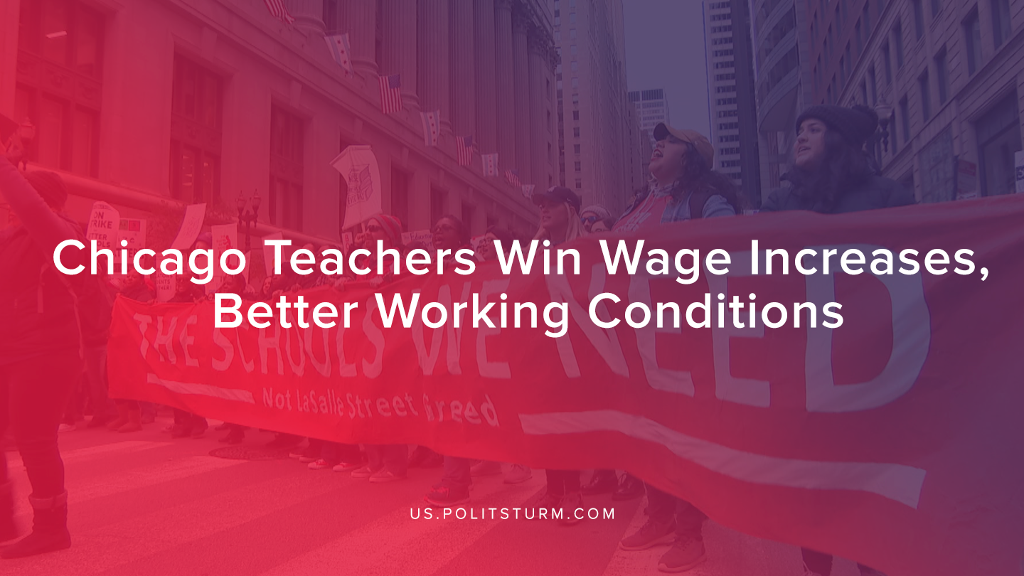

Original article
2019-11-16
1 min read

Chicago Public School teachers were on strike recently over wages and working conditions. Workers went on strike demanding increased wages and improving the working conditions that they face on a regular basis.
The Chicago Teachers Union represents more than 25,000 teachers and educational support workers in the Chicago public schools.
The teachers ended the strike by voting on an agreement that would guarantee a 16% raise and allocate $35 million to reduce class sizes. Specifically, the contract included a maximum class size of 28 students, and caps on class sizes for special education students that must comply with Illinois law.
Also, the agreement included language that would protect immigrant and refugee students and workers from Immigration and Customs Enforcement (ICE).
“This is a win for our students, their families, our educators, and all CTU members in charters or CPS district-run schools,” said teacher Mike Scott-Rudnick. “We were determined to raise the rights and benefits of CTU members at Passages to the standards that our sisters and brothers have been fighting and striking for all across the city in charter and district schools.”
The Chicago public school workers have shown that with proper organization workers can gain tangible concessions that improve the quality of their lives. However, the entire capitalist system is predicated upon the exploitation of workers and the division of society into antagonistic classes. If the workers were to organize upon strictly Marxist-Leninist lines with a proper understanding of the machinations of the capitalist system, they could improve the quality of public schooling beyond the limits of the capitalist system.
Sources: 1, 2

Original article

