Charles Schwab Acquires TD Ameritrade
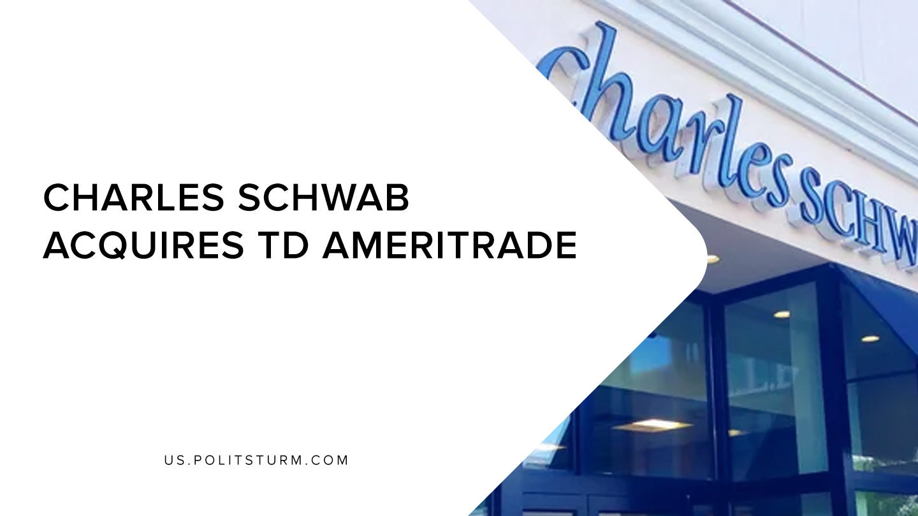

Original article
2019-12-04
1 min read

The Charles Schwab Corporation (Schwab) announced that it would be acquiring TD Ameritrade Holding Corporation in an all-stock transaction valued at approximately $26 billion. The shareholders in TD Ameritrade will be receiving 1.0837 Charles Schwab shares for each of their TD Ameritrade Shares, which represents a 17% premium over their 30-day moving average price.
The combined company will house 24 million client accounts with $5 trillion in client assets. The “discount” brokerage companies have been undergoing fierce competition, with several companies recently cutting their commissions to $0 for online trading. This deal will further consolidate the brokerage firms as Schwab and TD Ameritrade were already among the largest brokerage companies.
Even in 1916, Lenin noted the tendency of the financial oligarchy towards monopolization and their massive enrichment through this process. Shareholders of TD Ameritrade were able to realize a massive gain through this tendency towards monopolization as brokerage companies consolidate into fewer and fewer firms. Although there is cut-throat competition as firms struggle against each other in the marketplace, the process of monopolization allows the opportunity for capitalists to further enrich themselves through buyouts.
The press release announced that the deal would create “synergies” that are expected to increase earnings per share by 10-15%. This is typically indicative that employees would be laid off or dismissed through the “elimination of overlapping and duplicative roles”.
Brokerage companies house the accounts that hold stocks, bonds, mutual funds, and other financial products for their owners. Through the ownership of these products which entitle their owners to a share of surplus value, the capitalists can exploit the global proletariat and realize profits, capital gains, interest, dividends, etc. Even within the brokerage industry itself firms consolidate and compete through a dialectical process as the larger companies swallow their competitors. The financial oligarchs further enrich themselves from this process of monopolization and will do so until the expropriators are finally expropriated.

https://pressroom.aboutschwab.com/press-release/corporate-and-financial-news/charles-schwab-corporation-acquire-td-ameritrade
https://www.marxists.org/archive/lenin/works/1916/imp-hsc/ch03.htm

Original article

