CEO Compensation 312 Times Higher Than The Average Worker
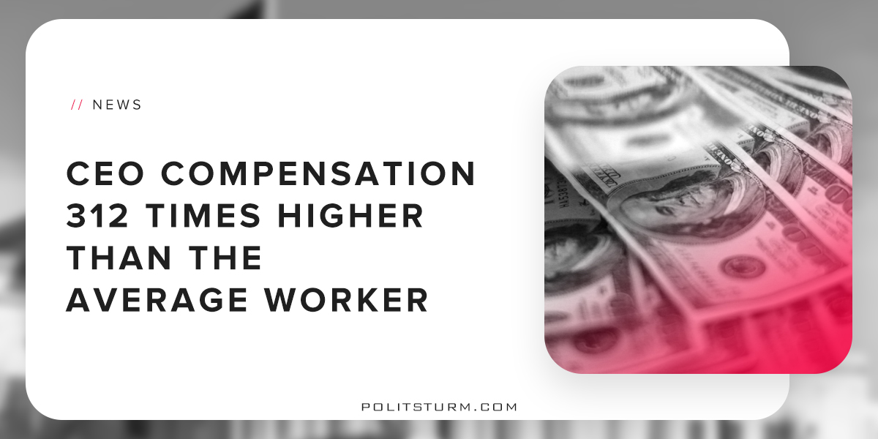

Original article
2018-09-02
2 min read

A new study released by the Economic Policy Institute shows that CEOs are compensated 312 times more than their average workers. The average CEO was compensated $18.9 million in 2017, which is an increase of 17.6% from the previous year. WIn comparison, workers compensation has increased only 0.3% over the same period.
This measure takes into account the fact that corporate executives from large corporations are compensated with stock options. Due to the fact that the stock market has reached all-time highs, executives are exercising their stock options. This means that they are selling their stocks at exorbitant prices to realize massive capital gains and realized profits.
The phenomenon of income inequality is merely a reflection of the differences of social classes and how they are compensated. The corporate executives and major shareholders are the owners of the means of production and are regularly compensated through their ownership of stocks, bonds, options, and other forms of property through which they derive unearned income. The workers, by contrast, only are able to sell their ability to work to the capitalist class in exchange for a wage.
The chief difference between the two classes is that CEOs receive compensation through the unpaid labor of the working class. Workers, by contrast, need to continually sell their ability to work to the capitalist class. The unpaid labor of the working class is being accumulated by the capitalist class. There is a two-sided, dialectical perspective to income inequality. The tremendous gains that accrue to the capitalist must be contrasted with the tremendous theft from workers around the world.
The study suggests that raising the marginal tax rate for individuals as well as corporations would disincentivize excessive CEO compensation. The problem with this policy prescription as well as all other reformist propositions lies in the class nature of modern, bourgeois governance.
The current government in the United States represents not a democracy for the mass of workers, but rather the dictatorship of the bourgeoisie. As such, the bourgeoisie benefit from the enrichment of executives and major shareholders at the expense of the working class.
Capitalist production requires expanded reproduction. This simply means that capitalist production is predicated on growth and expansion of capital that is invested. For example, if a capitalist invests $1 million, the capitalist must see a positive return on investment holding the value of money as constant. The profit can then be used to expand the scale of production by purchasing more means of production and hiring more workers. The profit could also be used by the capitalist to purchase commodities for consumption as well. The shares of stock that circulate on the stock exchanges are simply a legal claim to a portion of this profit that is produced by the global working class.
A government that represents the interests of the bourgeoisie would see no benefit in taxing corporations or corporate executives. The high marginal tax rates that occurred in the United States during the 1940’s were a compromise made out of necessity by the bourgeois class. These regulations, as well as the strength of the American workers unions, have declined dramatically from this period.
As evidenced by the recent tax overhaul by the Trump administration, it is in the interest of the bourgeoisie to lower taxes on the wealthy and corporations. U.S tax laws are purposefully constructed by representatives of the capitalists and landlords to favor landed interests and capital over labor. Only a government that represents the interest of the working class as a whole will be able to resolve the fundamental contradiction between the bourgeois and working class. To imagine a capitalist economic economic system that provides equality and freedom to the workers is merely to engage in bourgeois thought experiments.

https://www.epi.org/publication/ceo-compensation-surged-in-2017/?utm_source=Economic+Policy+Institute&utm_campaign=c264b1e6e6-EMAIL_CAMPAIGN_2018_08_16_06_08&utm_medium=email&utm_term=0_e7c5826c50-c264b1e6e6-58383941&mc_cid=c264b1e6e6&mc_eid=5d666a60ab
https://www.taxpolicycenter.org/statistics/historical-highest-marginal-income-tax-rates
https://www.marxists.org/archive/marx/works/1885-c2/ch02.htm#2

Original article

