Cases of Tuberculosis and Hepatitis Among Children Have Increased in Russia
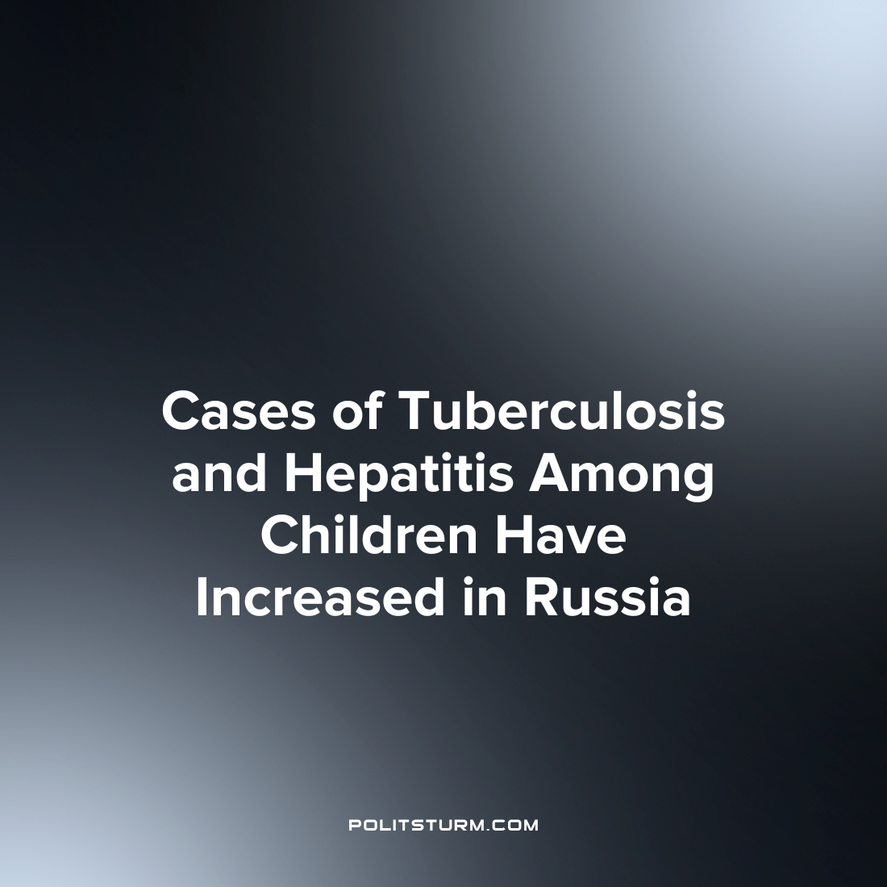

Original article
2023-09-08
3 min read

The incidence of tuberculosis and hepatitis in Russia continues to grow, especially among children, which is an alarming phenomenon. In the first five months of this year, according to the latest report of Rospotrebnadzor on infectious diseases, an increase in the incidence of these infections among children under the age of 14 was uncovered.
The number of cases in which children were first diagnosed with TB increased by 17% (to 703 cases), with the largest increase, respiratory diseases, rising by 19% (to 666 cases). It was noted that the increase in the overall incidences of tuberculosis was 4% (17.1 thousand cases), while cases of respiratory tuberculosis increased by 5% (16.5 thousand cases).
The incidence of acute forms of hepatitis increased by 22%, reaching 398 cases among children. Of these statistics, a significant proportion are cases of acute hepatitis A (359 cases) - an increase of 20%. For acute hepatitis B, a two-fold increase - from 2 to 4 cases. However, the incidence of acute hepatitis C decreased by 7% (to 13 cases).
This alarming increase in such incidences is causing concern among medical experts and professionals. The leading specialist of the Children's Scientific and Clinical Center for Infectious Diseases of the Federal Medical and Biological Agency of Russia, Valentin Kovalev, notes that the increase in cases of hepatitis and tuberculosis may be associated with a drop in vaccination coverage due to refusals of vaccinations and the spread of false medical information. According to the national vaccination schedule, hepatitis B and tuberculosis vaccinations are given immediately after birth, and scientists emphasize the importance of their implementation to ensure immunity.
These data from Rospotrebnadzor highlight the relevance and urgency of the issue of vaccination, which plays a key role in combating the spread of infectious diseases. The increase in cases of measles, whooping cough, mumps and chickenpox among adolescents under 14 years of age since the beginning of the year highlights the importance of vaccination and the need to pay attention to scientific advice.
The systemic crisis, which began with the transition to a market economy, affects health care, education, and other areas of society. The transformation of medical care into a paid service reduces its availability for the general population, while at the same time optimizing health care costs reduces its quality. This negatively affects the health of most ordinary citizens.
The decrease in funding for medical educational institutions leads to a deterioration in the quality of training and education of future doctors. In turn, the shortage of qualified specialists in hospitals, depreciation and dilapidation of material and technical resources worsen the possibility of providing quality medical care.
The commercial focus of healthcare creates a situation in which patients are viewed as potential sources of income for doctors, which distorts the priorities and goals of medical practice. The pursuit of profit jeopardizes the deep professional knowledge and skills that are critical in the medical field. Of no small importance is the fact that the state is negligent in educating citizens about vaccination. There is absolutely no educational activity in this direction. On the contrary, numerous “experts” in pursuit of popularity willingly share their shocking revelations about the dangers of vaccinations. In doing so, they reinforce their audience's mistrust of medicine.
As a result, the above trends lead to a loss of public confidence in the healthcare system and the professional skills of doctors. Therefore, ensuring the availability of quality medical care is an essential task for restoring and protecting the health of the whole society. But this is impossible within the framework of the existing capitalist economy, where money is placed above human life.
In order to provide everyone with affordable and free medical care, it is necessary to make the transition to socialism. In such a society there will be no division into rich and poor, and epidemics will remain only in the past, on the pages of history.
Source: RBC - «The incidence of tuberculosis and hepatitis among children has increased in Russia» From August 8th, 2023

Original article

