Capitalists Walk Back Liberal Climate Promises
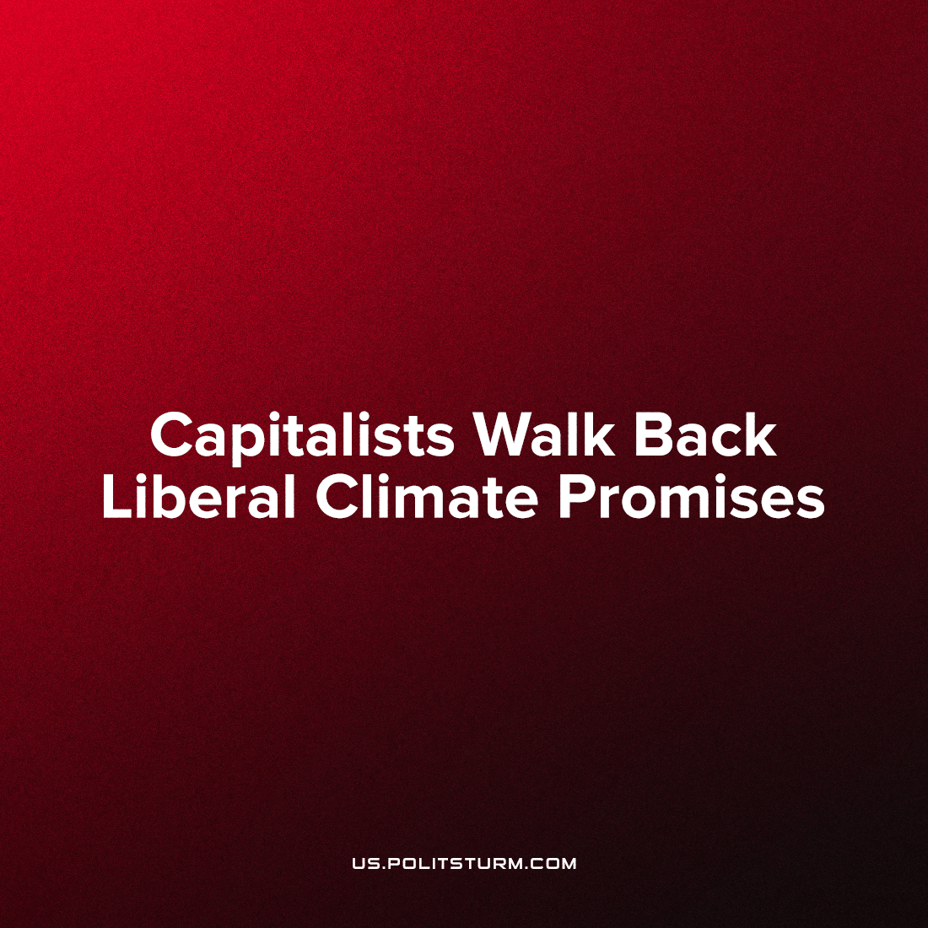

Original article
2023-03-07
2 min read

In 2020, Shell committed to a net-zero emission target, with a $6 billion promised investment [1], now, these investment plans have turned out unfulfilled, while Bloomberg reports Shell's major $29 billion investment into Qatar ’s gas industry expansion [2] - one of the most important exporters for the growing world market in liquefied gas.
Error loading image
This is only one throwaway story of the international capitalists change of heart over emissions-driven climate change - with a conscious guided by market prices[3]. All the rosy slogans encouraged by the liberal politicians and their industry lobbyists quickly paled in reality when the economic crisis took hold.
Shell "committed" to net-zero emissions in 2020, when oil and gas prices were low, and social tensions were high. Last summer, Shell invested heavily in gas production because of high gas and oil prices, and this arm of the fuel cartel does not act alone.
British Petroleum cut in half its ambition to reduce emission from fuels to 20% from 40% with its changing market strategy [4]. High petroleum prices allowed it to boost share-holders' dividends by 10%, to 6.61 cents per share.
Germany proposed a $40 billion transition support to coal mining in 2019 [5]. German energy for more than a half is produced by renewable sources. However, coal is critically needed for German industry - and now we are seeing an expansion of coal in Germany. In market competition, industrial enterprises are becoming non-competitive without cheap coal.
Monopoly corporations used their critical exposure in the media to advertise dazzling technological solutions to climate anxiety. When the channels changed, Exxon simply liquidated its algae biofuel project when oil prices rose and their original business model's profitability reigned [6].
After advertising its efforts to produce environmentally friendly fuels from algae for over a decade, Exxon Mobil Corp. is now quietly walking away from its most heavily publicized climate solution
All 'non-carbon' projects and technologies are just instruments for private enrichment. When such projects are profitable, they are heavily publicized, but the monopoly capitalists would fully commit to stop carbon emission etc, only if it were the most profitable course of action. During crisis, all commitments are nothing, all unprofitable industries can be closed, because profits the vital lifeblood for the capitalist parasites driving endless destruction and endless growth.
Companies cannot be for saving the environment because they can only care about enriching shareholders by exploiting greater and greater numbers of resources. All along, the push for climate industries was an in exercise in the growth of the portfolio of the petroleum and chemical and manufacturing industries who circulated their money in propaganda projects to delude the masses in their climate delirium, and increased some dividends by creating new markets for tech commodities. Now that this performance has ceased its circle of financing and collapse, the oil and gas cartels remain in their original place.
Sources: 1, 2, 3, 4, 5, 6

Original article

