The Myth of Capitalist Competition: What’s Really Driving Progress?
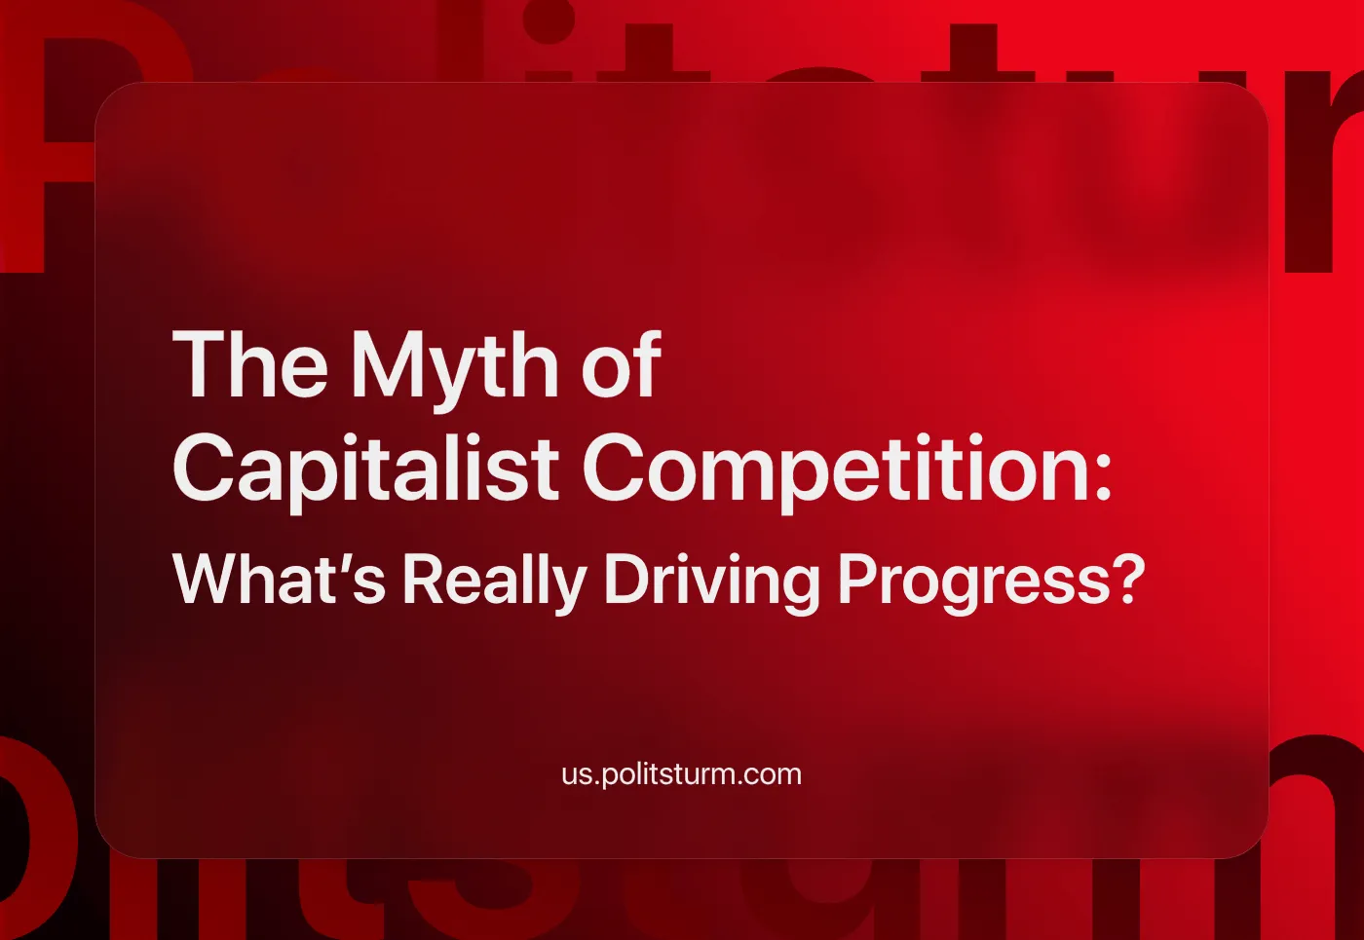

Original article
2024-09-09
19 min read

Nowadays, the word “competition” is one of the most popular when discussing economics and politics on TV shows, on the Internet, in books, games, and also including between ordinary people in conversation. You might have heard someone say “Competition is the engine of progress...”, quoting, perhaps unknowingly, Adam Smith.
Are you looking for success, or specifically how to achieve happiness, love and wealth? Winning the competition is the answer you will find almost everywhere. The term is so widespread that it is often perceived as a “peculiarity” of the human experience. But have you ever wondered why we actually need, say 15 brands of toothpaste?
“Although the law of competition can sometimes be harsh for an individual, it is best suited for the entire race because it ensures the survival of the fittest in each division. Therefore, we accept and welcome as conditions to which we must adapt, great inequality or the environment, the concentration of business, industrial and commercial, in the hands of a few and the law of competition between them, as not only useful, but also necessary for the future progress of mankind” — Andrew Carnegie, an American entrepreneur, a major steel industrialist, and a multimillionaire [1].
This is the opinion of a rather outspoken capitalist. Let's look at why he so welcomes this “concentration in the hands of a few” and whether it really leads to the progress of mankind.

Engine of progress
Before we begin, let's reveal the subject of our review. Competition - characteristic of commodity production based on private ownership of the means of production, an irreconcilable struggle between capitalists to obtain the highest profit [2].
At the very beginning of its formation, the capitalist system did not have time to create enough large-scale production that could saturate the entire globe with its goods. The global market was barely formed and had not yet acquired so many connections in production and supply. The world was dominated by free competition (the kind that everyone likes to reminisce about and promises to return to). Companies are created, compete mainly on price, merge, and conspire, little by little forming very large companies with huge influence in their industry.
This is how things went until the end of the 19th century, this gradual process outgrown itself and turned into the final stage of capitalism - as we call it the imperialist (monopoly) stage of capitalism. The world has already been divided into spheres of influence (comprised of the markets, labor, resources etc.), what remains is only to fight for their redistribution. In every industry, there are monopolies, trusts, oligopolies, etc. with extraordinary influence in several sectors of the economy and even states.
And now we are in the 21st century. It may seem strange to many readers that many well-known brands that seemingly “compete” with each other are actually owned by just ten of the largest multinational corporations. You may even find that some of your favorite opposing brands actually make a profit for the same company, even though different companies are listed on the packaging. Many leading and world-famous brands of toothpaste, detergent, and candy actually make a profit for a few companies.
They exist to create the appearance of competition, to give you the illusion that you have a choice in whose wallet you put your money. In some cases, this division is merely a formal and legal division, due to anti-monopoly legislation. As can be seen in the diagram below, this has not saved us from monopolies, but if we only had 10 brands on the shelves, it would be much more obvious. In fact, there are far more than ten such monopolies, and their tentacles literally sprawl across all aspects of life, but for the sake of brevity, we will analyze just one of them.
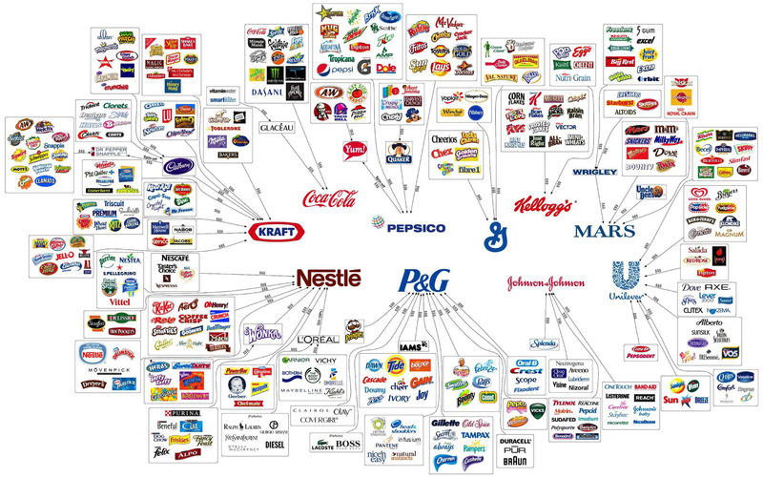
Let's take Procter & Gamble (P&G) as our example. It holds leading positions in a number of industries, such as Fabric & Home Care (detergents), Baby, Feminine & Family Care (children's and women's hygiene), and Beauty (cosmetics). How are the floors in every third home cleaned? Most likely with the Mr. Proper brand. What kind of laundry detergent is used? You and your friends may be familiar with Tide. The brands are different, as are the manufacturers, but the profits go to Procter & Gamble, which owns both brands [3].

How do you compete with such a giant? Perhaps the experience of their most dangerous competitor in the washing powder market - Persil, which was rapidly gaining momentum in the British market, will be instructive. In 1994, P&G sent to the media the results of sponsored research that talked about the harm of its main competitor and set up an entire PR company to harass it [4]. As a result, Persil was discontinued after several years. Ariel replaced Persil as the leading detergent in the UK. At the same time, Unilever (which is another giant monopoly), which owned Persil, was forced to write off nearly £260 million in development and marketing costs [5]. Even a thousandth of that amount could wipe out an independent fledgling company.
Maybe you need to establish a start-up and push out giants, which hold the market? To create a company that will find investors, good specialists, the right idea and ways to implement it, while surviving in competition against monopolies for several years is a task with a slim chance of success. At least 50% of all start-ups end in failure within the first five years, the second half will last longer at best and only as a rare exception can the start-up grow into something more [6]. At the same time, many do not think about the downside of the “success” of such startups, namely their obligations to investors, who can often make significant changes that contradict the original idea for the sake of short-term profits.
Even if we are not talking about start-ups, but about medium-sized companies, what prevents big capitalists from buying them up in the next crisis?
"When you swim with sharks, the only way to survive is to become the most shark-like of all the sharks" — Irvine Welsh "Porno (novel)".
Let's look at one of the sharks. A good example of such a case is that Mars wants to acquire the well-known brand “Pringles”, currently owned by “Kellanova”. To add this new brand to their collection will cost them $22 billion, which for Mars with annual sales of more than $50 billion looks substantial, but at the same time it is fairly ordinary for them.
Mars has pursued acquisitions, including the purchase of VCA (a group of 800 pet care clinics) for $9.1 billion in 2017. In 2008, the company paid $23 billion in a deal with Wm Wrigley Jr., the manufacturer of chewing gum and snacks. In 2024 Mars had already acquired Hotel Chocolat (a British premium chocolate company) for $0.7 billion.
According to the FT, in the first half of 2024, mergers and acquisitions worldwide showed a recovery growth (after the pandemic stagnation), reaching $1.5 trillion, that is, about 30 Pringles acquisitions in just half a year [7].
Until then, it will be a mystery whether the taste and quality of Pringles chips will be even better after absorption by Mars. But if competition works, where are the new brands and products that will displace Mars, Apple, Google, and other giants? Even if they emerge, monopolies will try to buy them out or destroy them through economic pressure combined with an unscrupulous PR company. Or, in extremely rare cases (or the case of new industries), the winners themselves that displaced the old monopolies, would become monopolies themselves. One only has to recall Google’s original motto when it was a startup: “Don't be evil”. That monopolies are bad things is recognized by almost everyone, yet monopolies do not just exist, they are getting bigger and bigger, as is their influence over as much of the economy as possible.
But the competition is not disappearing, it is reaching a new level. Monopolies now compete with each other for profits, but now they have the power of the state in their arsenal. To accept duties on imported goods, to receive subsidies from the state, to impose sanctions, to start a war - all these methods are actively used in the interests of monopolies.
It is at this moment that populists in politics and bourgeois economists take the dusty “free” competition out of the history books and begin to propose turning back the clock. Many claim that we live under “crony capitalism”, “corporate communism” or “techno-feudalism”, and harken to return to good old real capitalism. In line with the original theorists of liberal ideology, they claim competition will make our lives better, and move progress forward, but how does this relate to reality, where everything has been controlled by groups of monopolies for more than 100 years? After all, as we demonstrated above, it is futile at best to fight them within the framework of the capitalist system.
The dominance of monopolies does not really eliminate competition, because the appropriation of labor’s results remains private. The anarchy of production persists, as does the antagonism of the interests of different monopolistic groups and between different layers of the bourgeoisie. And the more intensively monopolistic capitalism develops, the more intense competition becomes, the nature of which depends on the degree of monopolization of the capitalist economy. V.I. Lenin wrote:
"... monopolies, which grow out of free competition, do not eliminate it, but exist above and beside it, thereby generating a series of particularly acute and steep contradictions, frictions, conflicts" (Complete Works, Volume 27, page 386).
Since monopolies can set monopoly prices (i.e. price gouge), at least for a time, the incentive for technological progress disappears to some extent, but nevertheless, "... monopoly under capitalism can never completely and for a very long time eliminate competition from the world market..." (ibid., page 397). Competition creates the appearance of progress, but even this illusion arises only when profits are threatened or vice versa, when capitalists want to protect an already existing piece. As long as child labor is beneficial, including on plantations, mining, etc., it will be used. For example, Tesla, which has robotic factories, also uses cobalt that is mined through child labor [8].
The real source of progress is the struggle of opposites - the new with the old. This development moves along the path from the simple to the complex. The progress you can see in your lifetime comes from the economy and the social structure associated with it. Capitalism, by destroying feudalism and developing machine production from handicraft and manufacture, really contributed to the development of mankind.
Then this development began to slow down. It is impossible to stop it because it is one of the universal laws of nature. The reason is that capitalism, having given way to progress on a global scale, developed the mode of production to such a level that it acquired social character. This means that one does not produce for just the city but for the country or the whole world in a single factory. It is almost impossible to find the necessary raw materials in the city - you have to bring them from the other side of the planet, where cobalt, for example, is mined for them by workers from another country. Every modern mass-produced commodity is the product of thousands of different workers across the world and is similarly used by thousands or millions. Production has become more complicated, and trade and economic relations have become so intertwined that they form a complex web of interdependence. At the same time, all of this social production is the private property of one or a few people. Society would like to produce more, better and cheaper for itself, but the capitalist (who is superfluous) in this scheme acts as a hamper on this because he will not be able to subsist otherwise by parasitizing on the work of others.
There is another struggle of opposites - on the one hand the social interest of the workers of the whole world, and on the other the personal interest of the capitalists. The course of social progress is unstoppable, and the more it develops, the closer it comes presses against the narrow framework of capitalism, the sharper the contradictions of capitalism become.
So does capitalist competition lead to progress? No, because progress is already underway, competition only weakens the chain by which the capitalists try to restrain it and slow it down. The main result of capitalist competition is... monopoly. Even in the new industries that have recently emerged, such as the market for neural networks, the main players have already formed. At the same time, competition is one of the main causes of wars, as we wrote about in our other article.
But is there an alternative to the arbitrariness of monopolies and their supposedly “unfair” competition? Do we really have to endure this battle of giants, of which we mere mortals are the victims? Is devouring each other in the pursuit of profit really the most rational way to advance the progress that humanity has achieved?

Socialist emulation
"I have neither friends nor enemies, only competitors.“ — Aristotle Onassis, Greek shipowner, and billionaire [9].
Both tender human social relations and explicit relations of fealty are eroded and replaced by impersonal market and wage relations. This approach is dictated by the capitalist system itself, along with private ownership of the means of production, the anarchy of production and irreconcilable competition for the most delicious pieces of the capitalist pie.
The most rational and, above all, scientific alternative to this is socialism with a planned economy, where competition and exploitation of man by man are destroyed and replaced by socialist emulation. It encourages competitiveness in work and at the same time is based on relations of cooperation, mutual assistance and collectivism. As J.V. Stalin said:
“Socialist emulation is sometimes confused with competition. That is a great mistake. Socialist emulation and competition exhibit two entirely different principles.
The principle of competition is: defeat and death for some and victory and domination for others.The principle of socialist emulation is: comradely assistance by the foremost to the laggards, so as to achieve an advance of all.
Competition says: Destroy the laggards so as to establish your own domination.
Socialist emulation says: Some work badly, others work well, yet others best of all—catch up with the best and secure the advance of all.” (Complete Works, Volume 12, page 116)
Socialist emulation is one of the driving forces for the development of society, which is expressed in the mass movement of the workers for the highest achievements in the production of material and intellectual goods. The highest labor productivity (and hastening the rate that labour productivity increases) is a crucial condition for the victory of communism.
Social emulation shows the creative initiative of the workers in the struggle for:
- the fulfillment of national economic plans
- the improvement of the quality of products
- the acceleration of scientific and technological progress
- the reduction of material and labor costs per unit of production.
It is emulation that contributes to the growth of workers' well-being, because the higher the productivity of their work, the higher the material reward for it. As V.I. Lenin wrote:
“For the first time after centuries of working for others, of forced labour for the exploiter, it has become possible to work for oneself and moreover to employ all the achievements of modern technology and culture in one’s work.” (Complete Works, Volume 26, page 407)
It is not only the growth of a single factory that is important but also the growth of the entire industry and even the entire economy of a socialist society. After all, under socialism, if one has invented and implemented some kind of innovation, they do not need patents to protect themselves from competitors and squeeze every possible iota of profit out of it. Instead of making a profit, the task becomes to make society better, and richer materially and culturally, and to this end, advanced enterprises regularly share their experience with everyone, while receiving compensation from society in line with the principle of socialism: “From each according to their ability, to each according to their work”.
At the same time, the form of the emulation corresponded to certain tasks of socialist construction and changed over time. At first, it was the Subbotniks (voluntary work on Saturdays to clean up one’s own local area), that showed a new, socialist attitude to labor without exploitation of man by man. Then the movement of shock workers was born, which infected other collectives with its example. Thanks to them, new equipment was mastered at a rapid pace. The creativity of the masses, together with public ownership of the means of production, allowed Soviet society to catch up and overtake most of the "developed" countries, advancing in decades the progress of centuries.
To downplay the merits of socialist emulation and of the workers, whose labor sent a man into space for the first time and for the first time subjugated the atom not as a weapon of destruction but for energy used by normal working people, is to paint one's own prejudices in myths and common ignorance.
As you can see, progress does not require capitalist and predatory competition. Soviet society has shown how not only to live without parasites but also how to work better without them.
In this kind of society, you will not find 15 brands of toothpaste that exist to give the appearance of competition when in fact they are all owned by the same one or two companies. Socialism doesn't need brands or any other flashy carapaces that mystify the true essence of things, while really differing very little. In fact brands and monopolies are united in using cheap shortcuts (like chemicals in toothpaste that are banned in soap [10]) and selling their commodities well about their value [11] in order to extract the maximum possible profit.
Socialist society, based on production for use, rather than exchange, would only need various kinds of toothpaste depending on the different use cases. Therefore, under socialism, you will find toothpaste personalised for all kinds of teeth. Rather than relying on market forces to perfect the product (which really perfects the profitability of the product), worker-consumer feedback channels would exist, whereby people can directly express and vote on their desires and needs within such a product. A concrete example of emulation within such a process could be experimental new flavors that various teams within the R&D department of the socially-owned toothpaste enterprise come up with, that are each tried by volunteers and voted upon by them (where the winner goes into mass production). After all, the task of the industry will be to provide each person with the best personal hygiene product, not to take more money out of their pockets. Emulation will help find the most effective way without ruining anyone.
But socialist emulation requires the destruction of exploitation, private ownership of the means of production and the introduction of a planned economy. All this can be combined and exist only within the framework of a socialist society. To build this society, a communist party is needed to lead the working class, armed with Marxist-Leninist theory. We are already working in this direction - if you want to help, join Politsturm.
Sources:
[1] PDF-file — Andrew Carnegie, “Wealth and Its Uses”, 1907
[2] The Great Soviet Encyclopedia. in 30 t.. – 3rd ed.. – M. : The Council. Encycl., 1969 - 1986.
[3] PDF-file — P&G 2023 Annual Report
[4] Independent — “Persil's whiter than white image suffers a new stain”, September 23, 1994
[5] Unisender — “7 examples of Black PR from famous brands”
[6] Inc — “5 of the Most Surprising Statistics About Startups”
[7] Financal Times — “Mars in talks to buy $22bn Pringles maker Kellanova” — August 5, 2024
[8] Forbes — “From the start: How Tesla is fighting child labor in African cobalt mines” — June 6, 2024[9] Exploring Greece TV — “Quotes from Onassis”
[10] New York Times — “Why a Chemical Banned From Soap Is Still in Your Toothpaste”
[11] ITV — “Dentists 'very concerned' after shoppers spot Colgate toothpaste priced at £10”

Original article

