Capitalism Causes U.S Income Inequality
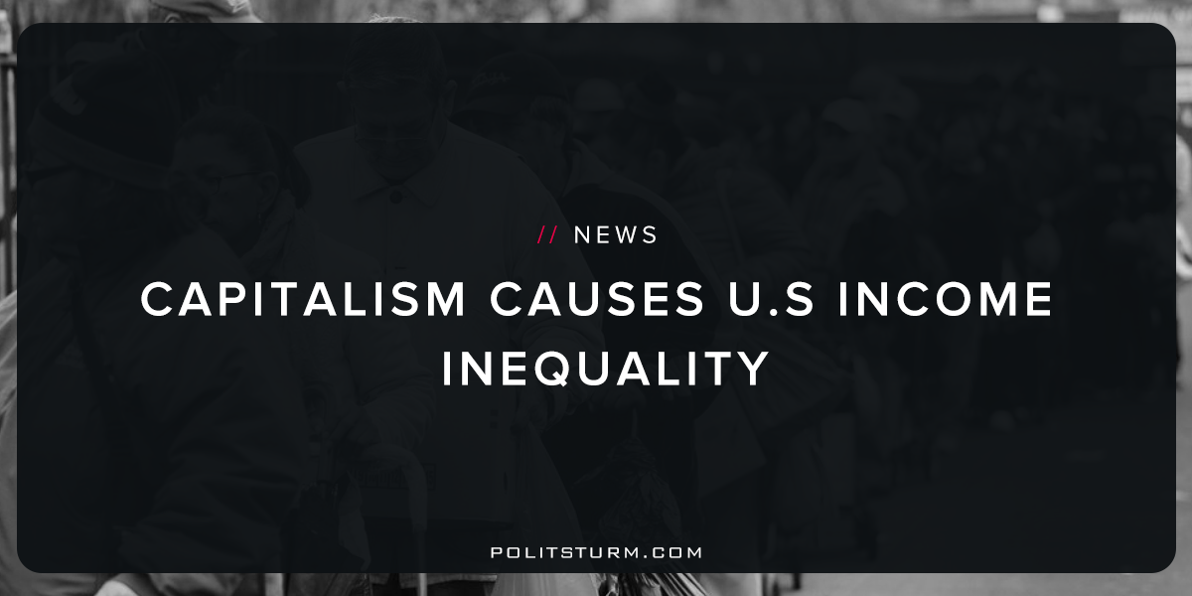

Original article
2017-10-01
2 min read

The rich are getting richer, and this trend has become so pronounced that even the wealthiest Americans, who have reaped the lion’s share of economic gains in recent years, are sounding the alarm bell.
“I think the greatest issue of our time is the disparity of wealth and the problems that exist for the lower 40% of the population,” said Ray Dalio, founder of Bridgewater Associates. Bridgewater is the world’s largest hedge fund, which about $160 billion in assets. According to Forbes, Dalio himself is worth about $17 billion.
“If you carve out that lower 40%, not only has there been no income growth, but death rates are rising because of opiate use, suicide, and because they’re losing jobs,” Dalio said. “This is the biggest issue of our time—the biggest economic issue, the biggest political issue, and the biggest social issue.”
Politstorm: Certain members of America’s economic elite, such as Ray Dalio, have come to see income inequality as a growing problem. He cites income inequality as the cause of economic, political and social turmoil in the country. The essential flaw with this line of thinking is that it assumes income inequality to be the root cause of these problems. Income inequality seems to be the essential problem for Dalio, and all of the other social problems are just derivative. Income inequality is itself a byproduct of the dysfunctional capitalist economic system and not the root cause of America’s mounting problems.
According to a recent study by the U.S Census Bureau the income of the top 5% of income earners increased by 1.8% last year. This is more than any other part of the American population.Another study released by the Census Bureau shows us how assets are distributed among the American population. The reason why there is such income inequality is that wealthy Americans overwhelmingly own property in the form of stocks and mutual funds, real estate, and individual businesses. This allows them to legally own all of the dividends, interest and rent that are associated with ownership of property. This data shows that these are the principal forms of property owned by the wealthy in America, but not by the majority of the population. Even according to the government’s own data anyone can see that capitalism is the root cause of income inequality. To be opposed to income inequality and supportive of capitalism is absurd and nonsensical.
Source

Original article

