Can Trump Stop The COVID-19 Pandemic?
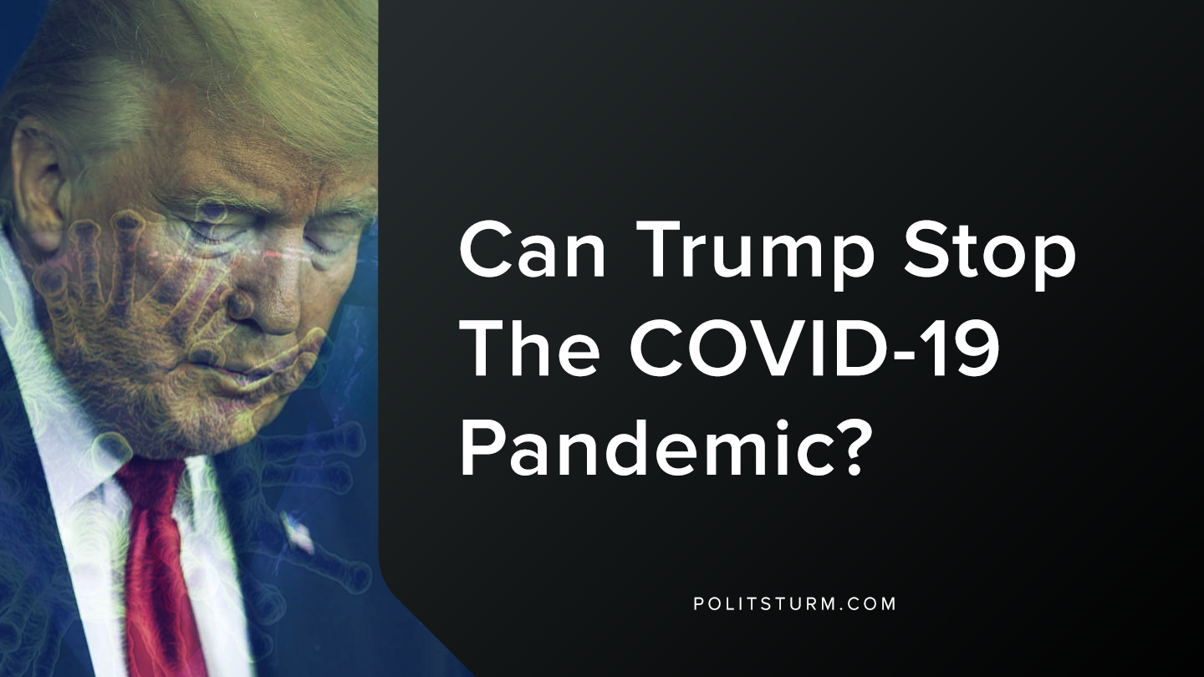

Original article
2020-03-22
1 min read

Recently, President Trump invoked the Defense Production Act. Alongside this, he referred to himself as a “wartime president” because of the COVID-19 Pandemic in the United States.
What is this Act? The Defense Production Act of 1950 authorizes the President to require businesses to fulfill orders for national defense. It also allows the President to prohibit hoarding and price-gouging with certain goods, and gives more authority in allocating materials to combat the coronavirus.
First of all, Trump’s response to the COVID-19 outbreak has been minimal, and any response has seemed to be ineffective; as other countries have had better responses.
The problem with Trump’s recent move is that the virus has already made its impact on the United States; over 18,000 individuals have already been infected with the virus. The lack of ventilators in the country will be an immense problem for patients, especially those among the elderly.
Trump’s response with the Defense Production Act, even if it strangles the virus, it is not a definite shield against future outbreaks. Has the United States not faced other viral outbreaks, ranging from SARS to Zika, just in the past decade? Why does the United States not have something automatic to deal with this? It is because it is not profitable to do so. The bourgeoisie will only make concessions to the proletariat if absolutely necessary, and this virus, causing turmoil, is such a time.
The capitalist mode of production prevents the prevention of such an outbreak in the future, as it won’t be profitable to keep producing respirators and masks.
What does this mean for American workers? Well, don’t let it distract you. It is not a permanent solution. It is a temporary concession to keep you docile, to make you feel like something is being done to protect your health. Do not fall for such claims. This process will repeat again and again until the capitalist mode of production is abandoned. Do not view it as a solution, it is a concession and nothing more.
Sources:
https://www.fema.gov/media-library-data/20130726-1650-20490-5258/final__defense_production_act_091030.pdf

Original article

