Budget slams student debtors
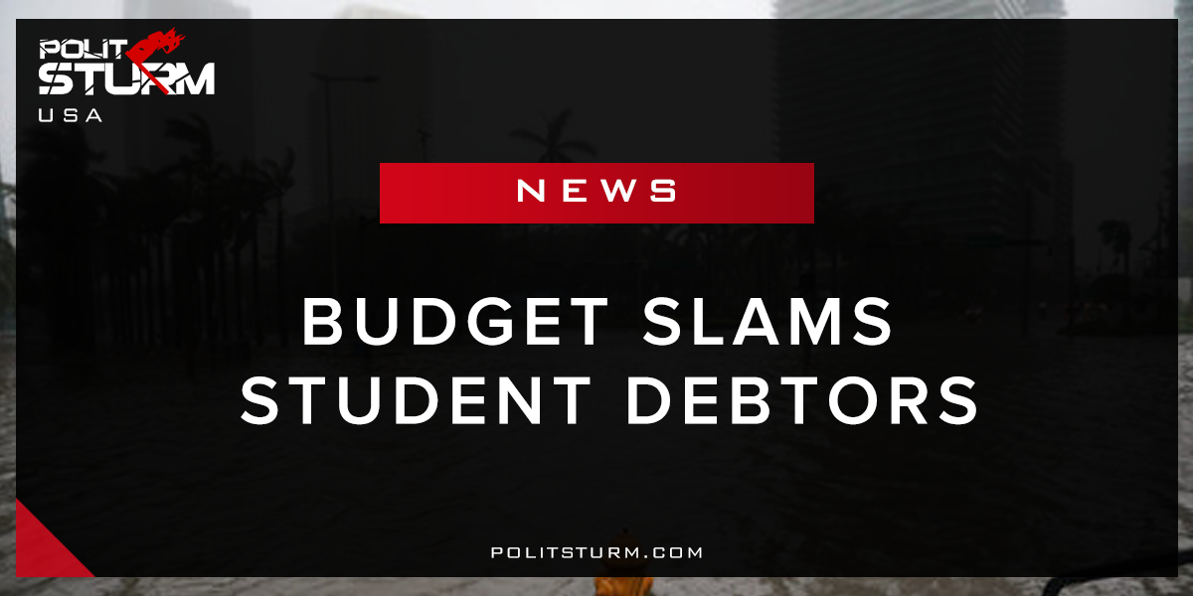

Original article
2018-03-05
1 min read

The President’s proposals would generate savings to the government from student loans of $100 billion between 2018 and 2027, according to CBO’s estimates. For borrowers who take out their first student loans beginning in academic year 2018–2019, the proposals would make the following changes to the Federal Direct Loan Program:
- Create a single income-driven repayment (IDR) plan. Under that plan, most borrowers would pay a higher percentage of their income than they pay in IDR plans under current law. In addition, undergraduate borrowers would have their remaining debt forgiven.
- Eliminate loan forgiveness for borrowers who make 120 payments on their student loan debt while employed full time in certain public-sector jobs.
- Eliminate the subsidized loan program. Under that program, borrowers accrue no interest on their loans while in school, in the six-month grace period after school ends, or in other authorized deferment periods.
Politsturm: The 2018 budget tells a very interesting story when you look at the numbers and realize their significance. Since the government of the USA represents the capitalist class, it makes decisions that reflect the interests of their class. With the new budget we have cuts in the budget for education, training, employment and social services. The reduction in spending is made worse by the increased costs pushed onto the indebted youth. The working class bears the brunt of this budget, without a doubt.
As intelligent people we must ask ourselves which groups benefit and suffer from these proposals. People who work and those who are unable to work through no fault of their own benefit from the aforementioned public services. These groups combined make up the majority of the population. We can conclude that these people will be hurt most by these changes. Capitalists and landlords do not necessarily need to work to earn income. Through the extraction of dividends, interest, capital gains, returns of capital, business income, and land rent this class of people can live without working if they choose. We can see as clear as day that the working class is strained providing for the parasitical caste of oligarchs.
https://www.cbo.gov/system/files/115th-congress-2017-2018/reports/52846-apb.pdf

Original article

