British Rail Strikes End Without an Agreement: New Strikes Are Coming
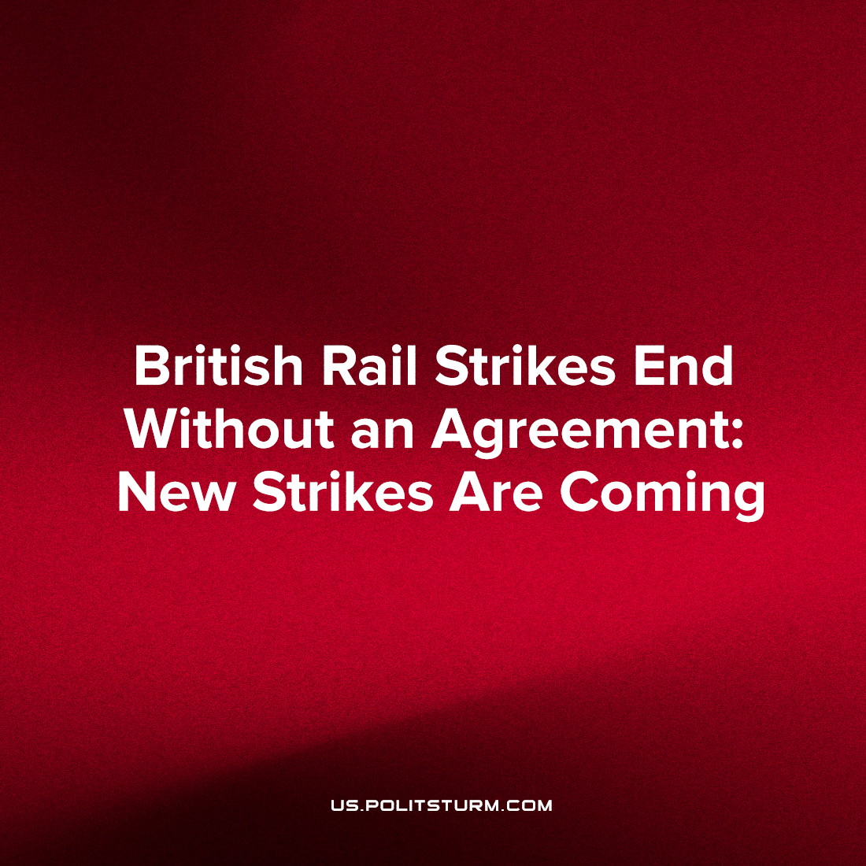

Original article
2022-06-30
2 min read

The RMT (Rail, Maritime, and Transport) union strike has come to an end, without an agreement. The British government and its state monopoly on rail maintenance primarily (as well as the private rail services cartel) have not acquiesced to the demands of the RMT, namely the safeguarding of 2,500 crucial rail maintenance jobs as well as wage increases to account for inflation (i.e., to keep real wages the same). While negotiations are still ongoing, it’s likely the RMT will ballot to strike again soon.
Despite the heavy disruption caused by the nationwide strike, the strikes seem to have had popular support. In one of the polls, 84% of respondents believe that the profits from British rail industry should go to protecting jobs and services, instead of shareholder dividends. The General Secretary of the RMT, Mick Lynch, has faced down the lies, slander, and provocations of the bourgeois media, and emerged a popular figure and household name.
The government’s initial response to the strikes was to feign pity for the healthcare workers (and their patients) unable to reach hospitals and clinics. However, this is the same government that woefully mishandled the Coronavirus pandemic, resulting in the death of 180,000 people as well as unsafe and arduous working conditions for these same healthcare workers. At the same time as this, government ministers were holding parties and awarding hundreds of millions of pounds in contracts to their friends and family. Consequently, the nurses and doctors were outraged that their plight was being used cynically by the government that bears a great deal of responsibility for it and their unions have demanded similar pay increases (in line with inflation). Furthermore, inspired and emboldened by the RMT workers, the largest teachers’ union is discussing and considering industrial action, as well as many others. Already, British Airways airport workers, post office workers, and even barristers have balloted to strike.
Inflation in Britain is the highest it has been in 40 years, while most wages stagnate. Working people are left with two choices; either to kneel at the altar of capital and be led by the nose by bourgeois lies and pseudoscience to be forced deeper into poverty, starvation and immiseration, or to stand up and fight for their rights. This incoming wave of strikes is evidence more and more people are choosing the latter and this solidarity of working people in the struggle for their rights can only be supported. The renaissance of the labour movement in Britain paves the way for the fight for socialism and the spread of revolutionary consciousness.
Sources:
https://www.theguardian.com/uk-news/2022/jun/26/i-dont-want-to-be-an-icon-mick-lynch-on-winning-the-rail-strike-pr-battle
https://www.rmt.org.uk/news/rmt-on-opinium-poll/
https://www.prospectmagazine.co.uk/politics/how-popular-are-the-rail-strikes
https://youtu.be/h9ZQLI500hA
https://nursingnotes.co.uk/news/nurses-stand-with-rail-workers-after-health-secretary-calls-strike-unjustified/
https://www.theguardian.com/society/2022/jun/27/uk-doctors-demand-pay-rise-of-up-to-30-over-five-years
https://www.theguardian.com/uk-news/2022/jun/27/the-system-is-in-crisis-barristers-make-their-case-as-strike-begins
https://www.theguardian.com/uk-news/2022/jun/22/largest-teaching-union-threatens-to-ballot-members-in-england-on-strike-action
https://www.reuters.com/world/uk/uk-acted-unlawfully-with-vip-covid-contract-lane-court-rules-2022-01-12/
https://www.bbc.com/news/business-61923815
https://www.bbc.com/news/business-61906236
https://www.theguardian.com/business/2022/jun/27/post-office-workers-strike-crown-branches-11-july
https://www.bbc.com/news/business-12196322

Original article

