UK Nurses Announce New Strike
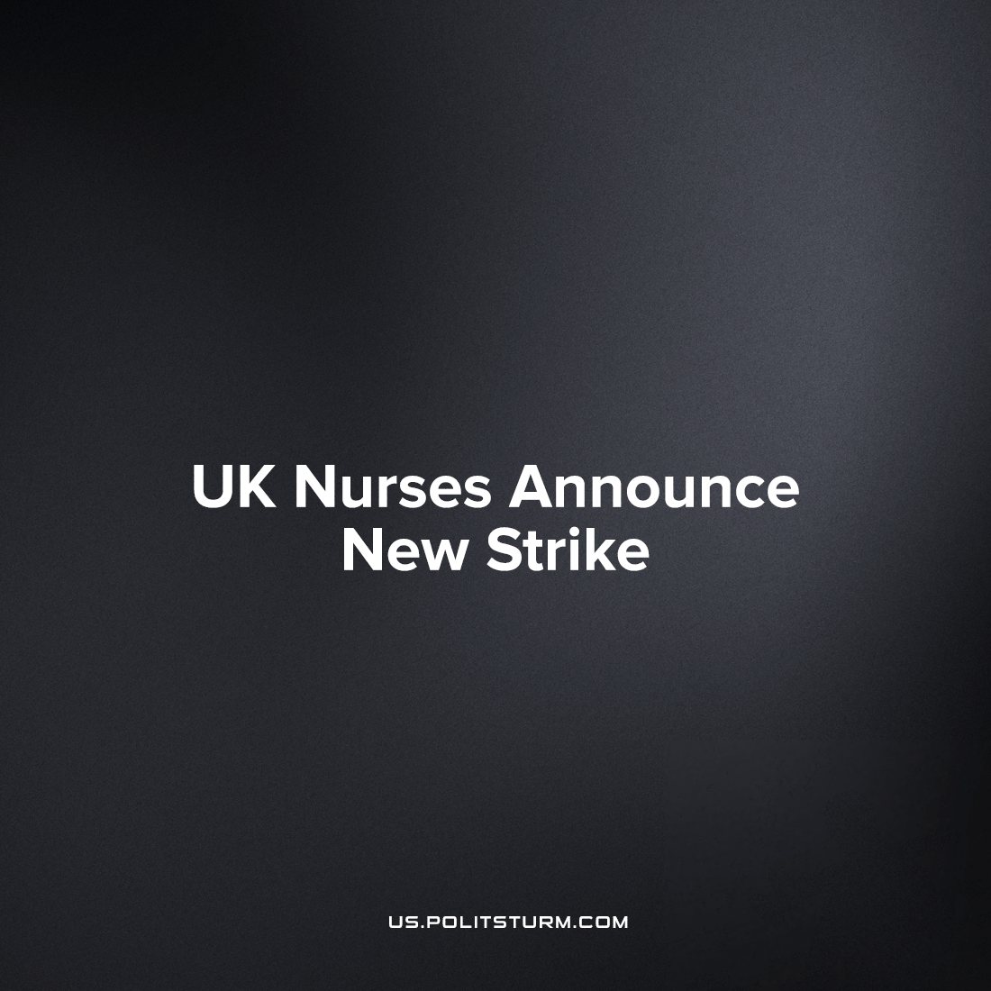

Original article
2023-01-06
2 min read

Royal College of Nursing has triumphantly overturned a 106-year record with its strike activity which previously took place on December 15th and 20th of last year. The union which represents the nurses of the United Kingdom's National Health Service (NHS) announced a further two days of strike action after the government their calls to negotiate over pay.
RCN stated Prime Minister Sunak ‘left [them] no choice’ but to walk out, as the British bourgeoisie held its line against the nurses’ need for a raise that at least exceeds inflation and begins to compensate for the low working conditions in a healthcare system looking at collapse.
The 48-hour walk out which will begin on January 18, will escalate the already bitter industrial dispute between the nurses who have been subjected to overexploitation and real-term pay cuts and the capitalist class which is reaping record profits amidst increasing poverty in Britain.
The scale of the second is larger than the first: from 44 NHS trusts striking out of 55; an increase of 25%, showing the great strength of the strike activity in growing union participation. In total 70 NHS employers in the United Kingdom will see nursing strikes.²
General Secretary of the RCN Pat Cullen, arguing against government statements, explained that the situation was caused by the government’s own intransigence:
‘The Government had the opportunity to end this dispute before Christmas but instead they have chosen to push nursing staff out into the cold again in January.
‘I do not wish to prolong this dispute but the Prime Minister has left us with no choice.’
She added:
‘The public support has been heart-warming and I am more convinced than ever that this is the right thing to do for patients and the future of the NHS.
‘The voice of nursing will not be ignored. Staff shortages and low pay make patient care unsafe - the sooner ministers come to the negotiating table, the sooner this can be resolved.
‘I will not dig in, if they do not dig in’.³
The capitalists of Britain, indeed of any nation, have no shame. Throughout the wave of strikes that has rocked the United Kingdom recently, the ruling class and their lackeys in the media have attacked and vilified the workers that are not only striking for an improvement in their pay and work conditions but also fighting against the very destruction of the healthcare system of the UK by the rapacious capitalists. The striking workers had been accused of aiding Vladimir Putin⁴ and recently the Health Secretary Steve Barclay has stated that striking ambulance drivers are making ‘a conscious choice to inflict harm on patients.’⁵ NHS workers have been given below-inflation pay deals for all but two of the last 12 years yet to Mr. Barclay the “greed” of the ambulance drivers is what is putting lives at risk, not the systematic looting and profiteering him and his fellow parasites have indulged in whilst many in Britain go hungry and cold, left in rampant disease and untimely deaths for the nation's children from the most preventable illnesses.
Continuance of these strikes heralds new growth in the strength of the proletarian movement.⁶ With every strike ballot, the working class increases the awareness of its position in bourgeois society and sharpens its desire to be rid of it. It is up to the communists to usher forward this sentiment into the full fruit of the world-historical objective of the proletariat: the victory over property rule and exploitation of man-by-man through the foundation of a truly socialist society.
Sources: 1; 2; 3; 4; 5; 6.

Original article

