British NHS to Cut Standards of Public Care
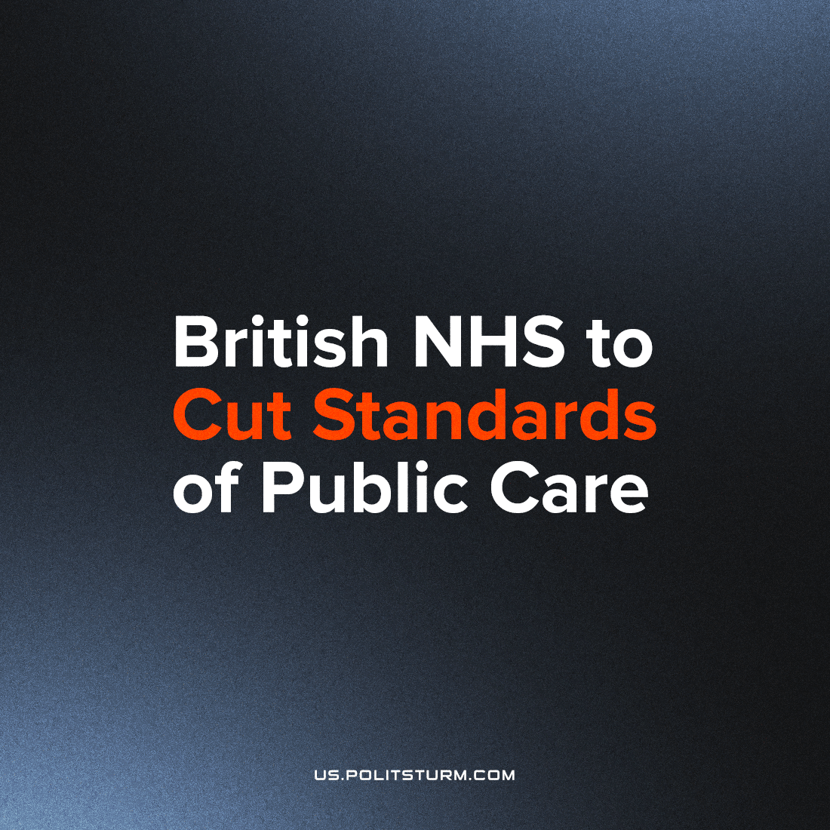

Original article
2022-12-31
2 min read

The British government has planned to scrap many National Health Service (NHS) targets for service by the spring of 2023. NHS targets consist of things like: “ensuring that patients with depression have a review between 10 and 56 days after their diagnosis”, “administering statins to up to 90 per cent of diabetics”, “patients should wait no longer than four hours at A&E” and “patients should wait no longer than 12 hours to be admitted to a ward”.
In fact, many of these targets are already missed by large margins each month, with only 68.9% of emergency patients admitted into A&E within the target of four hours last month – this specific target has not been met nationally since 2015. Instead of correcting any problems with their agencies, the capitalist state simply cuts their service to the public.
The government is slashing the NHS’s quality standards in order to further cut costs and advance the full dissolution of the service as a whole. Unlike healthcare under socialism, despite providing service free at the point of use, the NHS still has to “fairly” renumerate the pharmaceutical monopolists for their commodities (who charge incredible markups for products that are otherwise cheap to produce), as well as allow them to spend millions bribing NHS doctors and pharmacists. As a result, it is very easy for the capitalist government to funnel any extra funding for this public service into the hands of private capitalists, with Pfizer making almost £2 billion in profit for COVID vaccines alone.
NHS nurses, paramedics, and likely junior doctors too in January are going on strike to not only fight against their own shrinking wages, but also to protect this public service from the government’s intentional mismanagement and underfunding, as one of their demands.
Social democratic policies such as the NHS were designed to give capitalism a popular basis in order to quell the workers’ revolutionary movement, however these policies have become 'too much' of their proportion of profits for the bourgeoisie who do not wish to “waste” money on "frivolities” like the health and stability of working class people.
Capital, in its insatiable thirst for surplus value, seeks to reduce the workers share of the national wealth to the bare minimum, even encroaching on the workers’ necessary product for survival. These social democratic policies were easier and more desirable to fund when Britain enjoyed the prime position on the imperialist ladder and was able to draw super profits from its many oversees colonies. Now, British imperialism is declining rapidly along with British social democracy. However, without these policies the British working class will be increasingly subject to the same naked aggression as the working class of semi-dependant or dependant countries and be forced to become increasingly militant and disillusioned with their ruling class. However, the success of this movement will be largely dependent on its’ leadership which it needs to guide the class struggle from the economic sphere towards the political sphere and ultimately revolution, making the task of forming a genuinely communist party in Britain an urgent one.
Sources: 1, 2, 3, 4

Original article

