British Minister Admits Strikes Cost More Than Pay Raise
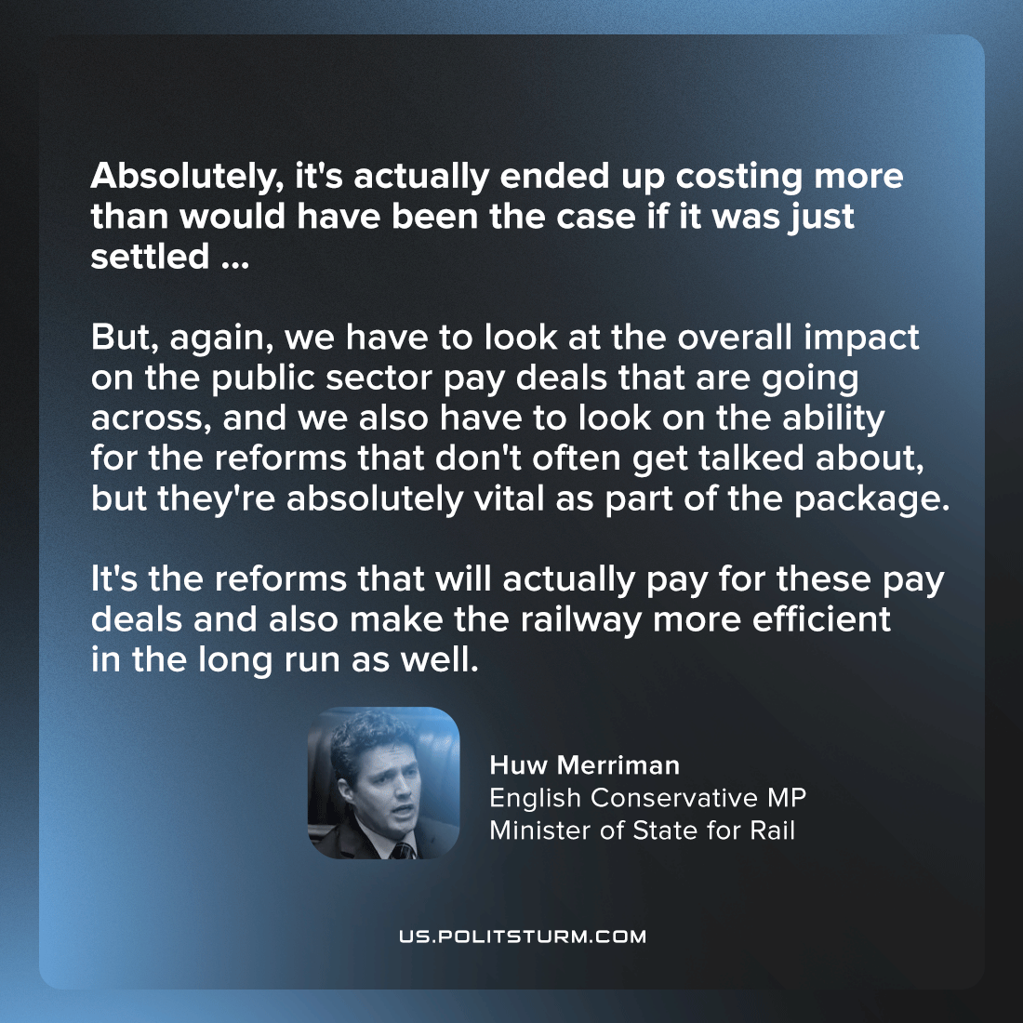

Original article
2023-01-25
2 min read

Conservative Party MP and British Rail Minister Huw Merriman was asked about the cost of the rails strikes and if it was more than the cost of the pay raise. He responded: “If you look at it in that particular lens, then absolutely, it's actually ended up costing more than would have been the case if it was just settled in that part. But, again, we have to look at the overall impact on the public sector pay deals that are going across, and we also have to look on the ability for the reforms that don't often get talked about, but they're absolutely vital as part of the package. It's the reforms that will actually pay for these pay deals and also make the railway more efficient in the long run as well”.
The “more efficient” reforms that Minister Merriman refers to are things like gutting rail maintenance staff which will thereby crippling rail safety. During the rail strikes, the capitalist state hasn’t just lost the value created by the striking railway workers but has deemed it necessary to compensate the cartel of private rail service providers with equivalent revenue every day on which there are strikes.
It is clear that the government’s refusal to give the rail workers a pay increase at or above inflation is not done on an economic basis (as Minister Merriman has admitted) but on an explicitly political and ideological basis. This is especially ironic as British trade union laws withdraw protection from striking workers if the strike is not for economic reasons, but for ideological/political purposes. The capitalists of Britain are openly waging a political struggle against the workers, who they ever more restrict within the confines of economism through law. They accept losses in order to win this dispute as they are acutely aware of the indirect effects on the whole labour movement, and particularly on the precedent of matching pay with rising inflation, should the rail workers be victorious. It is clear that the workers must organise a force to combat and defeat this campaign launched against them by the capitalists in the political sphere.
What a great moral influence strikes have, how they affect workers who see that their comrades have ceased to be slaves and, if only for the time being, have become people on an equal footing with the rich! Every strike brings thoughts of socialism very forcibly to the worker’s mind, thoughts of the struggle of the entire working class for emancipation from the oppression of capital. It has often happened that before a big strike the workers of a certain factory or a certain branch of industry or of a certain town knew hardly anything and scarcely ever thought about socialism; but after the strike, study circles and associations become much more widespread among them, and more and more workers become socialists.
-V. I. Lenin, On Strikes
Sources: 1

Original article

