British Military in Decline
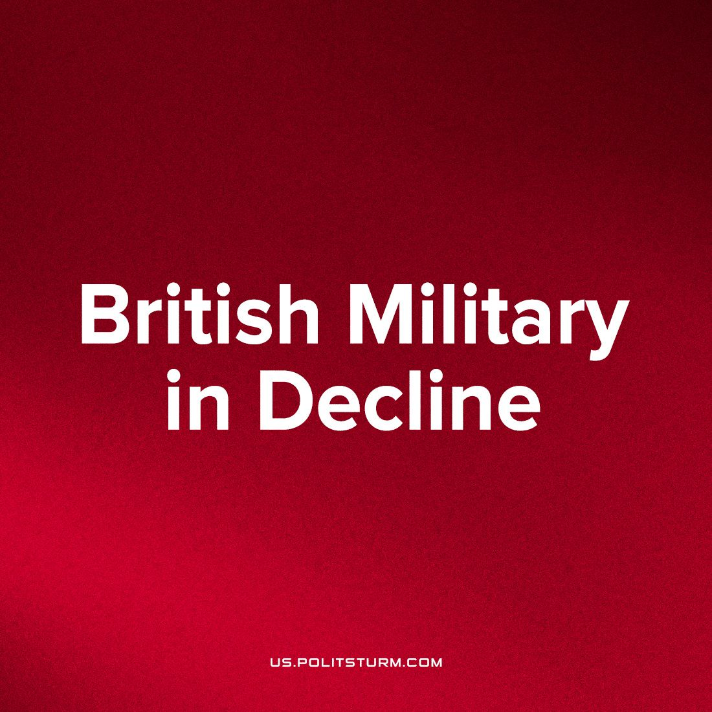

Original article
2023-02-23
9 min read

The United Kingdom has appeared in a front-line role in the Western imperialist military coalitions of the 21st century, but it's no secret that the once-great empire now struggles to maintain its ranking in the global imperialist hierarchy.
This is despite the best efforts of its ruling class to increase its portion of imperial profits- most recently, for example, by ‘doubling down’¹ in aggravating potential nuclear conflict through promises to be the 'first country' to provide long-range weapons to Ukraine to strike Russia and by training Ukrainian pilots for NATO-standard fighter jet operation: a clearly laid plan to profit from its own efforts at escalation.
Decades of looting state coffers has resulted in the multi-faceted crisis in the country today. Great Britain is rocked by increasing proletarian outrage as the nation’s bourgeoisie bicker and feud over the last crumbs of the country's gutted inheritance, further aggravating the crisis with its chaotic developments; but the fall in the share of the world's imperial holdings will mean that the downturn ensures no matter which policies are implemented, Britain will continue on this path and may even fall to the position of a semi-dependent state.
The British crisis is starkly shown in the state of its armed body.
While funding for the British military is near its all-time high, with the Armed Forces receiving its largest budget increase since the Cold War³, the actual proportion of defence spending has been consistently decreasing since 1960, meaning that the British Armed Forces have had drastic financial cuts over the course of the last decades in line with the rest of the public sector as the British state finds it difficult to maintain the cost-efficacy and efficiency of the army, navy and air force.
This has been an ongoing problem for years, during the COVID-19 Pandemic, Boris Johnson’s government announced that budget cuts and a reduction of the size of the military was to be implemented drawing the vitriolic ire of the more hawkish sections of the ruling capitalist class and conservative politicians alike. But this policy would have been inevitable whoever held the reins of power as Britain does not have the capacity to maintain an effective imperialist military.
As of October last year, the British military had a ‘total strength of 192,300 personnel’. This marked a ‘6,640 decrease in service personnel from that same point’⁴ the previous year. Similar statistics for the Royal Navy, Royal Marines and Royal Air Force (RAF) underscore the situation of the Armed Forces: the British military seeing its effectiveness decrease year on year.
A major factor as to why the military is stagnating is salary. The aforementioned spending cuts have inevitably led to salaries being frozen for long periods of time with the current economic crisis and inflationary pressure now eroding the already low pay of soldiers, seamen and pilots. In 2021/22, only those on salaries ‘below £24,000 per annum received a pay rise of £250, with all other pay increment levels remaining frozen at 2020/21 rates of pay.’⁵ Thus according to figures compiled by the Office for National Statistics, in 2021/22, the growth of military salaries ‘was lower than the real growth of average earnings. Relative to the Consumer Price Index, military salaries were down 3.7% during 2021/22, whereas growth in UK average earnings for the economy experienced a growth rate of 2.6%.’⁶ If one takes into account that the rate of inflation is hovering at 10% as of January 2023 and is set to remain high through most of the year, soldiers along with the working class are actually facing pay cuts.
This ultimately leads to a predictable recruitment and retention crisis within the British military itself, which sees a brain-drain to the private sector with its veteran staff. Recruitment has dropped steeply, with ‘11,982 people joining the UK regular forces in the past 12 months (1 October 2021 – 30 September 2022), a decrease of 5,090 (29.8%) compared with the previous 12-month period.’ Similarly, outflow is a major concern; across all services, voluntary outflow (that is, encompassing all trained personnel who voluntarily exit before the end of their agreed engagement or commission period) was cited as being the most common reason for personnel departure, accounting for ‘59.4% of outflow in the 12 months to 30 September 2022.’⁷ Voluntary outflow was highest specifically in the Royal Navy and Royal Marines at 6%, followed by the British Army (5.7%), and the RAF (5.3%).
It is undeniable that the current crisis is leading to soldiers exiting the military in droves but the roots of this are deeper. According to figures published in 2015 by the Ministry of Defence (MoD)⁸, Britain’s fighting prowess was facing a massive reduction due to constant reduction in military spending. It was reported in 2015 that the two new aircraft carriers that the UK had commissioned to be built (HMS Queen Elizabeth and HMS Prince of Wales) were not ‘due to enter service until 2017’⁹ with one important feature missing: the aircraft. The new F35 stealth fighter jet designed by Lockheed Martin (‘the most expensive plane in military history’) would not enter service until 2020, having been ‘beset by problems’ since the project started in 2006 with engineers facing numerous delays and serious problems with its complex computer systems: ‘including reports that the software it needs to be able to fire its guns may not be ready until 2019 and rumours (denied by the US Air Force) that its systems cut out if the planes are filled up with jet fuel that is too hot.’
As such, these aircraft carriers would not have the aircraft it needs available for 3 years, effectively reducing them to ‘floating hotel[s]’ for the ‘first three years.’¹⁰
If one were to look at the long-term trends, one would find that since 1996, the British military has seen a sharp reduction in its offensive and defensive capabilities; the Royal Navy has seen the number of cruisers, destroyers and frigates — ‘the traditional workhorses of the fleet’ — fall from a total of ‘36 in 1996 to 18’¹¹ as of April 1 2015 (5 destroyers and 13 frigates). These numbers have remained static according to recent MoD statistics, the number of overall craft has decreased from 2014 to 2022. Meanwhile the number of submarines has ‘fallen from 15 to 11’¹² between 1996 to 2015 with the number since falling to 10 as of 2022¹³ and the number of aircraft carriers ‘boasted by the navy has dropped modestly from 5 to 4.’¹⁴ Considering that these ships would be over a decade or more old, they are increasingly becoming obsolete as China develops cutting-edge missile technology designed to target and take out enemy fleets from land; even if they were put to use in an inter-imperialist conflict before being scrapped, they would be out-classed and out-gunned, revealing the sheer scale of British imperialism’s inability to maintain its military and economic status among the imperialist powers.
In addition to the long-term decline of its equipment, Britain has also faced a long-term decline in its military retention. The current crisis has exacerbated the trend, to be sure, but since 2000, Britain has had significant trouble keeping personnel within the armed forces. According to the MoD:
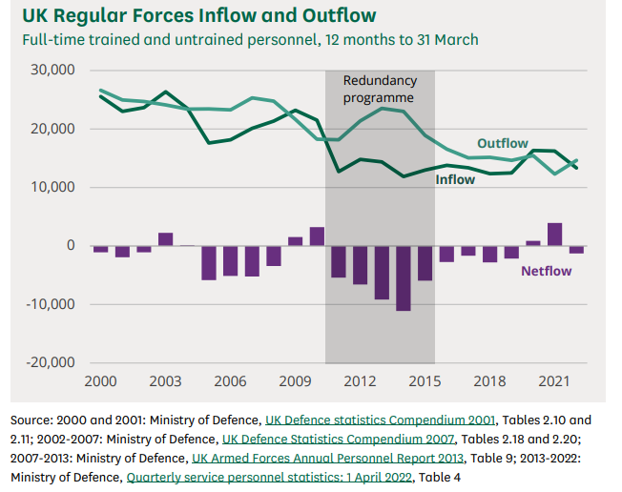
During the period shown [2000-2021], total inflow and outflow over the 12 months to 31 March have both decreased over time. Inflow to the UK Regular Forces has decreased from 25,550 in 2000 to 13,350 in 2022 (a 48% reduction) and outflow decreased from 26,620 in 2000 to 14,630 in 2021 (a 45% reduction). Between 2000 and 2022 inflow has only been higher than outflow for six years. In the 12 months to 31 March 2022 there was a negative net flow of personnel. This followed two consecutive years of positive net flow.¹⁵
How, then, can this be possible? Capitalism frequently enters into periods of crises which are impossible to avoid due to its very nature; in order to maintain a rate of profit, exploitation, among other methods, must increase; as has been discussed in previous reports, the British proletariat has faced growing misery for over a decade, the consequences of which are being felt as the level of immiseration and exploitation is now becoming unbearable for the working-class. But this is merely a temporary solution, the rate of profit as discovered by Karl Marx has a historical tendency to fall; this is a scientific law: profits will always fall long-term. As such, the British bourgeoisie cannot offer more funding as it would eat away their profits which decrease over time no matter what, it is better for their bottom line to hoard as much wealth as is possible. It is clearly evident, then, that British imperialism has been declining and its demise is all but inevitable as her current peers continue to outperform in nearly all fields, leaving Britain lagging, both economically and militarily, and drifting towards being a moribund power.
This has elicited concern from Britain’s imperialist ally, the United States of America, who after decades of propping up the military apparatus of NATO virtually alone. at great expense to herself (as European members routinely refused to set aside the required 2% of their GDPs for military funding) is now worried that one of her most important partners appears to be incapable of fielding an army that can help in the growing inter-imperialist conflicts that are now in motion. If the US wants to maintain her near hegemonic power in the imperialist chain, she will need strong allies in order to confront the growing might of China, something that is sorely lacking at present. On the 29th of January 2023, a senior American general warned the British Defence Secretary Ben Wallace that the British Army is ‘no longer’ considered a top-tier fighting force, with one defence source adding separately that ‘it's an entire service unable to protect the UK and our allies for a decade.’¹⁶ Further reports from the bourgeois media have suggested that ‘as things stand, the army would already run out of ammunition within a few days if called upon to fight and would take up to 10 years to field a modern warfighting division of some 25,000 to 30,000 troops.’¹⁷ To the imperialists in Britain these are scathing comments, it underscores the decline of Britain’s power on the world stage.
But the imperialists of Britain are caught in a difficult position: the efficacy of their military is decreasing much to the chagrin of their allies who now have to shoulder more of the burden but the British capitalists cannot fund the military in any meaningful way. For too long, the United States of America has picked up the slack of her NATO allies, which has enabled the British bourgeoisie to embark on the current fiscal policy which despite lauding itself as increasing the military’s budget annually, actually represents a decreasing proportion of Britain’s GDP. US dominance in terms of her army and wealth have created the perfect conditions for the British bourgeoisie to appear to be funding the armed forces but in actuality is gutting the sector in order to ensure that the funds can be funnelled into the bank accounts of the capitalist class. The British proletariat is forced to pay exorbitant and extortionate taxes which end up lining the pockets of the bourgeoisie.
However, this Arcadia of corruption is now coming to an end; America is waning as the premier imperialist power. The rise of China as a competitor (and to a lesser extent, Russia) has meant that the US can no longer accept NATO members not contributing more to the alliance’s funding and is now demanding that they proceed to invest more into their armed forces. Britain however, can no longer do so without serious damage to her astronomically unproductive and parasitic economy. The United States military has made the junior role of its British counterpart more and more explicit- with one US general declaring to British Defense Secretary Wallace that its British Army is no longer one of world’s top-most fighting forces, citing the same budget cuts as we do above.
it’s an entire service unable to protect the U.K. and our allies for a decade.
Should the British bourgeoisie be unable or unwilling to commit as its allies do, meaning to pay greater sums to military corporations, it risks drawing the ire of the other imperialists on whom it relies and who will demand compensation by other means. This would entail the end of Britain as a foremost imperialist power, and the beginning of an era as a semi-dependent nation.
Reactionaries and opportunists inevitably use this situation to accrue influence for themselves, telling a narrative of the destruction of British prestige and that “national honour”, and even restoration of imperial status, can be reclaimed if they were to boldly take charge and refund the armed services which serves as a catch-all for a 'strong nation'. This serves to disorient and weaken the workers of the country. Marxist-Leninists have never fallen for this bourgeois trickery as our analyses of capitalism at its highest stage (imperialism) demonstrates that this degradation is an unavoidable result of its basis in a monopolized economy. We state simply that a diminishing state apparatus demonstrates that the ruling class state is weak, and getting weaker, making the prospect of smashing the rule of the exploiters' that much brighter. The role of the state's military apparatus is ultimately to violently suppress the revolutionary movement and protect corporate interests in a global system. If not used to slaughter the workers of another country in the inevitable imperialist wars, the military has equal utility to violently suppress the workers’ movement internally when it threatens bourgeois rule; it is no mistake that 96% of British servicemen are stationed within the UK’s borders, the threat is implicitly there.¹⁸
Sources: 1; 2; 3; 4; 5; 6; 7; 8; 9; 10; 11; 12

Original article

