British Industrial Action on the Rise
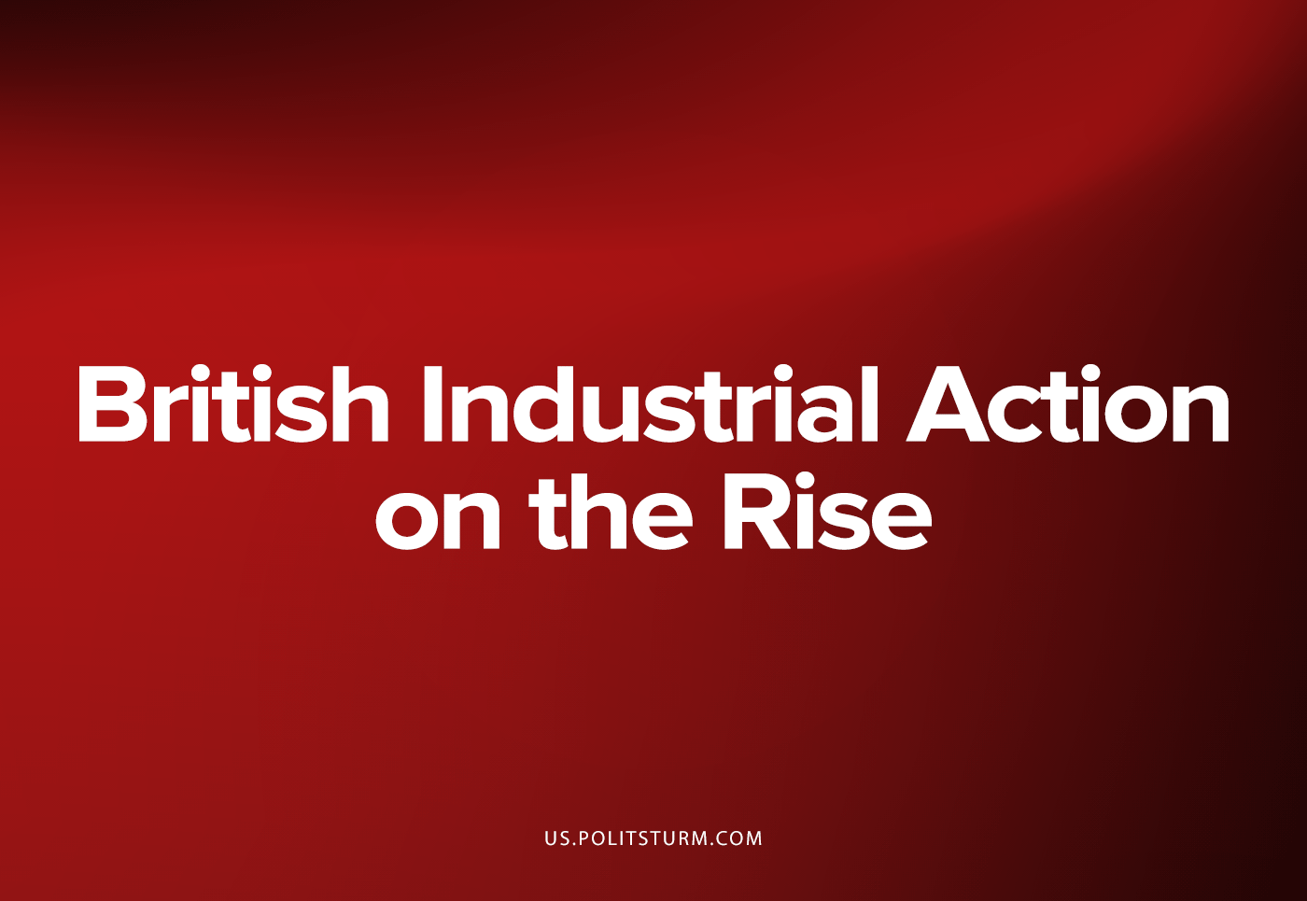

Original article
2022-11-30
8 min read

In the wake of capitalism’s world-spanning crisis, following the COVID-19 Pandemic’s aggravation of capitalism’s natural tendency to lead to economic crises, workers in the United Kingdom have taken up the fight for their rights and wages against inflation, the rising cost of energy, and the general assault of capitalist exploiters.
Over the summer, after a torturously long nadir of trade union activity in Great Britain, the frustration of union members have become unleashed in a campaign of strikes. The scale of industrial action has since increased in scope: in addition to transport workers, education staff, postal workers, refuse workers, telecommunication staff, General Practitioners and even barristers all having gone on strike during the summer in protest over their pay being degraded, several more strikes were announced to take place over the autumn and winter should employers not heed the workers’ demands.
One of the latest and by far one of, if not, the most serious in the eyes of the British public is the announcement on the 9th of November by the Royal College of Nursing that it had a mandate to go on strike at a majority of NHS Trusts. The RCN on the 17th warned the Secretary of State for Health and Social Care that the government had five days to come to an agreement with the nurses over their pay or dates for strike action would be announced for December.¹ Having had their pay stagnating for years has led to shortages in healthcare staff up and down the country which can no longer be filled by recruiting staff from Europe post-Brexit, coupled with healthcare workers being exploited immensely during the coronavirus pandemic (where their labour was considered essential to avoid catastrophe) has led to the announcement that for the first time in history, nurses are striking over their deteriorating conditions.
The announcement of nurses going on strike marks a new phase in the struggle of the proletariat to resist the onslaught of capitalist policies. Nurses in the UK have never gone on strike in their history, the significance of this is not lost on the British public or the British bourgeoisie. This unprecedented measure comes after a decade of austerity that has overwhelmed the National Health Service and led to healthcare in Britain crumbling at a rapid pace. The deliberate neglect of the NHS by the British state has left the healthcare system on the brink of collapse contributing to the deterioration of the health of the proletariat in Britain with the pandemic accelerating its decline to where it currently stands. As of October 2022, 6.8 million people (almost 1 in 8 of the population) are waiting for routine hospital treatment in England alone, 377,689 of which have been waiting for more than a year to start hospital treatment and 2,665,004 of which had been waiting for more than 18 weeks, which is the supposed maximum waiting time for procedures such as a joint replacement, hernia repair or cataract removal.² In addition to the rising wait times, patients are also facing long waits for accident and emergency care, cancer treatment (such as surgery or chemotherapy) or even just waiting for an ambulance to arrive. A particularly tragic instance was the death of Yusuf Ahmed, a five-year old boy from the city of Rotherham. He was taken to Rotherham general hospital on the 14th of November by his uncle, Zaheer Ahmed, after complaints of a sore throat. He had been prescribed antibiotics by his GP the day before but his condition did not improve. However, Zaheer said he had waited all night for Yusuf to be seen, and his nephew was sent home by a doctor despite saying it was ‘the worst case of tonsillitis he had ever seen.’
‘They kept saying to us, “We’ve got one doctor. What do you want us to do? We’ve got no beds available. What do you want us to do? We’ve got no space for him. What do you want us to do? Complain to the big people, don’t complain to us. Complain to the big ones that only gave us one doctor”.’³ After being turned away from the hospital due to a lack of doctors and beds available, Yusuf returned home despite being now unable to swallow and breathe. He was then taken to a specialist paediatric team in nearby Sheffield at the Children’s hospital there. By that point the infection had spread to his lungs. Yusuf then had multiple organ failure leading to several cardiac arrests. He died of pneumonia on Monday.
The social murder of Yusuf by an easily preventable condition can be laid squarely at the capitalist class which by the very nature of its existence leads to such monstrous occurrences. The fact that nurses are going on strike and the healthcare system is on the brink of collapse underscores the crisis that British imperialism is facing.
Years of cuts place the interests of striking nurses in alignment with the interests of the workers to fight for better than the National Health Service √ as the bourgeoisie of Britain \ seeks to cut government expenditures and further the privatisation of the healthcare system in an effort to boost their rate of profit.
What is clear is that the proletariat will be further immiserated as this process unfolds; already being subjected massively to exploitation and a rapidly diminishing standard of living, the destruction of the public healthcare system would be a huge blow to the working-class: cases such as Yusuf’s shall inevitably become more common. Two centuries since Friedrich Engels wrote his world-historical report ‘The Condition of the Working-Class of England’ ⁴ the British proletariat faces the same problems: poor health, unemployment, misery, deprivation and low education:
‘Children who are half-starved, just when they most need ample and nutritious food – and how many such there are during every crisis and even when trade is at its best – must inevitably become weak, scrofulous and rachitic in a high degree. And that they do become so, their appearance amply shows. The neglect to which the great mass of working-men’s children are condemned leaves ineradicable traces and brings the enfeeblement of the whole race of workers with it. Add to this the unsuitable clothing of this class, the impossibility of precautions against colds, the necessity of toiling so long as health permits, want made more dire when sickness appears, and the only too common lack of all medical assistance; and we have a rough idea of the sanitary condition of the English working-class.’
This is the reality of capitalism for the majority of humanity contrary to the false claims of bourgeois ideologues that capitalism enriches everyone: capitalism necessitates poverty for the vast majority of humanity for the profit of a tiny minority.
In addition to the unprecedented strike of British nurses, unions representing civil servants announced that following a meeting between union representatives of the Public and Commercial Services (PCS) union and Cabinet Office officials that yielded no results, they too would walk out of the workplace. It was reported that ‘they [the Government] did not make any proposals that addressed its [the workers] demands for a 10% pay rise, pension conditions, job security and scrapping planned redundancy reforms.’⁵ As such 100,000 civil servants voted to go on strike with 126 different departments and other public bodies crossing the 50% threshold required for industrial action to take place. As such, workers from the Home Office, the Department for Transport and the Department for Environment, Food and Rural Affairs will walk out in mid-December.
Of the workers going on strike perhaps the most surprising are those of the Border Force, the organisation which polices Britain’s borders and those arrivals into the country. It has been alleged that the Government is planning on bringing in the military as scab labour to fill in any shortages and gaps caused by these strikers: further militarising the border and undermining the place of workers in civil society.
The significance of civil servants going on strike cannot be understated: British imperialism is facing such a profound crisis that even their own administrators and employees are demanding wage increases and better work conditions.
The nurses and civil servants are but the latest in mounting industrial disputes between the British proletariat and the capitalist class. The bourgeoisie of the United Kingdom, desperately attempting to maintain and increase their profit rate at the expense of the working-class during a period of particularly intense capitalistic crisis, is facing resistance not seen in decades. It is abundantly clear that there is an upswing in the labour movement as the proletariat- facing a disastrous cost-of-living crisis; a crumbling social security system and, therefore, utter destitution- has taken upon itself to fight for better wages and conditions. It is in these periods of labour agitation that the seeds of socialism are nurtured within the workers, the united action of proletarians and the united response of the bourgeoisie in this struggle lays bare the ideological and social relations that are usually obfuscated under capitalism in an effort to stymie the workers and their cause. Lenin described it thus:
‘Every strike brings thoughts of socialism very forcibly to the worker’s mind, thoughts of the struggle of the entire working class for emancipation from the oppression of capital. It has often happened that before a big strike the workers of a certain factory or a certain branch of industry or of a certain town knew hardly anything and scarcely ever thought about socialism; but after the strike, study circles and associations become much more widespread among them and more and more workers become socialists.
A strike teaches workers to understand what the strength of the employers and what the strength of the workers consists of; it teaches them not to think of their own employer alone and not of their own immediate workmates alone but of all the employers, the whole class of capitalists and the whole class of workers. When a factory owner who has amassed millions from the toil of several generations of workers refuses to grant a modest increase in wages or even tries to reduce wages to a still lower level and, if the workers offer resistance, throws thousands of hungry families out into the street, it becomes quite clear to the workers that the capitalist class as a whole is the enemy of the whole working class and that the workers can depend only on themselves and their united action.’ ⁶
During the preparation of this document further strikes have since been announced: rail and transport workers, having reached an impasse with the network companies that run Britain’s transport routes, have voted to extend their industrial action into the Christmas period. Mick Lynch, head of the RMT Union, announced that the extension and escalation of the strike was due to being told by ‘'the most senior person working for the Train Operating Companies that he has been stopped from offering us a deal… by the Department of Transport…'’ ⁷ indicating that the bourgeois government is determined to not give in the proletarians striking, going so far as to refuse to even negotiate with the trade unions.
Teachers in Scotland, represented by the country’s biggest teaching union, the Educational Institute of Scotland (EIS), have also since gone on strike against their deteriorating pay and work conditions, shutting down almost every primary and secondary school in Scotland on Thursday the 24th of November.⁸ University staff and lecturers joined their fellow workers on strike.
The crisis has caused an unprecedented growth in the scope of the labour movement and shows no signs of abating; indeed, it is seemingly accelerating. The so-called Communists of Britain, being plagued by revisionism, opportunism and theoretical deficiencies, are struggling to link up with the unfolding situation; at such an important period they are woefully unprepared. It is imperative that dedicated Communists, guided by deep Marxist-Leninist analyses of the state of capitalism in Britain, must join with the trade union struggle in order to reach out to the workers and develop the current, spontaneous class-struggle into a higher, revolutionary one. Only then can bourgeois power be smashed and the workers be free.
Sources: 1 2 3 4 5 6 7 8

Original article

