British Government Releases November 2023 "Mini-Budget"
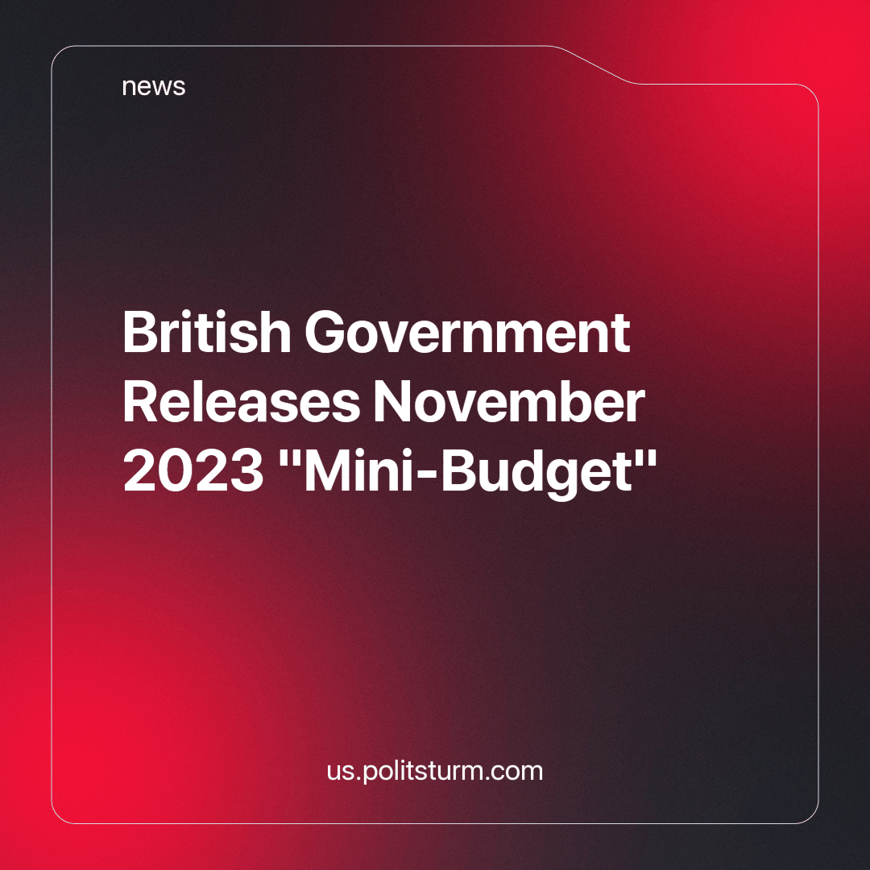

Original article
2023-12-01
3 min read

It has been 13 months since Liz Truss' minuscule tenure as PM almost caused the British economy to collapse. Now, with Tory Grandees running the government much effort has been made to calm their capitalist bosses and prove that they indeed know how to protect the wealth of millionaires whilst ordinary Britons starve. On the 22nd of November Jeremy Hunt gave the Autumn Statement "mini-budget" to the House of Commons in which he promised a vast shake-up of Britain's finances and gave the Labour Party a poisoned chalice as they'll be stuck with the effects of it should they win next year's general election as is widely predicted.
The raft of measures appears to be significant. But as always, bourgeois governments give the illusion of significant reforms in order to mask the rapacious looting by the giant monopolies that are the basis of modern capitalism: imperialism. The measures have already drawn some criticism for attempting to downplay the "biggest decrease in standard of living" since the OBR's records began in the 50s.
The government has touted a cut to National Insurance as one of the flagship policies in this gargantuan budget statement. However, the OBR (which is independent) has claimed that ordinary Britons will see little benefit as inflation and stagnant growth are set to last for the next few years
This along with the rest of the policies that promise tax cuts is said shall improve the lives of working people in the UK. However, various analysts have pointed out that the key benefactors are the richest 20% of households, who are set to gain half of the money spent on these tax cuts. Much hullabaloo is being made over this "sensible" budget, especially by the millionaire-backed media but it is clear: this budget is set to further enrich the rich and further impoverish the impoverished
Even the Chancellor himself has admitted that it would "take time" to reduce the overall tax burden which is still set to remain high despite all the fuss made about how much people will save with these "tax cuts" and "freezes." This leads to the second aspect of this: the political machinations of a dying government.
The "tax cuts" and "freezes" are set to take effect in January, meaning that by May the results will be clearly seen. This has been done so that the Conservative Party, despite hopelessly sliding down the polls can attempt to shore up support and push for an election next autumn. This will maximise their slim chances of winning.
However, this isn't merely about survival but about fatally crippling the Opposition, the so-called Labour Party, with a time bomb. As the OBR has mentioned, growth is stagnant and will not pick up until near the end of the decade, inflation will remain stubbornly high for the next couple of years as well and the Office has similarly warned that there is "little headroom" in this budget. This means an unforeseen crisis will ensure that the government will have to borrow and strain the already strained finances. Should Labour win, as they are expected to, they will have to spend most of their tenure trying to solve the woeful state of the economy.
Labour, also being a party subservient to the monopolies will dutifully ensure that their profits will not be hurt, even as Britons continue to suffer until the 2030s; indeed, much of Labour's "opposition" is merely criticising the Tories for not being friendly enough to the bankers! And if the Conservatives by some miracle win, they will have to deal with the same problems but at the very least they will remain in power for another 5 years; this ensures that Britain's managed decline can continue unabated.
This is the reality of a capitalist state, no matter who is in charge and no matter how "patriotic" they make themselves out to be, they will always work for the benefit of the rich. Millions of children are now in poverty in Britain, further millions cannot afford food or to heat their homes but no matter who wins next year, neither Labour nor the Tories can end this vicious attack on the working people as they are the ones attacking ordinary Britons. This is the real significance of the Autumn Statement.
Sources:
https://www.bbc.co.uk/news/business-63555313
https://www.theguardian.com/uk-news/2023/nov/22/autumn-statement-2023-key-points-jeremy-hunt

Original article

