British Doctors’ Strike
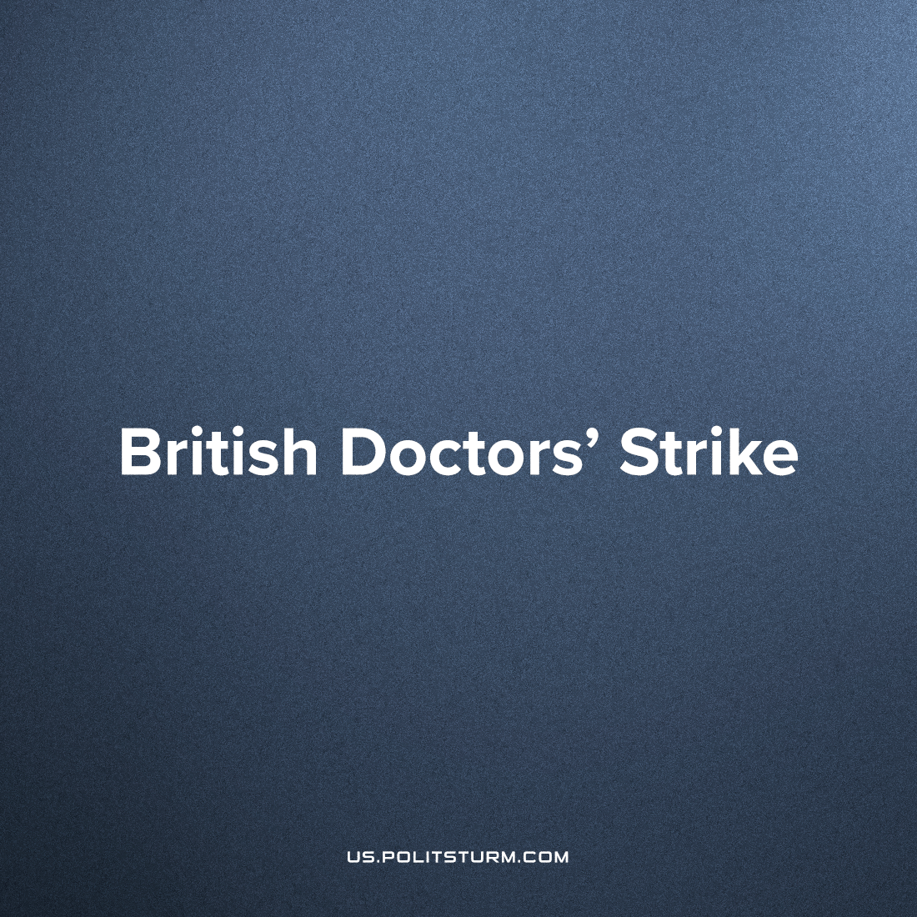

Original article
2023-07-05
3 min read

This month tens of thousands of doctors will go on an unprecedented strike over pay and conditions. They include nearly 40,000 unionised junior doctors (of out a total of around 75,000) who have voted to go on strike from July 13th to the 18th - the longest doctors’ strike in British history. They will be joined by nearly 35,000 (out of a total of almost 60,000) senior doctors for the first time since 2012 who have voted with an 71% turnout and 86% majority to go on strike on the 20th and 21st of July. Most routine and elective services will be cancelled for the duration of the strike while emergency care will remain in place.
The nurses’ union also balloted for further strike action (we have covered their previous strike) with 84% voting in favour, however with a turnout of 43% the union failed to reach the required 50% for an industrial action to be legal in the UK. British trade union ballot law is intentionally very restrictive; the vote must be sent by mail (and cannot be in person) meaning that each union must maintain a current postal address for all its members. The capitalist state doesn’t apply the same democratic standards to itself, with an entirely unelected (and hereditary) monarch as head of state, an unelected prime minister and an unelected secondary chamber of parliament. In addition, there are sitting MPs elected with lower than 50% turnout with in person votes and that’s without even considering the millions of people who haven’t register to vote. As is always the case with bourgeois legality there is one standard for the workers and another, much more favourable one, for the capitalists.
Junior doctors earn an average of £27,000 annually, and can only work after having graduated from medical school and being shackled with five years of student debt. In the wake of recent soaring inflation this is insufficient to cover the rapidly increasing cost of living. Senior doctors earn an average of £128,000 annually and are highly skilled professionals that are impossible to replace. Junior doctors have seen a 26% pay cut in real terms since 2008, while Senior doctors had a 35% pay cut in real terms since 2008.
These new strikes are in the wake of a record over 170,000 National Health Service (NHS) workers quitting last year due to poor (and decreasing) pay, intense stress, gruelling conditions and a lack of government investment in the crumbling service. There is already a shortage of 8,500 doctors as well as thousands of other health workers and a waiting list of over 7.4 million people and counting. Instead of attempting to fix the service, the government continues to cut funding as well as quality standards. This is not an error on behalf of the British ruling class, but a cognisant policy to drive as many health professionals away from the service and into the growing and more profitable private sector. Those who have not left are attempting to strike not only for petty pay and conditions but to win more funding for the service. This includes the so-called “labour-aristocracy” like the senior doctors who are highly skilled and vital to the service and can demand very large wages due to this. They are progressive in as much they struggle with the rest of the workers, however also afflicted with their own narrow craft prejudice and they will also likely struggle for their privileged position even if it is against the demands of the rest of the health-workers or workers’ movement as a whole.
The “welfare state” was a temporary historical phenomenon that arose as a response to the socialist countries and workers’ revolutionary demands as a means to lull class consciousness and give capitalism at home a popular basis. With the defeat of the socialist countries, retreat of the international communist movement and decline of the country’s position within the world imperialist system, Britain’s capitalists choose not to maintain such a large labour aristocracy and many social-democratic policies any longer.
The British workers’ movement has few revolutionary traditions and the decades of relatively peaceful and stable development of capitalism domestically has led to ubiquitous right-wing deviations within the labour movement, especially delusions about class conciliation.
Decline in the national centers of developed capital have opened up a new battlefront in the class war. Workers of all sectors offer spontaneous resistance to their declining livelihoods and social services however on their own victory will be fleeting at best. The striking workers’ need to be united in an all-workers’ militant front with a political programme that aptly reflects their common, united class interest drawn up by a genuinely communist party armed with Marxist-Leninist theory.
Sources: 1, 2, 3, 4

Original article

