Brazilian Population Living in Slums Grows by 43%
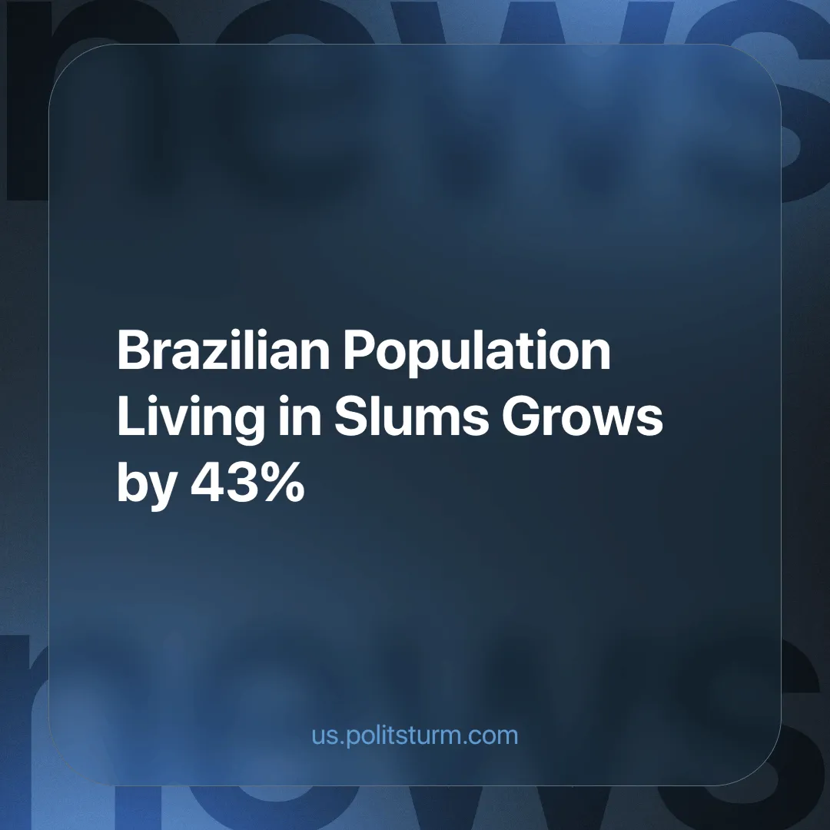

Original article
2024-11-18
4 min read

The Brazilian Institute of Geography and Statistics (IBGE) has revealed that 16.4 million people live in favelas (slums), or 8.1% of the total Brazilian population. This is an increase of 43% compared to 2010, when it was 11.4 million [1].
The research was carried out in 2022 and published on Friday 8 November 2024.
It also shows regional differences in the country. The two regions with the lowest percentages of population living in favelas are the South (3.2%) and the Centre-West (2.4%) regions, while the two with the highest percentages are the North (18.9%) and the Northeast (8.5%) regions.
Some individual cities have extremely high percentages, such as Vitória do Jari (69.2%) and Ananindeua (60.2%).
IBGE states that part of this increase is due to improved data collection, especially in small towns.
The public body has noted that favelas are concentrated along the coast, in the Amazon basin and in regions of agricultural expansion.
Favelas are caused by unplanned and unorganised urban expansion, side by side with the construction of houses not for their social use, but for profit. With millions of people forced to live in favelas or homeless, Brazil had 11 million uninhabited houses in 2022 (an increase of 87% in 12 years) [2].
Taking into account access to public services, health and food, education, access to financial services, transport and leisure, the IBGE has found that living conditions in rural areas deteriorate twice as fast as in urban areas [3].
The poor living standards of the rural working class lead them to seek employment elsewhere in the hope of a better quality of life; they do this alongside the recently ruined peasantry, who are now landless and must seek employment for a wage like the rest. This is reflected in the areas where favelas are concentrated.
When they try to find better opportunities, what they find instead are low wages and exploitative conditions caused by the large number of job-seeking workers who are willing to sell themselves as cheaply as possible in order to secure a living.
Capitalism can never guarantee a job for everyone, because the unemployed masses serve as a stark reminder to the disgruntled worker of what they can become if they do not accept their working conditions, and a constant downward pressure on the price of labour. In 2024 Brazil will have an unemployment rate of 6.9% [4] and in 2023 there were nearly 39 million workers in irregular employment [5].
Landlord capitalists in particular stand to gain from this. The high demand for housing caused by this internal migration means that buyers will compete with each other and landlords will be able to charge extortionate amounts for renting or selling property. By 2023, the average rental price will have risen at three times the rate of inflation [6].
These facts mean that most of those who move to urban areas cannot afford housing and end up in favelas. These houses are often unsafe, as their construction is not regulated and they are commonly built in unsuitable locations, such as very steep slopes, unstable terrain or too near other dangerous places (railway lines, power stations, etc.).
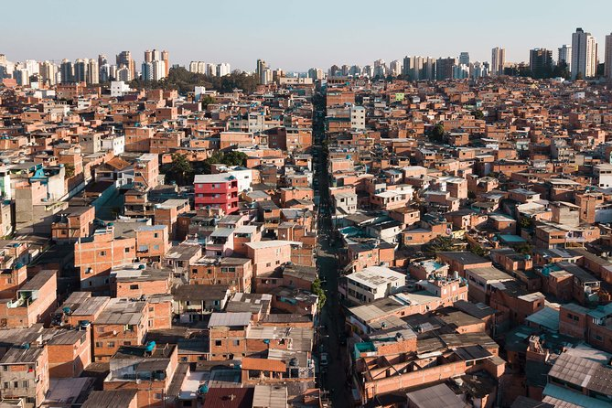
Paraisópolis favela (São Paulo) — the third largest favela in Brazil.
Slums are a common symptom of many capitalist countries, caused by market economies structured around maximising profit for private monied interests. This would not be the case in a socialist system.
In socialism, the means of production are the common property of the workers. This means that the whole of industry, and consequently the economy and the state, are geared towards satisfying the needs of its common owners — the working-class.
The socialist economy must guarantee a job for all workers, as labour is no longer a commodity, but a duty and a right. In every country there is work to be done, from the maintenance and expansion of crumbling infrastructure, to transitioning the economy to run on a sustainable basis, to implementing cutting edge technology and the construction of wonders. Yet it is largely not done, as there is little profit to be made. Capitalism now holds back our productive capacity.
With the socialist state concerned with meeting people's needs, housing would become a guarantee for everyone. Slums would cease to exist, as workers would no longer have to settle in irregular, unsafe places.
It is necessary to build a vanguard party, which has deep roots among the working masses and can lead them in their struggle for socialism, for true workers’ liberty - liberty from want and need. Only under socialism can the billions of workers worldwide have guaranteed housing and employment and freedom from starvation an poverty.
Currently, no parties of this type exist. If you want to help Politsturm in the task of building such parties, join our organisation.
Sources:
[1] G1 — População que vive em favelas cresce e chega a 8,1%, mostra Censo; no Norte, são 19% — 08/11/2024
[2] Brasil de Fato — 11 milhões de casas vazias e 6 milhões de pessoas sem casa: o que explica a crise habitacional? — 17/07/2023
[3] Agência IBGE Notícias — Perda na qualidade de vida é quase duas vezes maior nas áreas rurais — 26/11/2021
[4] Uol — Desemprego diminui em 15 estados e cai para 6,9% no Brasil — 15/08/2024
[5] CNN Brasil — Quase 39 milhões de brasileiros estão na informalidade, aponta IBGE — 29/09/2023
[6] Outras Palavras — Em gráficos, o drama da escalada dos aluguéis — 04/09/2023

Original article

