Booming Housing Prices Spur Employers to Become Landlords
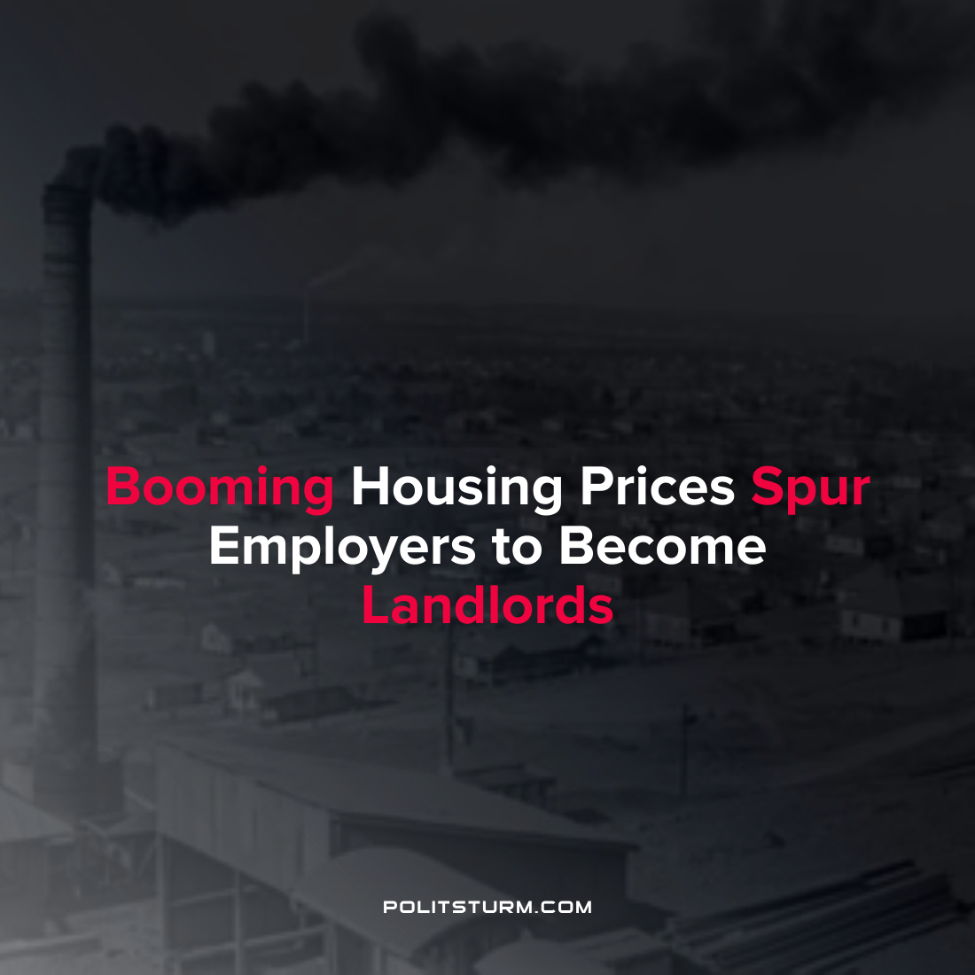

Original article
2022-03-16
1 min read

A recent article by Bloomberg highlighted one of the consequences of the increase in housing prices within the United States. With the median sales price for a home in the United States at $408,100, owning a home is falling out of reach for many Americans. In a similar vein rents have also risen across the country, with the average monthly rent standing at $1877 at the end of 2021 according to Redfin.
Given the lack of affordable housing, some capitalists have put a modern twist on an old concept: the company town. The idea is that private employers will construct housing for their employees and the employer would double as a landlord. Such arrangements have existed in the past in the United States. For example, Pullman, Illinois was built in the 1880’s by capitalist George Pullman to provide housing to the workers who produced railroad cars in the Pullman factories. Abuse of employees under such arrangements were common, with workers often being paid in scrip for use at company stores, and would be buying commodities from and paying rent back to their employers.
Holtz Builders is planning to construct employee housing in Branson, Missouri. Walt Disney Co. is also considering building residential housing for its workers.
Under the capitalist system housing prices are regulated by profitability, and the price of housing becomes unaffordable for many workers. Looking to capitalize on such a situation, capitalists are eager to serve in the double capacity of landlord-employers and further immiserate the workers with sub-par accommodations in a purported effort to “solve the housing crisis”. From history we can see that such attempts have ended in failure. Any attempt to fix the problems associated with housing affordability using “employer-sponsored housing” are utopian fantasies which just so happen to enrich the bourgeoisie.
Source: 1 2 3

Original article

