Billionaire Commissions State Border Patrol
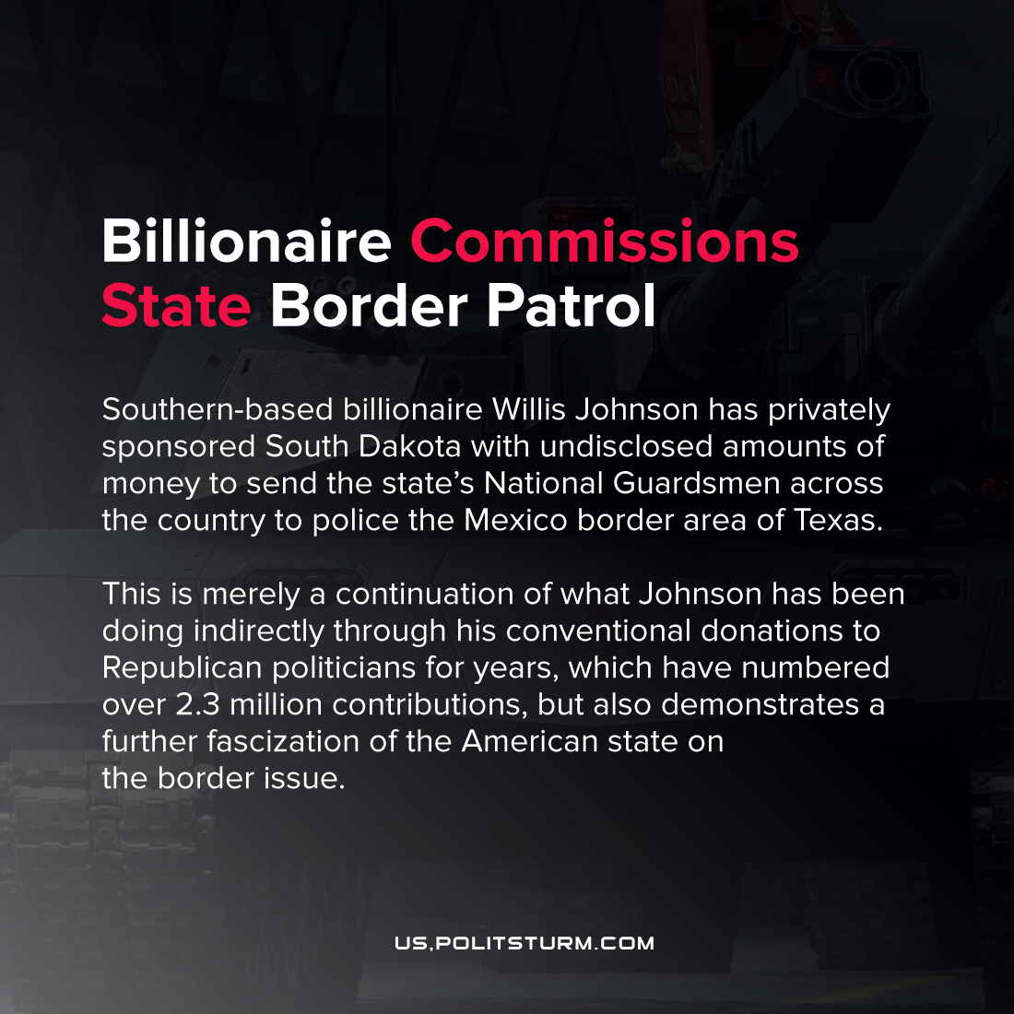

Original article
2021-07-10
2 min read

Southern-based billionaire Willis Johnson has privately sponsored South Dakota with undisclosed amounts of money to send the state’s National Guardsmen across the country to police the Mexico border area of Texas.
This is merely a continuation of what Johnson has been doing indirectly through his conventional donations to Republican politicians for years, which have numbered over 2.3 million contributions, but also demonstrates a further fascization of the American state on the border issue.
This comes at the order of the state’s Governor, Republican Kristi Noem, to respond to Texas’ declared state of so-called ‘migrant emergency’.
To the political mechanics of the move, the South Dakota Governor’s office spokesperson Fury told POLITICO
“The Governor has authority under SDCL 5-24-12 to accept a donation if she determines doing so is in the best interest of the State (editorial: of South Dakota). The Governor has additional authority to accept donated funds for emergency management under SDCL 34-48A-36.”
The exact amount of the capitalist’s ‘donation’ to the state of South Dakota’s Emergency and Disaster Fund is kept undisclosed through the legal mask of a private foundation that the capitalist owns. However, Johnson claims it’s only a million dollars. Donations like these are intended to be earmarked for the South Dakota agency Division of Emergency Management, but which are ultimately offices established at the appointment of the Governor.
Johnson states that he was inspired to make this donation because South Dakota has “fewer resources”, while other right-wing Governors of states including Iowa, Arkansas, Georgia, Nebraska and Florida have also pledged deploy forces to Texas and Arizona in support of the massive effort to staff the American capitalist state’s border policing apparatus.
This development demonstrates the taking up by the private capitalists of an increasingly direct role in the execution of state power to inspire the fulfillment of their interests; a key feature of the concept of fascization as defined by Dmitrov. In order to bring their dreams of heightened migration policing to political fruition, state finance laws have been arranged to allow capitalists like Johnson to grease the wheels of the state machinery. No more is “high-level corruption” endemic to the bourgeois political system, it has become simply the patriotic contribution of a concerned private citizen.
Source: 1, 2

Original article

