Biden Admin. Suggests ‘Finishing’ Trump’s Border Wall
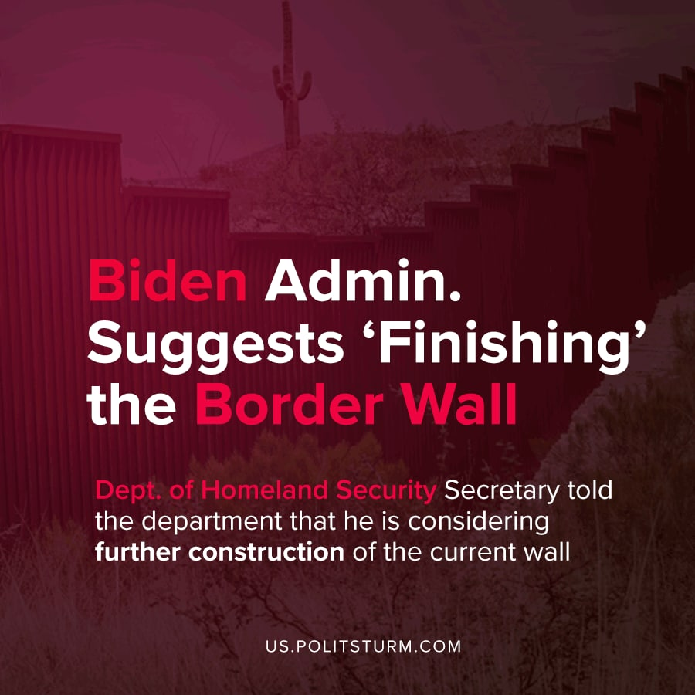

Original article
2021-04-09
2 min read

President Joe Biden has signaled the continued construction of the border wall started by Donald Trump upon the request of Border Patrol representatives.
Last week, Department of Homeland Security Secretary Mayorkas held a meeting to inform employees of Immigration and Customs Enforcement (ICE) that he could be approving future work on the wall to connect “gaps”.

In words which reflect a cold blooded approach to the decision, Secretary Mayorkas emphasises;

”There are different projects that the chief of the Border Patrol has presented and the acting commissioner of CBP presented to me,”

He continues.

“The president has communicated quite clearly his decision that the emergency that triggered the devotion of DOD funds to the construction of the border wall is ended. But that leaves room to make decisions as the administration, as part of the administration, in particular areas of the wall that need renovation, particular projects that need to be finished.” -Per Washington Times report
In this statement by Biden’s Executive Secretary, we see that the decision is couched in language which indicates that DOD funds should ordinarily go to the construction of the border wall project, despite Biden’s declared ‘pause’.
The current Democratic Party-controlled Congress slated 1 billion, 375 million dollars to fund construction of the wall, as a part of its first 2021 budget which also allocated 900 million dollars for Covid-19 relief.
Former President Trump had constructed over 490 miles of walls to outdo Obama’s previous accomplishment of 100+ miles of fencing. Now, more parts of Trump’s wall, such as in Cochise county Arizona, are likely to be expanded using the already-allocated federal funds.
This construction project doesn’t just mean erecting more concrete and steel barriers, but focuses largely on installing gates, paved roads, and outfitting sections of finished wall with observation technology.
Is the hypocrisy of Biden’s Wall apparent to the bourgeoisie who elected him? Maybe so, but since Biden represents the interests of the American capitalist so efficiently these actions will go unremarked upon in the prevailing discourse.
To the regular Americans who voted for the ‘better of two options’ last November, maybe the disgusting hypocrisy of Biden’s support for all of Trump’s programs will prove a future sticking point.

Source: 1

Original article

