Biden Admin. Heightens Trump-era Drilling Fervor
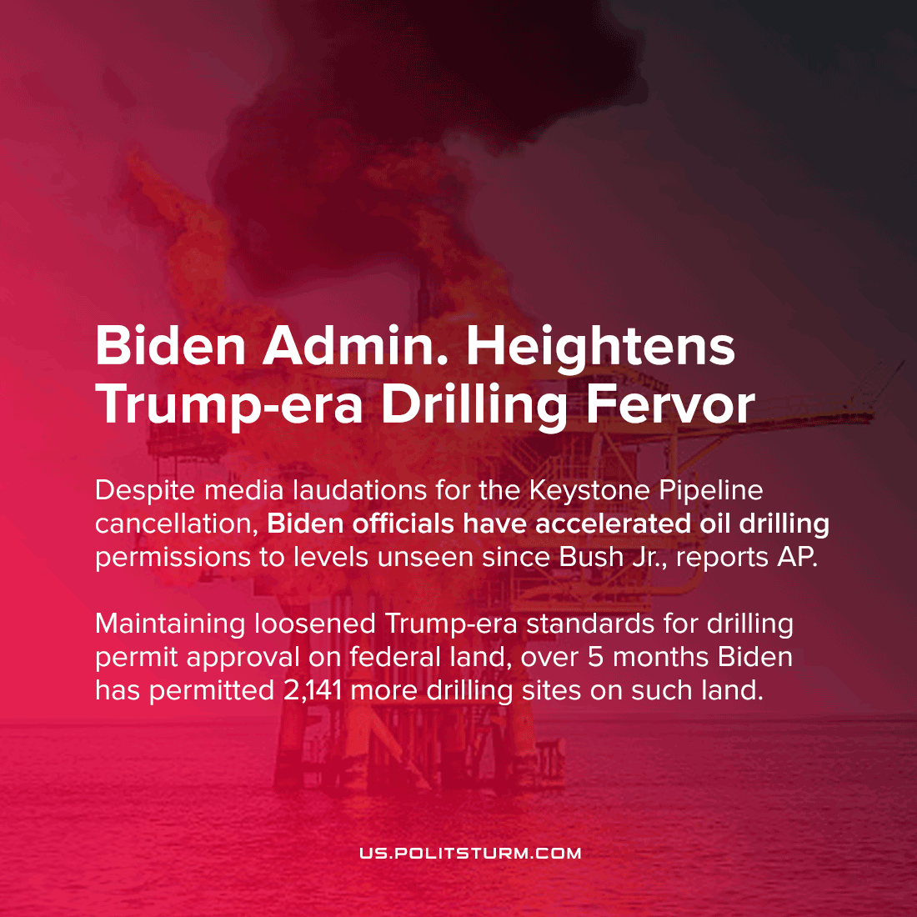

Original article
2021-07-17
1 min read

Despite Biden’s cancellation of the Keystone Oil pipeline, which garnered extensive media coverage after lengthy and sometimes violent protest demonstrations, American oil extraction is on the rise. In direct contradiction with outlined plans towards halting drilling on public land, 2,141 permits have been approved by officials in the Biden administration’s Interior Department on public and “sovereign” Native American tribal lands.
This has even outpaced drilling approvals by Trump administration officials, as recently reported by AP, officials whose own stated goals were the unimpeded execution of the oil industry’s wishes.
Former President Trump cut the time it took to approve new drilling on these lands, and current President Biden only seems to have embraced this change. Under his leadership, more permits are being approved each month than the previous average monthly amount being approved under Trump.
Biden appointed New Mexico’s representative Debra Haaland, of the Laguna Pueblo tribal nation, as the oil industry’s domestic overseer; with New Mexico itself seeing 60% of these new drill sites. Somehow, Secretary Haaland has reconciled her support for the Green New Deal and her stated opposition for drilling on public land to end up enforcing the exact opposite with a greater efficacy than Trump’s own, white male appointee.
4,700 drilling permits are still waiting for approval, many filed under Trump, and we have no reason to believe they will have long to wait under Biden’s policy.
As the American economy slows in its Covid recovery, accompanying a rise in domestic gas prices, the capitalist’s need for growth in the oil industry has become more severe. And while sea-water erosion undermines coastal cities, and wildfires ravage unprecedented spans of the landscape, this drilling is more than just business as usual. No climate necessity will ever withhold this fossil-fuel machine’s acceleration under capitalist leadership, without any regard for the grim consequences to America and its people.
Source 1, 2.

Original article

