Jeff Bezos Became the Richest Man in the World
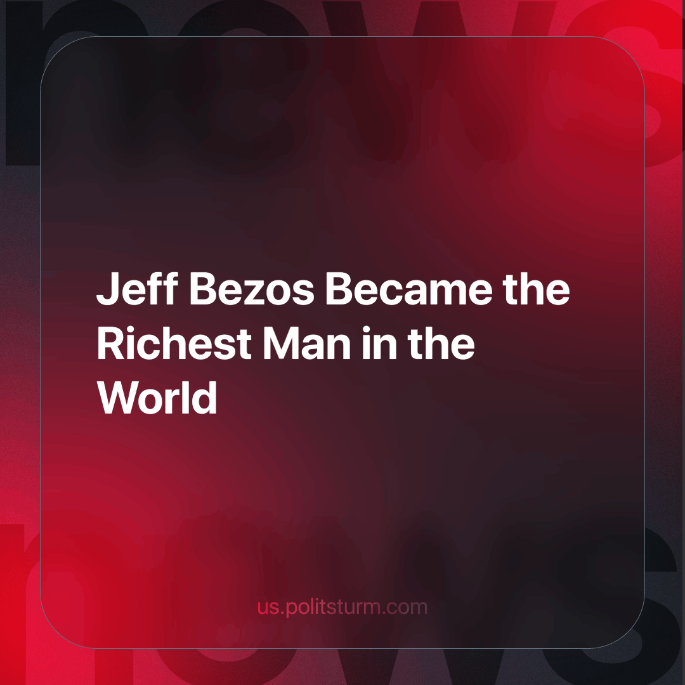

Original article
2024-04-21
2 min read

Jeff Bezos, the founder of Amazon, is currently the world's richest individual, with a fortune estimated at $200 billion. He is closely followed by Elon Musk with $198 billion and Bernard Arnault, owner of the LVMH group, with a fortune of $197 billion. Mark Zuckerberg, the head of Meta (which is recognised as an extremist platform and is banned in Russia), is the next highest with a net worth of $179 billion. In fifth place is Microsoft founder Bill Gates, whose fortune is estimated at $150 billion.
The list of the world's ten richest people also includes former Microsoft CEO Steve Ballmer ($143 billion), Berkshire Hathaway founder Warren Buffett ($133 billion), Oracle co-founder Larry Ellison ($129 billion) and Google founders Larry Page ($122 billion) and Sergey Brin ($116 billion).
One of Bezos' strategies, similar to Musk's, is an active anti-union stance. Amazon effectively bans union organising within its operations. The latest wave of protests, aimed at raising wages to £15 an hour and collective bargaining rights, took place in the UK on 13-15 February at a warehouse in Coventry. At warehouses in the Midlands, Amazon used union-busting tactics, with workplace notice boards telling staff: "We want to talk to you. A union wants to speak for you."
Capitalists accumulate their wealth through exploitation, made possible by the private ownership of the means of production, including everything we use to produce. They employ workers to run their production, exploiting the fact that workers have no way of surviving without selling their labour. This immediately makes it clear why the capitalists do not want the workers to unite into a large, organised and cohesive team capable of stopping the flow of wealth that lines the capitalists' pockets and demanding better conditions, in which case it will be very difficult to deceive the workers whose daily intense and hard work created Jeff Bezos' "self-made" economic miracle.
In the battle for the redistribution of raw materials and markets, corporations are moving from 'friendly' competition to more aggressive measures. In peacetime, ordinary people struggle to make ends meet; in times of economic and political crisis, we see their working and living conditions deteriorate sharply. And in contrast to these conditions, the fortunes of the biggest businessmen have grown at an accelerated rate. These are the unshakable values of capitalism: the right to private property, legal exploitation and speculation, and above all for every capitalist - profit.
Source: RBC - “Jeff Bezos has once again overtaken Musk on the list of the world's richest people.” from March 05, 2024

Original article

