Belarusians Banned From Using Drones
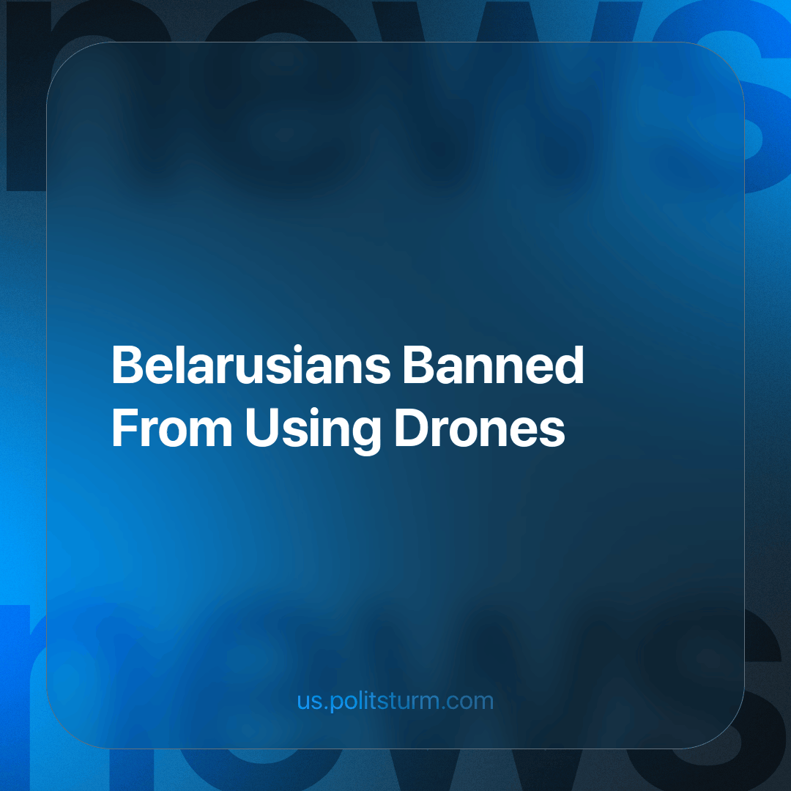

Original article
2023-11-16
1 min read

On September 25, Belarusian President Lukashenko signed Decree No. 207, which prohibits individual Belarusians from importing, storing, trafficking, operating, and manufacturing drones. It also regulates their use by organizations and businesses, as the decree preserves the possibility of using such devices by organizations and individual entrepreneurs as part of their business and professional activities.
In accordance with the new regulations, the Department of Aviation will keep records of unmanned aerial vehicles, and issue permission for the import of drones by organizations and individual entrepreneurs.
This decree reflects the essence of the modern state and society. Only a representative of the entrepreneurial class can become the owner of a drone, which discriminates against representatives of the class of hired workers.
Discrimination against the working class by businessmen through the institution of the state emphasizes the class basis of society. This decree also shows which class the state is in the service of, and whose interest laws that aggravate and expose class inequality are adopted.
It would be naive to assume that every entrepreneur will have the opportunity to conduct business using drones. Only privileged parts of the bourgeoisie will receive this honor, which will create favorable conditions for the formation of a monopoly in the production, turnover, and use of drones for production purposes, because business is closely intertwined with administrative resources.
According to Marxist-Leninist theory, monopoly capitalism is the last stage in the development of class society. The future is in a classless society, where class inequality and discrimination are unknown, and the use of advanced technology is free and commonplace. Such a society can be achieved through the class struggle of the exploited against the exploiters, the oppressed against the oppressors. And not just any class struggle, but a class struggle according to the advanced theory of Marxism-Leninism under the leadership of a communist party.
Sources:
Belta - “Belarus introduced a ban for individuals on the import, storage, circulation, operation and production of drones” dated September 25, 2023.
Onliner - “A decree on the use of drones has been signed. What is changing?” dated September 25, 2023

Original article

