Barr’s Response to the Recent Nationwide Protests
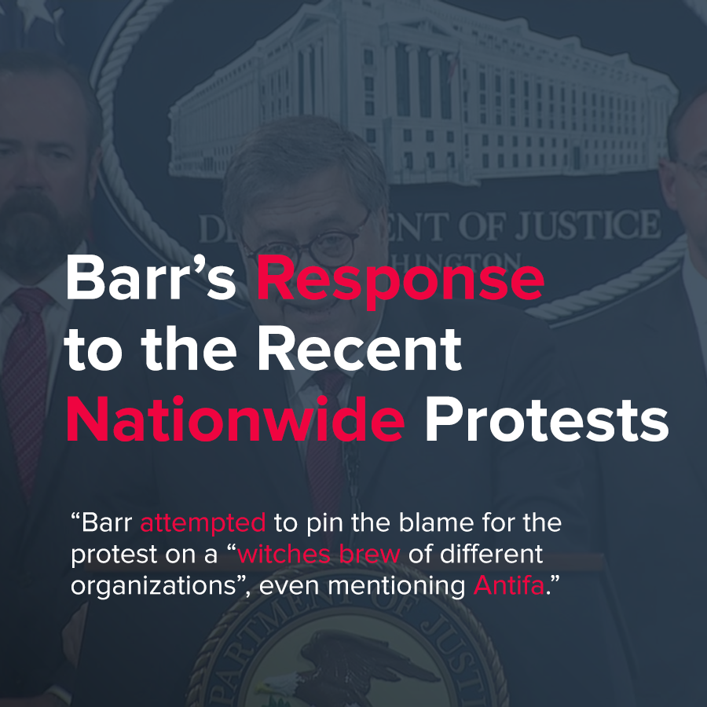

Original article
2020-06-07
2 min read

Attorney General Barr stated about the death of George Floyd, and the video tape of the officers, who died after the police officer Derek Chauvin, now charged with second degree murder, knelt on his neck for nine minutes (which has caused nationwide protests): “It is impossible for any normal human being not to be struck to the heart with horror.” Barr also stated on a Thursday conference that it is undeniable that African Americans face discrimination in the American criminal justice system.
However, despite his kind words, Barr continues to defend the US government’s response to the protests about the Floyd Murder. He himself has even been involved in the government responses to the protests in certain areas. For example, he defended the government’s response to the protesters in Lafayette Square, referring to the protesters as “becoming increasingly unruly”.
On Monday, President Trump went to St. John’s Church, and he held a bible, following his threat to use military power against the protesters. The church has voiced against such a statement, but Barr defended it.
Despite this, Barr again gave kind words with FBI director Chritospher Wray on the death of Lloyd, whilst defending the actions of the US government.
The cops involved in the incident have all been arrested, and the perpetrator of the killing fired along with it, but the protests have seemed to continue, and will do so for the time being.
Barr attempted to pin the blame for the protest on a “witches brew of different organizations”, even mentioning Antifa, which the current administration has capitalized on every opportunity to attack.
What can be concluded? Do not listen to the kind words of Barr, or official statements that offer sympathy. Barr still stands with the Trump administration on the issue, and is even using it to attack Antifa. He has justified the government’s use of force, and supported Trump’s threat to use the military against the protesters. He is not a genuine person who cares about the suffering of Floyd and his family, but is rather a representative of and staunch defender for the capitalist class who act to repress the working class of the country.
Sources : 1 , 2 , 3

Original article

