Bangladesh Garment Workers Clash With Police Over Wage Demands
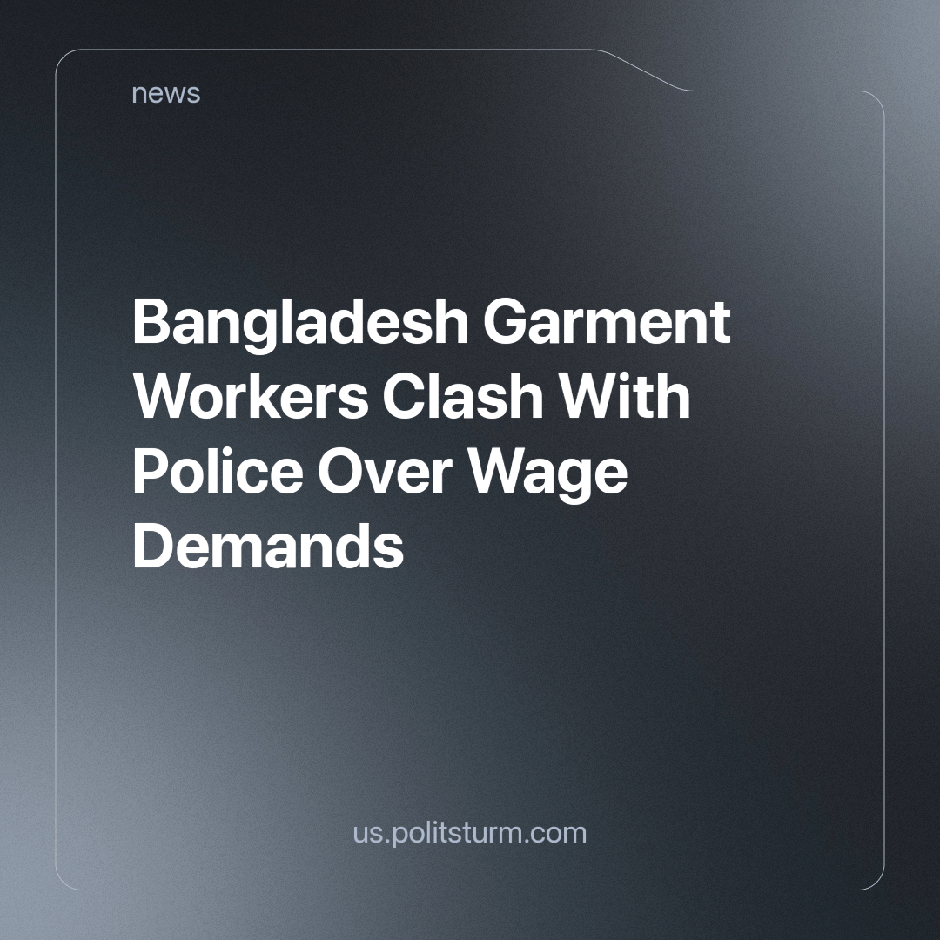

Original article
2023-11-06
2 min read

On Tuesday, thousands of garment workers in Bangladesh clashed with the police and obstructed roads leading towards manufacturing centers near the capital city of Dhaka. They were demanding a nearly threefold increase in their wages from their employers. [1]
The police deployed teargas and water cannons to disperse the protesting workers in Ashulia, located on the outskirts of Dhaka. These workers are advocating for a minimum monthly wage of 23,000 taka ($209), a significant increase from the current rate of 8,000 taka ($70).
The garment industry in Bangladesh, employing approximately 4 million workers, plays a substantial role in the country's economy, contributing to around 10% of its GDP. Moreover, it is responsible for over 80% of Bangladesh's exports and supplies products to major global retailers. The volume of exports amounts to 55 billion dollars, and supplies companies including Hennes & Mauritz AB, Adidas AG, Walmart Inc., and Gap Inc.
But the living conditions of many of the four million workers in the garment industry is terrible.
Trade union leader Kamran said that about 50,000 workers broke tools in protest in Ashulia, with rising prices being a key factor.
According to Kamran, the cost of some staple foodstuffs, such as potatoes and onions, has more than doubled since last year.
"The rent for housing has also jumped. The only thing that has not increased is salaries." said Taslima Akter, head of the Garment Sramik Samhati trade union. He also said that the compensation offered by manufacturers is "less than what the employee received in 2017," if we take into account inflation and currency depreciation.
Unions said workers expressed their anger on the streets after an influential manufacturers' association proposed a 25 percent increase, ignoring the demands for a new monthly minimum base wage of 23,000 taka, which is almost three times more. [2]
Protests by laborers have persisted in Bangladesh for over a week, coinciding with the country's preparations for potential general elections in January. Local media reported two worker fatalities during violent clashes on Monday, with one of them reportedly shot dead by industrial police.
This is yet another example of when the state does not protect the interests of workers, but on the contrary suppresses protests for the benefit of the owners of the production facilities. Bourgeois propaganda lauds capitalism for its "advantages", with all sorts of honeyed words about private property, the fact that you can easily earn money, personal freedom, etc. However, the negative sides like: corruption, inequality in the distribution of goods created by labor, unfair competition, the negative influence of business for ordinary employees, about whose interests the state serves, are all hushed up.
Sources: 1, 2

Original article

