Baltimore Children Freeze in Public Schools
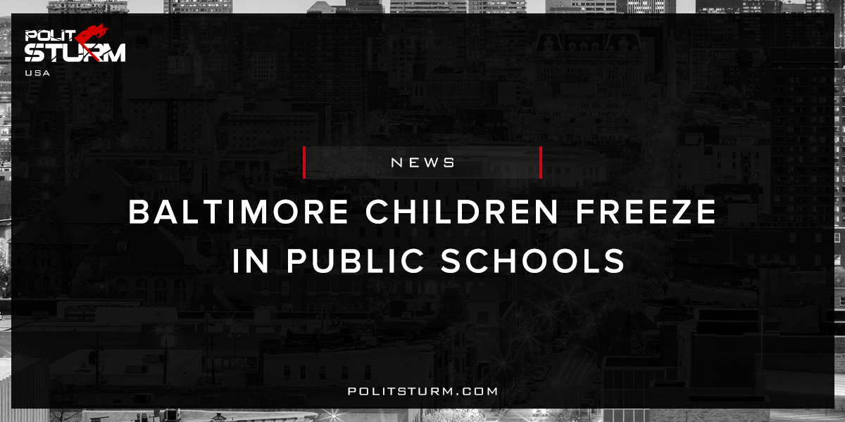

Original article
2018-01-10
1 min read

As temperatures plunged along the East Coast,photos emerged this week of Baltimore students wearing coats, hats and gloves inside frigid classrooms — igniting criticism from parents and others who wondered why those classes weren’t canceled.
Photos spreading virally online showed children bundled up in Baltimore schools where heating systems weren’t keeping up with the weather. The school system closed four schools and dismissed students early at two others Wednesday, and closed all schools Thursday as low temperatures persisted citywide.
Thursday’s systemwide closures came only after parents and a teachers’ union excoriated the school system for Wednesday’s heating issues.
Politsturm: The state of Maryland statistically has the highest median income in the United States. In the richest state, in the richest country in the world, basic services are not being rendered to children. This is a despicable failure of the capitalist economic system. One the one hand you have Maryland, the state with the highest number of millionaires per capita in the United States. These households represent the propertied households which have substantial holdings in stocks, bonds, mutual funds, alternative investments, property, etc. Through this property ownership, the capitalists are able to earn dividends, interest, capital gains, and rent. All of this requires no labor, only the ownership of property.
As the millionaires and billionaires accumulate wealth, the working class produces the profits that serve as the lifeblood of the capitalist class. The needs of the working class are not considered by the bourgeois government. For example, as the government faces budgetary pressures the proposed solution includes implementing tax cuts and tax credits for business. Thus, in order to resolve the growing contradictions of capitalism the bourgeoisie adds fuel to the fire. There is no intention to provide more services and support to the public school children in Baltimore. The government apparatus only serves the interests of the oligarchy. The fact that the richest state cannot provide the most basic services, despite having the resources to do so, serves as irrefutable proof of this fact.
Sources: 1, 2, 3, 4

Original article

