Bailout Recipient AIG Posts Stock Returns of 265%
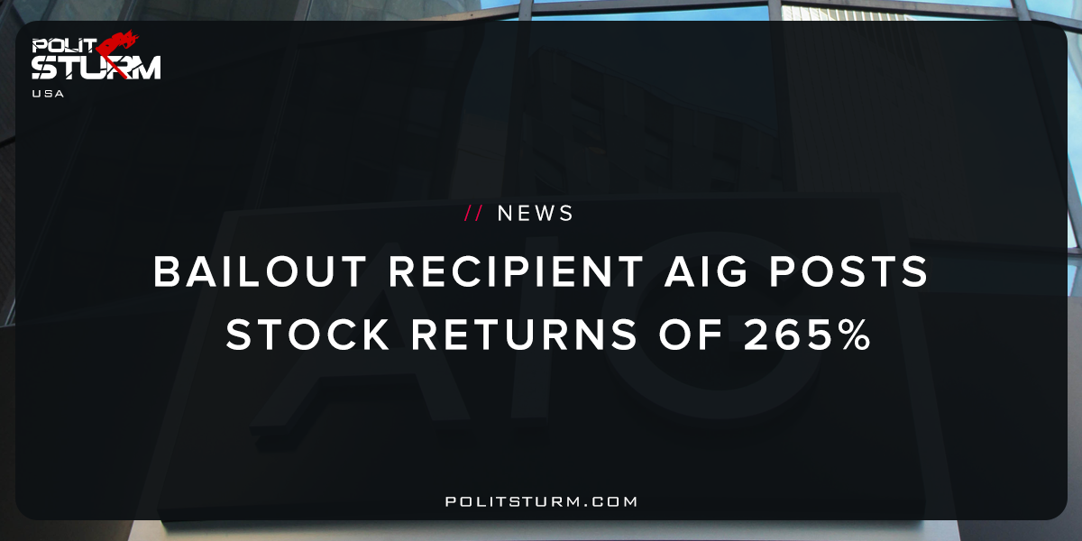

Original article
2017-11-01
1 min read

Since I joined the company in 2010, AIG ranks second among the 25 peers identified in our proxy statement with respect to total shareholder return (TSR). Through the end of 2016, AIG delivered a TSR of 265% versus 141% for an investment in an equal-weight portfolio of our peers and 142% for the S&P 500.
The path of this exceptional value creation has never been a straight line. And value creation has always been about navigating extraordinary challenges with a persistent focus on the long term.
“Politsturm”: American Insurance Group was one of the bailout recipients of the Economic Stabilization and Recovery Act of 2008, commonly known as the government bailout. AIG needed support from the Federal Government in the form of various loans and preferred stock purchases. AIG has boasted that it paid back the loan with a profit and simultaneously returned large returns for stockholders. These results display the demarcation in results achieved by the two different political classes in our society.The capitalist class has seen their wealth increase dramatically since the preceding recession, as evidenced by the spectacular growth of the stock market. The working class, however, has seen stagnating real wages, political instability, and a pessimistic outlook for the future. If this shareholder press release evokes a feeling of anger in you, that is your right. You, the American taxpayer, funded AIG’s bailout but you in no way get to share in the private spoils it distributes to its shareholders. The economic system, capitalism, produces these results. If you bemoan the excesses of corporations but do not expressly criticize capitalism and organize we are bound to repeat these mistakes endlessly.
Source

Original article

