Azerbaijan Launches Attack on Armenia
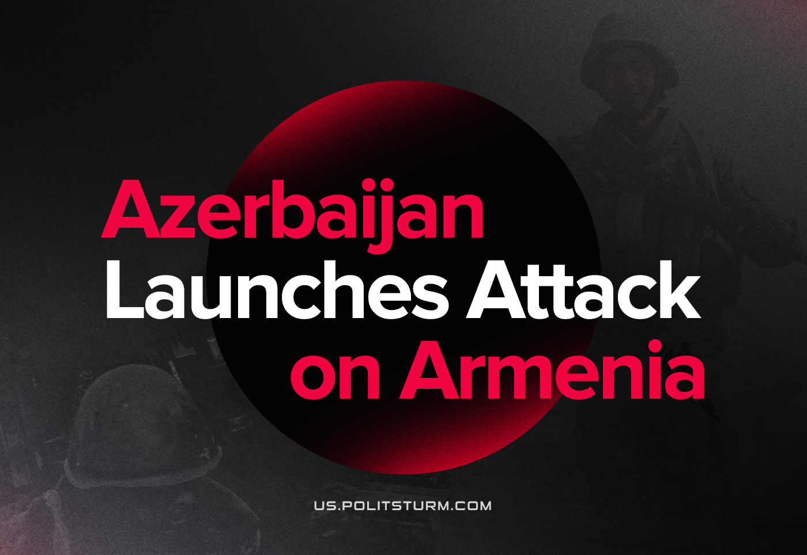

Original article
2022-09-14
2 min read

Shelling by Azerbaijan began yesterday night and continued throughout the day. In several regions, infantry movements were observed. Today, hostilities continue.
Armenian casualties: 105 soldiers dead.
Azerbaijani casualties: 50 soldiers dead.
Error loading image
Armenia stands against the campaign of aggression by Azerbaijan. Azerbaijan, in turn, claims provocative attacks by Armenia on September 12th, affirmed by its NATO ally Turkey.
Given the one-sided outcome of Azerbaijan’s victory in the 2020 conflict, and its territorial gains then, they will likely acquire even more land at their easily-paid cost of human life, particularly paid by the Armenians, unless there is some change in the international situation.
Russia and CSTO expressed concern about the escalation and asked the parties to resolve the conflict diplomatically. During the urgent meeting, CSTO proposed to send its general secretary to the border to assess the situation. Military intervention is not considered at the moment.
U.S. Secretary of State Blinkin called the presidents of both Azerbaijan and Armenia. In his words, “whether Russia tries in some fashion to stir the pot, to create a distraction from Ukraine, is something we’re always concerned about.” At the same time, the US has urged Russia to use its “outsized influence” with Armenia and Azerbaijan to put an end to military actions.
France displayed an active position and brought up the Armenia-Azerbaijan hostilities at the U.N. Security Council. The extraordinary meeting is scheduled for today.
Turkey’s Foreign Minister expressed support for Azerbaijan and mentioned that “Turkey will continue to stay by Azerbaijan and will never leave it alone”.Iran reacted harshly to the escalation between Armenia and Azerbaijan and warned that it wouldn’t accept any border change in the region. Despite this, further actions were limited to calls for a peaceful solution to the problem.
At the same time in Georgia, a chairman of the ruling Georgian Dream party Irakli Kobakhidze answered Ukrainian calls to open a “second front” against Russia in the Caucasus. He said that the government doesn’t want to do it but is ready to “hold a poll, a plebiscite, whether people want to open a second front in Georgia or not”.Once again, we are seeing capitalistic contradictions plunge humanity into chaos, and the tragedy of a war between brothers as these two nations had once been inside the USSR. Bourgeois governments compete to find a “peaceful” or “diplomatic” solution, while profiting and lobbying and enabling hostilities, instead of uncovering the origin of this conflict. Driven by private interests, Azerbaijan seeks to strike decisively at its weaker competitor, appropriate his wealth, or simply destroy him and his nation. Bestial nationalism has grown in Azerbaijan during the last 30 years, supported by Turkey, and is just an example of a worldwide trend.
Social-chauvinism, with its heavy tread, is marching across the world, while capital salutes its progress. Armenia and Azerbaijan, Russia and Ukraine, Greece and Turkey, USA and China are all deadly links of a single socioeconomic chain, a chain of reaction threatening death for all mankind.

Original article

