AUKUS to Send Nuclear Submarines to Australia Despite Chinese Objections
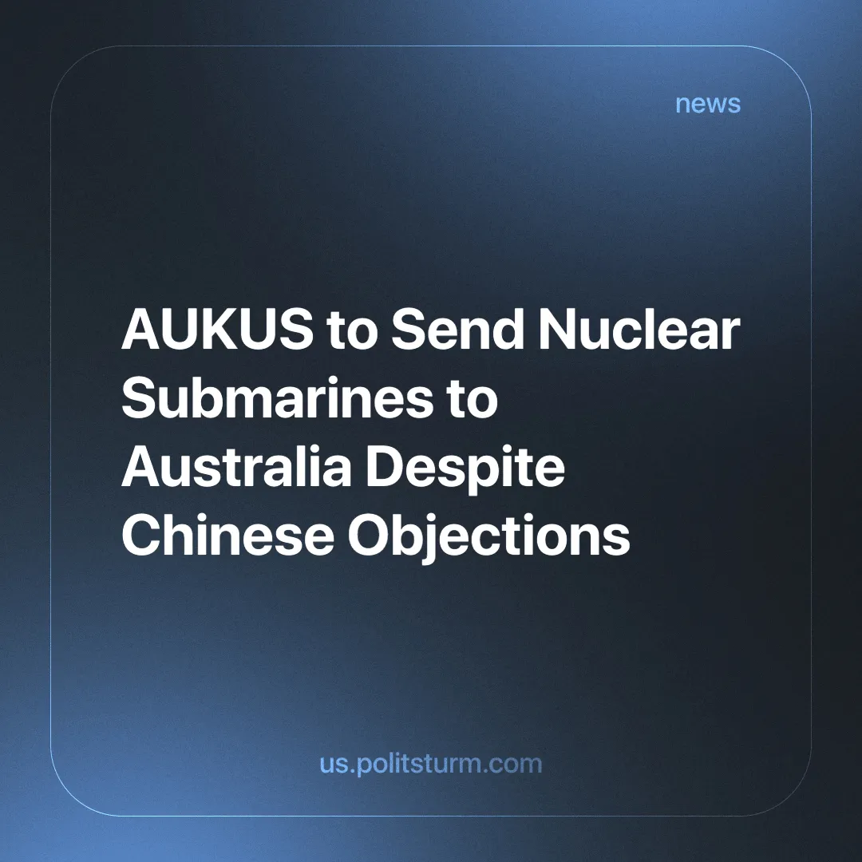

Original article
2024-08-26
3 min read

AUKUS is a security partnership announced in 2021 between Australia, the United Kingdom and the United States. Its main aim is to promote Western capitalist interests in the Indo-Pacific region, in opposition to China and other imperialist powers who are disputing this highly contested area.
The organisation has agreed to transfer eight nuclear-powered but conventionally armed submarines to Australia by 2050. This advances ‘pillar one’ of AUKUS, this being arming the country with its first nuclear-powered submarine fleet [1].
China has urged AUKUS to not move forward with this, with the foreign ministry spokesperson Lin Jian saying the programme undermines efforts to maintain regional peace and security.
The South China Sea has seen several clashes between the Chinese navy and several other countries' coast guards, with the former often accused of provocative or violent behaviour [2][3].
The South China Sea is an extremely strategically important area, with an estimated 21% ($3.37 trillion) of the world's trade passing through these waters in 2016. There are also rich fishing grounds that contain possible unexplored reserves of natural resources [4]. Therefore we can see why various different nations have a vested interest in controlling the region.
We have previously written about the New Silk Road, a project aimed at extending Chinese influence and capital across various countries. The Maritime Silk Road part of this project passes through the South China Sea and is therefore of great importance to this initiative.
Another focal point is Taiwan, an incredibly important island off the coast of China. Both countries claim it is the legitimate government of China and it has also been the focus of escalating tensions. The US has also stationed troops on the island [5].
Two Taiwanese companies control 60% of the market share in the semiconductor industry [6]. Semiconductors are the foundation of modern industry and technology, being a key component of memory chips and microprocessors. We have previously written about the importance of Taiwan and the microchip arms race.
These are just two examples of areas in the Indo-Pacific where imperialist forces are seeking influence and re-division of the world. There are many more which are further explored in our aforementioned articles.
While Chinese imperialism will resort to war when the contradictions become unbearable, it has mostly expanded and subjugated through economic investment and the debt trap system.
Imperialism is the highest stage of capitalism, also known as monopoly capitalism. At this stage, finance capital tries to expand beyond national borders as its own home market is already dominated and monopolised.
The United States also uses economic subjugation such as embargoes and sanctions. In many cases it does this through the International Monetary Fund or the World Bank, organisations that give loans (it is important to emphasise that they are loans, not investments) to struggling developing countries in exchange for extreme liberalisation of their economy or taking any other action that most benefits international capital.
However, the US also heavily relies on military force to guarantee its interests. As of July 2021, it had some 750 bases in at least 80 countries, and in that same year, it ended its 20-year war in Afghanistan, the longest in US history [7].
China, while not as active in military conflicts, is investing heavily in its military expansion, increasing its spending by 7.2% compared to 5% for education [8]. This is a clear symptom of rising tensions as the great powers prepare for a likely armed conflict. China is also the country with the highest amount of active-duty personnel in its military [9].
The world is slowly being divided into two opposing imperialist blocs. AUKUS is a symptom of this. Its aim of military cooperation and development between Australia, Britain and the USA is to threaten and prepare for war against China. Sending nuclear-powered submarines to Australia is a clear demonstration of this.
The competing powers seek to re-divide the world among themselves. This leads to inter-imperialist conflict as all "peaceful" options are exhausted.
“Modern monopolist capitalism on a world-wide scale — imperialist wars are absolutely inevitable under such an economic system, as long as private property in the means of production exists.” - Lenin, Imperialism: The Highest Stage of Capitalism
As long as profit remains at the centre of our economies, it will always require expansion and eventually lead to conflict. Profit comes at the price of ever-greater exploitation and competition. The ever-increasing competition between the capitalists eventually leads to its logical conclusion: imperialist wars.
These wars are of no benefit to the working class. The proletariat is sent to its death to protect and increase the profits of those who exploit them. Both Chinese and Western (and from all nations of the world) workers will be sacrificed on a massive scale for the sake of predominantly Western and Chinese monopolies.
Only in a socialist society, where the means of production are under workers’ control and under the leadership of a genuine communist party, can society strive to satisfy human needs. Only after the victory of socialism on a world scale can these wars cease and the world's natural resources be brought under rational planning and used for the development of human society. A socialist society is built on cooperation, not cutthroat competition. Due to this, world wars, which are far from an ‘unnatural’ abomination, but merely imperialist (monopoly) competition carried to its logical conclusion, can be entirely avoided.
Join Politsturm and help work towards the building of communist parties that can lead the struggle towards socialism.
Sources: 1,2,3,4,5,6,7,8,9

Original article

