August Bebel on Religion
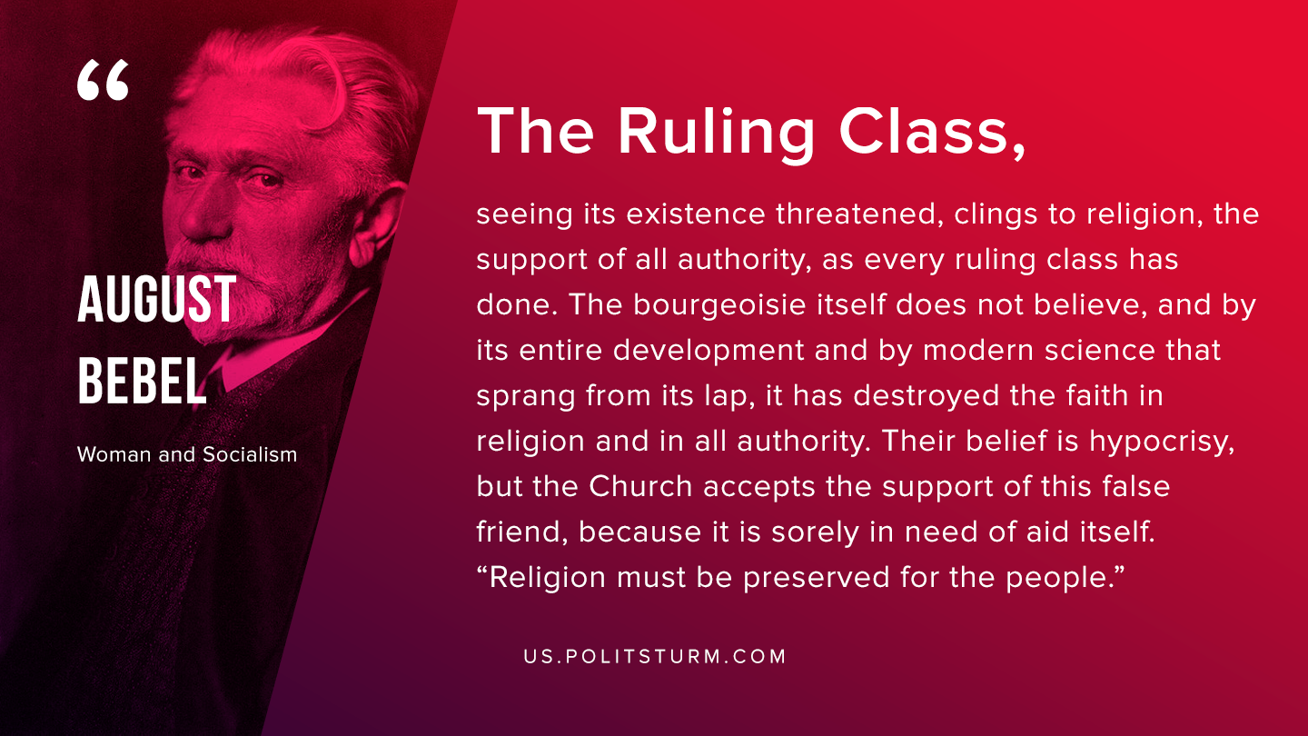

Original article
2019-08-30
1 min read

The ruling class, seeing its existence threatened, clings to religion, the support of all authority, as every ruling class has done. The bourgeoisie itself does not believe, and by its entire development and by modern science that sprang from its lap, it has destroyed the faith in religion and in all authority. Their belief is hypocrisy, but the Church accepts the support of this false friend, because it is sorely in need of aid itself. “Religion must be preserved for the people”.
August Bebel “Woman and Socialism”

Original article

