August Bebel on Culture
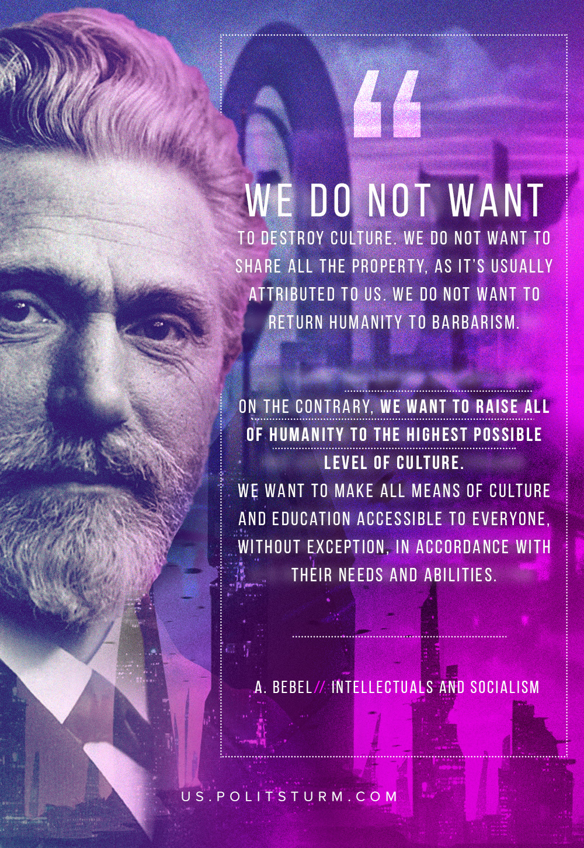

Original article
2020-05-17

We do not want to destroy culture. We do not want to share property, as is usually attributed to us, we do not want to return humanity to barbarism.
On the contrary, we want to raise all of humanity to the highest possible level of culture. We want to make all means of culture and education accessible to everyone, without exception, in accordance with their needs and abilities.

Original article

