AT&amp;T Workers End Strike
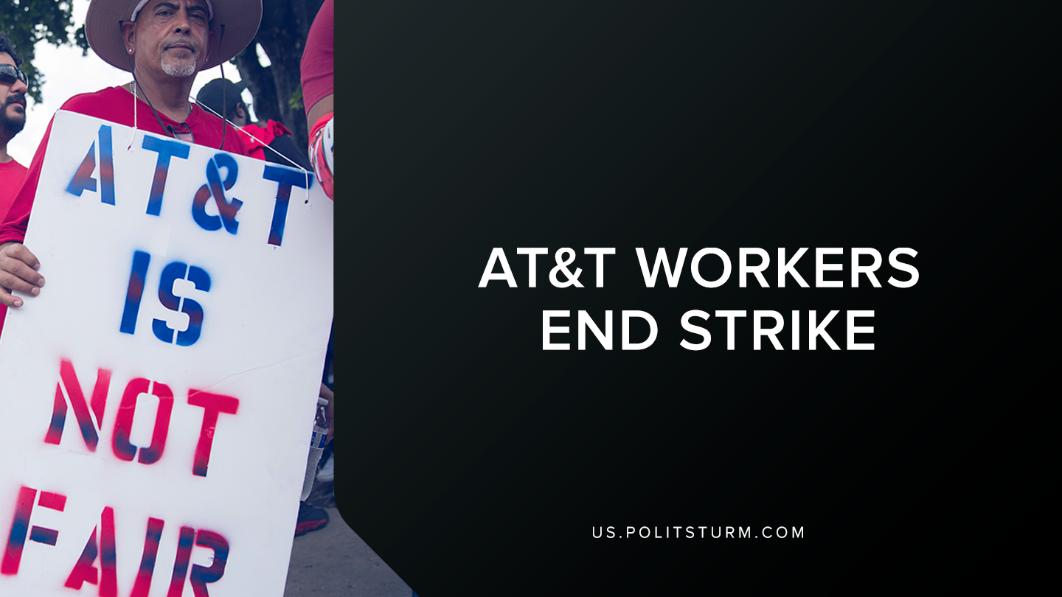

Original article
2019-08-28
1 min read

Over 20,000 AT&T workers had gone on strike over unfair working conditions across the southern United States. The strike involved technicians, customer service workers, and others who maintain and support the AT&T wireless telecommunication networks.
The union that represents the workers, Communications Workers of America, also alleges that the company had been unfairly disciplining workers who wore union memorabilia in Florida. The workers planned to start striking at midnight on Friday August 23rd, 2019 amid contract negotiations.
On Wednesday August 28th, 2019 the Vice President for the union, Richard Honeycutt, announced that the strike is over and that the workers will be returning to work at 1 p.m. EDT. Honeycutt stated that the company is now bargaining with the union in good faith and the strike shows the power of organized working people.
The strike does demonstrate that when workers organize collectively they can accomplish their goals and win concessions and improve working conditions. However, within the current trade union structure the workers can only win concessions and there are definite limits to what the capitalist are willing to concede. Despite the victory of the union, the workers continue to be exploited and shareholders continue to profit off the unpaid labor of the working class. Only when the workers develop their strategy along Marxist-Leninist lines, with the goal of eventually dismantling the capitalist system and building socialism, will the workers be a threat to the capitalist class and their class domination.
Source

Original article

