Assassinated Black Activist Was Tracked and Detained by Feds Shortly Before Death
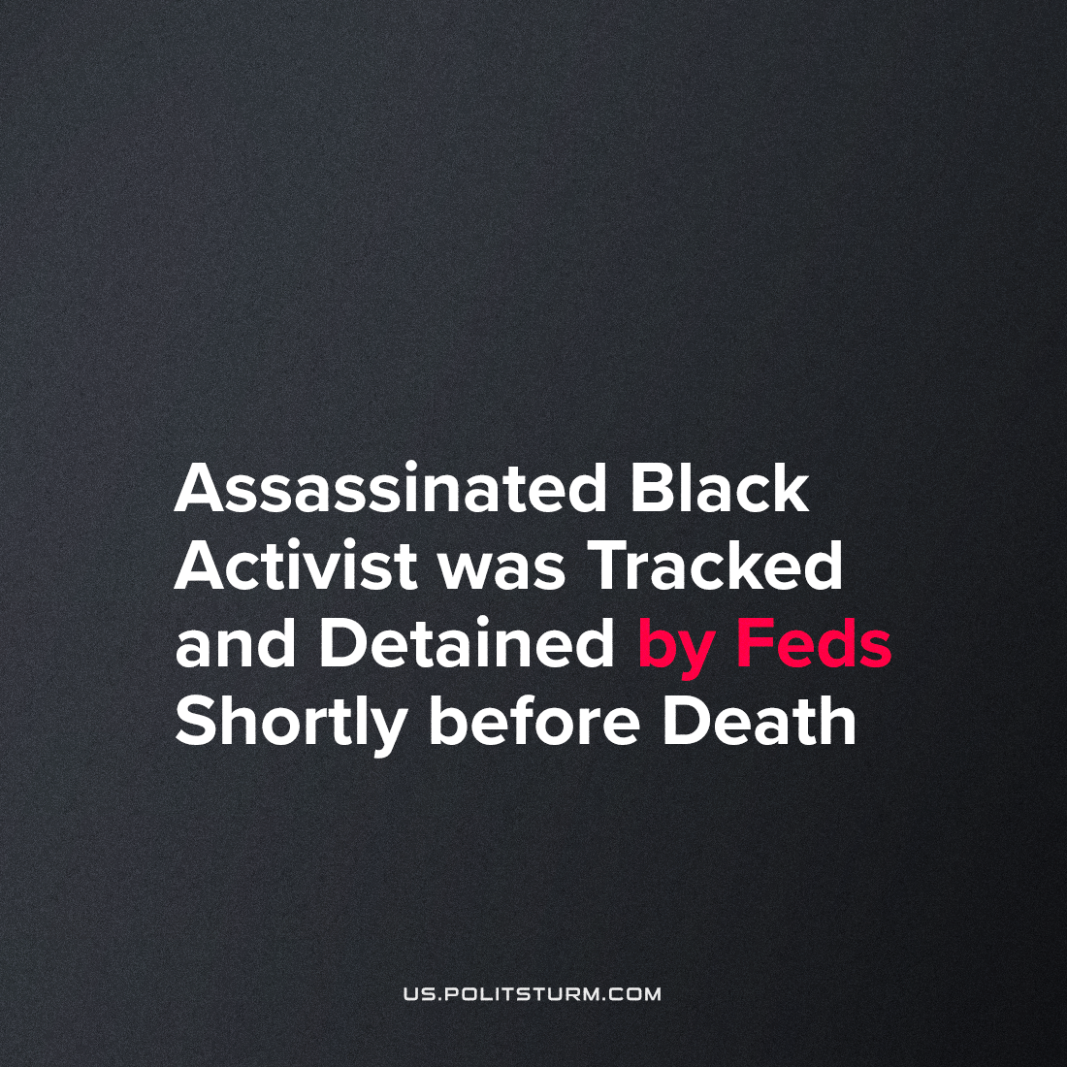

Original article
2022-09-28
2 min read

COINTELPRO remains in operation, quietly doing its work all these years. Recently-released and heavily-redacted files reveal independent police brutality activist Darren Seals was under intense federal observation and intrusion in the short time before his assassination.
In June of 2016, less than four months before his murder, the Freedom of Information Act release revealed that Seals was “investigatively detained” along with his younger brother in a traffic stop by the Ferguson Police Department. As soon as the stop began, police jumped from their vehicle with guns drawn, and pulled Seals from the car to place him in handcuffs.
According to Seals, Ferguson PD called-in persons over the phone whom Seals calls “detectives”, who proceeded to illegally search his car (or at least, did not properly announce their legal ability to do so) during this detainment. These “detectives” allegedly asked Seals if he had attended a Trump rally and posted about then-Presidential candidate Trump on Facebook, telling Seals that he “might wanna pick [his] enemies better”.
What is critical about the disclosure is the way in which this detainment came to be- with the assistance of both an FBI agent and a U.S. Marshall. Clearly, this was not a stop regarding the traffic warrants which were cited by officers as a reason for Seals’ future arrest. It’s likely that the “detectives” mentioned by Seals were in fact the same FBI agent and Marshall listed in the file.
After this detention, a note was added to the Seals file which states “”Traffic warrants for subject’s arrest remain active if additional car stops are deemed merited.” At minimum twice a year, the local FBI office’s legal counsel was required to review the Seals case and offer legal guidance on the question of continuing the investigation or not. Within the next window of such a review, Seals would be dead and the official murder investigation would be called into serious question by witnesses and Seals’ father.
A local researcher was given access to Darren Seals’ FBI file – but not all 900 pages of it. Out of all this material, less than 45 pages were actually made partially available.
Clearly, there is relevant material in those remaining 865 pages which would reveal too much about the FBI’s policy and activity towards pro-black activists. This is stated explicitly in the redaction notes, which explain that many redactions were added in order to protect the secrecy of “investigative techniques and procedures”. These details may even involve the coordinated use of the massive surveillance network created by police to track police-brutality activists like Seals.
Seals’ activism was noted for its principled position against those who sought to feed off of the media attention around the police killings of black Americans in order to siphon-off money for themselves. His position is fully corroborated today, when BLM organization leaders have been found to have gained millions of dollars which they had drawn away from the grassroots work.
Just like the shooting of Breonna Taylor revealed deeper goings-on about police involvement in pushing residents out of gentrifying neighborhoods on behalf of real estate developers, the murder and arson cover-up of Darren Seals may yet reveal more of the answers behind the charred bodies of more than one citizen-activist and the true politics of American capitalism.
Sources: 1, 2, 3

Original article

