Arkansas Governor Signs Bill Making It Easier to Employ Children
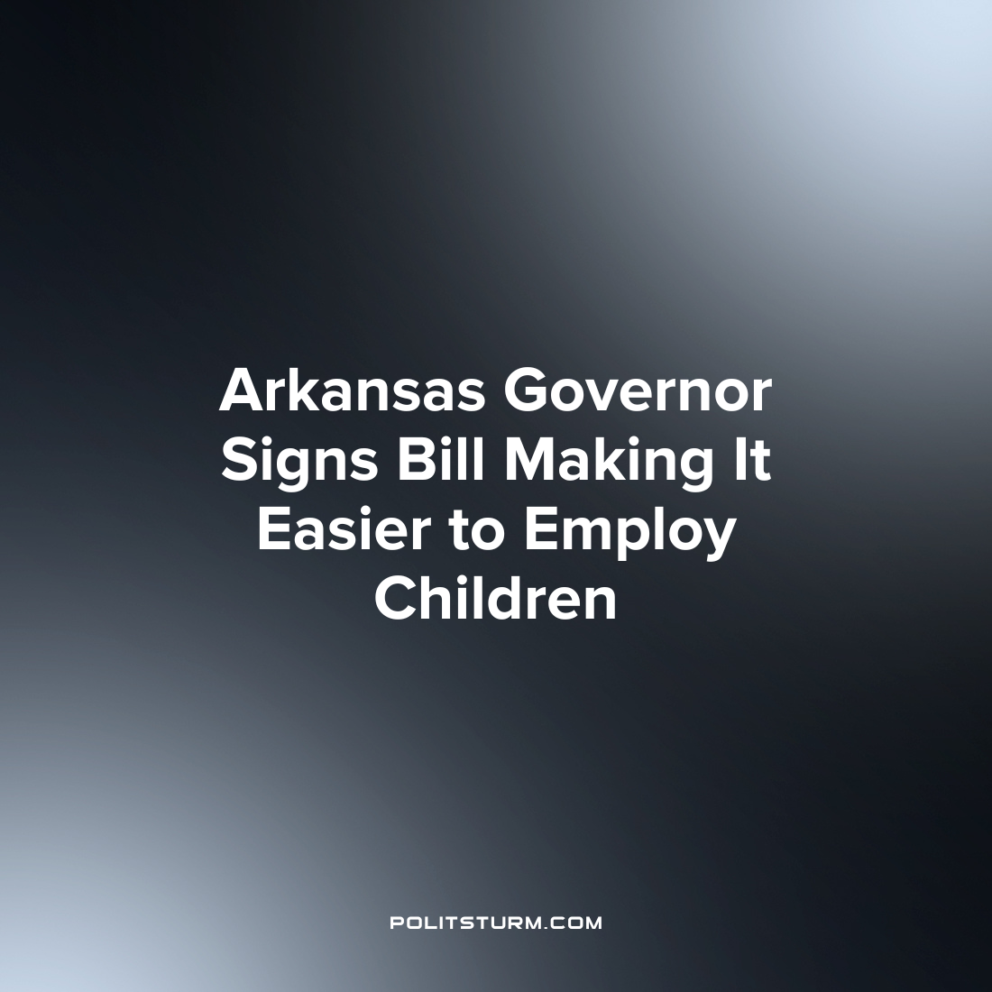

Original article
2023-04-26
1 min read

Arkansas Governor Sarah Huckabee Sanders recently signed House Bill 1410 into law, a law which revises the requirements for the employment of child labor. The act, known as the ‘Youth Hiring Act of 2023’ makes it easier for employers to hire children under the age of 16. Previously, children would need an employment certificate from the state’s Division of Labor in order to obtain employment. Before the bill was signed children would also need to provide proof of their age, a description of the type of work they would be doing, and the written consent of a parent or guardian.
The bill claims that the act restores “decision-making to parents concerning their children” and streamlines the process of hiring children under the age of 16 for employers.
When describing the consequences of the bill, the Arkansas Advocates for Children and Families questioned why lawmakers would want this act implemented.
“Lawmakers want to get rid of these work permits for children. Why? They’re not simply red tape. They exist to make it harder for people who would take advantage of our most vulnerable for the sake of greed”, said Laura Kellams of the Arkansas Advocates for Children and Families.
The beneficiaries of such a bill are the capitalist class who have for centuries benefitted from the employment of child labor in the U.S. By loosening the legal requirements for the employment of 14 and 15 year old children, the capitalists can expand the supply of available labor to exploit and further their own private profit-driven interests. The lawmakers are simply the representative of the capitalist class and so it is not surprising to see them pursuing such a reactionary agenda as it serves their class interests.
Source: 1 2

Original article

