ArcelorMittal Lays Off 450 Steel Workers
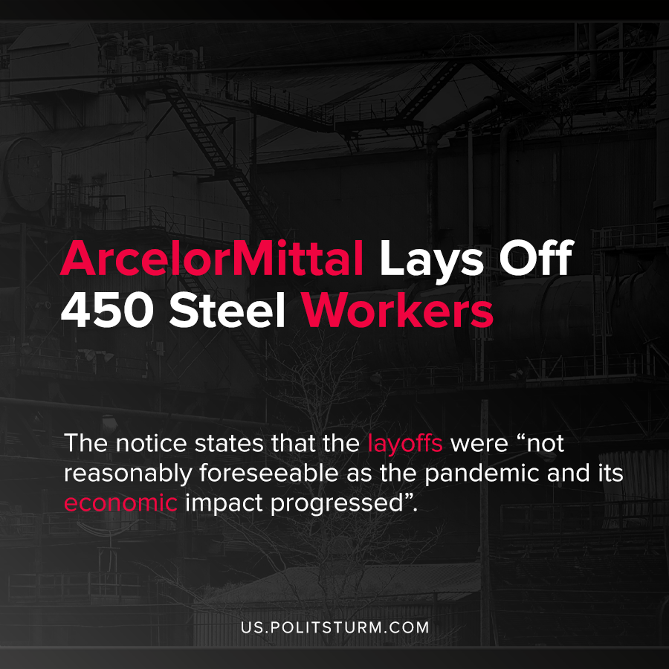

Original article
2020-07-29
1 min read

Multinational Steel manufacturing company ArcelorMittal announced that it will be laying off over 450 employees in Cleveland, Ohio. The majority of the layoffs affected the union employees who were laid off indefinitely.
The indefinite layoffs will begin on August 1st, 2020 or the 14 days thereafter. When providing the rationale for the layoffs, the Vice President referenced that there was a deterioration in market conditions due to the pandemic. There has not been a significant increase in demand for the produced steel in months, and so a mass layoff was initiated.
The notice states that the layoffs were “not reasonably foreseeable as the pandemic and its economic impact progressed”, and that the company would have liked to have given more notice to the affected employees.
The mass layoffs, particularly of represented union employees, shows how the employment of workers is subject to the anarchy of the market. Despite the statement that these economic crises are not reasonably foreseeable, capitalist crises of overproduction occur regularly roughly every decade.
As a result of uncoordinated, unplanned production in the pursuit of profit, capitalists are not always able to sell their products at profitable prices and lay off their workers. The affected workers lose their incomes through no fault of their own. Through a proper understanding of Marxist-Leninist theory, it is clear that the capitalist crises and their associated negative repercussions on the working class are not unpredictable nor unavoidable.
Source: 1

Original article

