Apple Workers Vote To Unionize
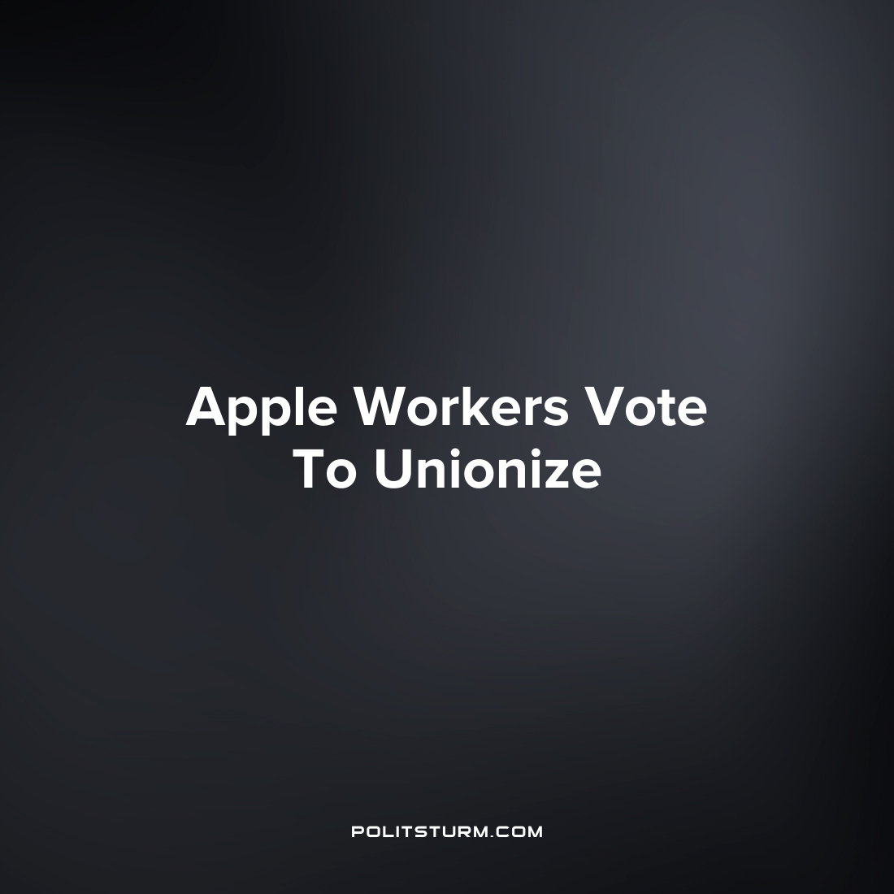

Original article
2022-06-19
1 min read

Apple workers in Towson, MD voted recently to join a union, the first Apple store in the United States to Unionize. The workers were recently organized into the Coalition of Organized Retail Employees and then voted overwhelmingly to join the International Association of Machinists and Aerospace Workers (IAM).
The workers and their union had previously sent a letter to Apple CEO Tim Cook informing them of their intention to organize into a labor union.
“Today we are writing to let you know that we have organized a union (CORE- Coalition of Organized Retail Employees) with the assistance of the IAMAW and currently have the support of a solid majority of our coworkers. This is something we do no [do] to go against or to create conflict with our management”, the letter says.
It is valiant that the workers are organizing to fight for improved working conditions and to collectively bargain with their employer. However, Apple is focused on the maximization of its profits subject to its “constraints” of which labor costs are a constituent part. The company and the board of directors will do everything in their power to maximize profit and are not interested in forming any good faith partnerships with the workers to the extent that it interferes with this primary objective. Marxism-Leninism reveals that class struggle is the driving force of history and in modern times this is the struggle between capitalists and the workers. In order for the working class to achieve success and end the class dictatorship of the capitalists, it is necessary to understand and incorporate Marxist-Leninist theory.
Source: 1 2

Original article

