Amherst Laborers Receive No Wages Over Five Weeks
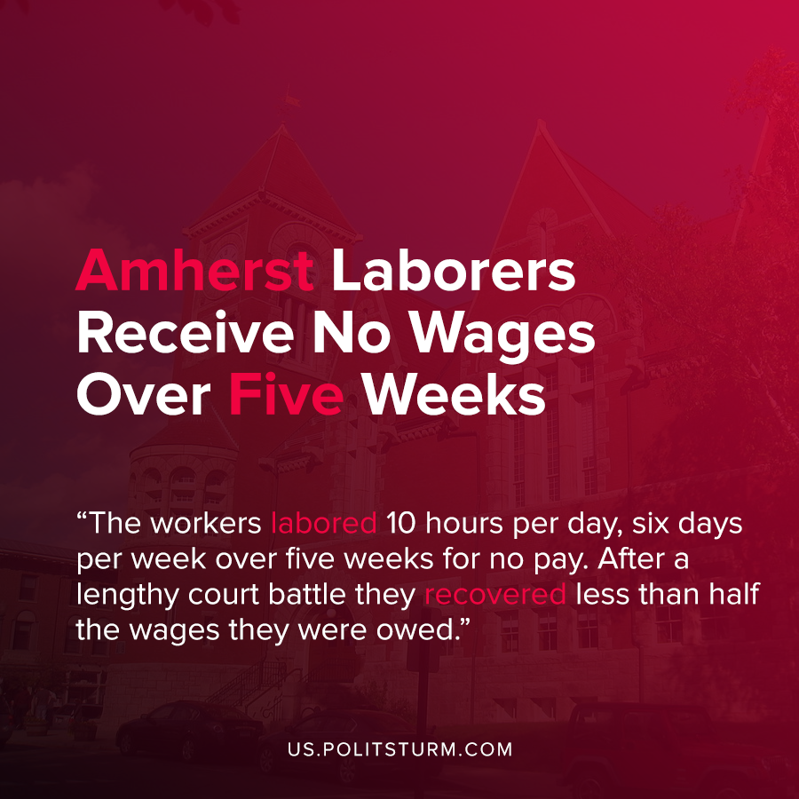

Original article
2020-08-04
1 min read

A report by Tom Juravich at the Labor Center at the University of Massachusetts-Amherst investigated wage theft at a residential development in the town called North Square Apartments.
Boston-based real estate developer Beacon Communities will receive $2,795,009 in tax credits over the next 10 years to build affordable housing from the town of Amherst, Massachusetts. The general contractor for the dry-walling of the units was contracted out to a company called Combat Drywall, Inc.
This company, Combat Drywall, further sub-contracted the actual labor through a broker, Alvarez Drywall, who brought laborers to the workplace to perform the actual labor. The undocumented workers who immigrated from Honduras confirmed that they worked 10 hours per day, 6 days a week and received no compensation for their labor over five weeks.
After months of legal proceedings the workers were only able to recover $23,977.85 in back wages, and the fines to the companies involved amounted to $17,500. The cost of back-wages and fines for wrongdoing were lower than the wages that the employees should have been paid.
Thus we see that under capitalism there is rampant wage theft and companies are incentivized to act in this manner. Unscrupulous brokers hire undocumented immigrants and then not pay any of the wages due to their vulnerable legal status. The legal system, which represents the interests of the capitalist class, does nothing to disincentivize this behavior through its legal proceedings because it serves the capitalists, and not the workers. Only under a socialist system, which represents the interests of the working class, will this theft be impossible.
Sources: 1 , 2

Original article

