Americans Waste 768 Million Vacation Days Annually
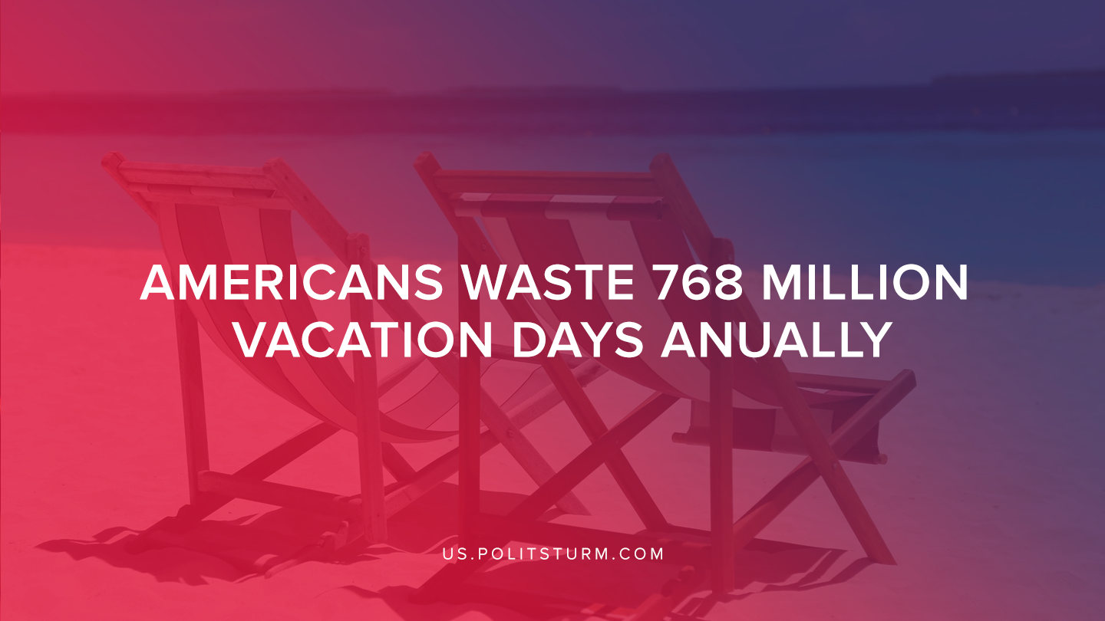

Original article
2019-08-23
1 min read

According to a recent student conducted by Oxford Economics and Ipsos, more than 55% of Americans are not utilizing all their time off. The numbers suggest that Americans failed to utilize 768 million days of PTO which was a 9% increase from 2017.
The amount of leisure time that American workers have utilized has been on a historical decline. As of 2018, Americans used an average of 17.4 days off per year. In 1981 Americans utilized 21.2 days off per year.
Not all Americans are using the same amount of paid time off. For example, workers who made $150,000 or more annually averaged 22.5 days and only left 3.1 days of paid time off on the table.
As we can see, over approximately 40 years the tendency of capitalism has been the reduction in leisure time for the average American workers. The highly paid workers can have relatively more leisure time, however when looked at as a whole the American worker has faced a reduction in leisure hours.
The majority of American workers (55%) are not even using all of the time off that is available to them. While the capitalists are making record profits, the workers are working more hours and utilizing less paid time off. The capitalist economic system is predicated upon the capitalist class profiting off the unpaid labor of the working class. Only under a socialist system would the American working class be able to enjoy the fruits of their labor and see increasing leisure.

Source: 1

Original article

