Americans Putting Rent on Credit Cards Up 70%
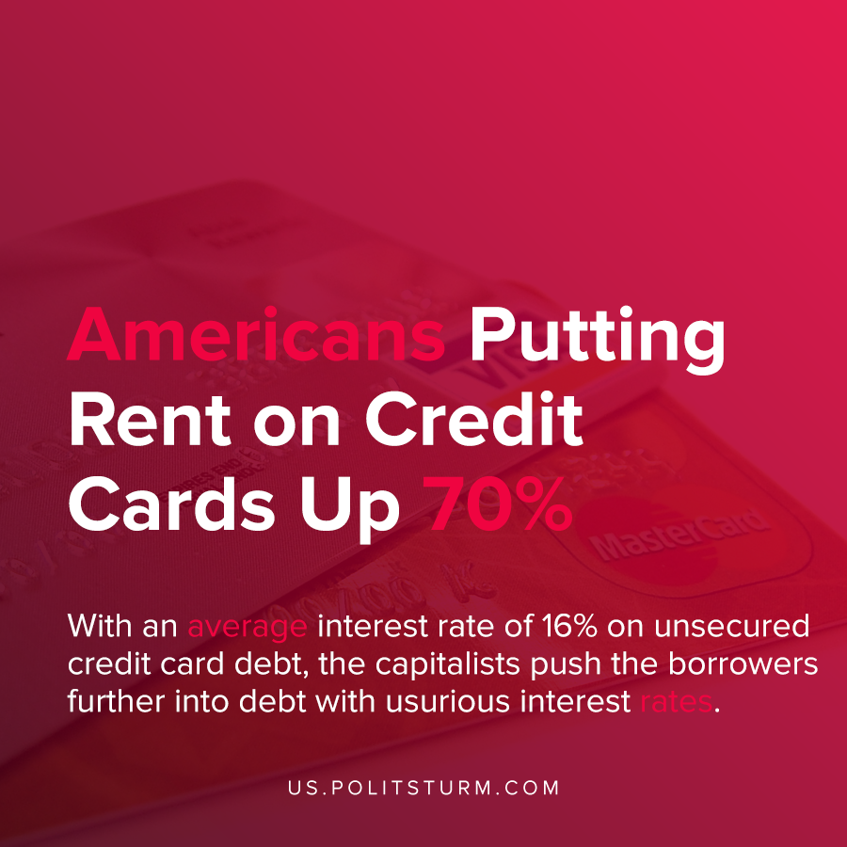

Original article
2020-12-02
1 min read

According to an analysis by the Federal Reserve Bank of Philadelphia, the percentage of Americans putting rent payments on their credit cards increased by 70%.
As the economic crisis and coronavirus pandemic have taken a toll on the workers and unemployed, many have depleted their savings and need to rely on credit to avoid homelessness.
In a survey by the Philadelphia Fed in the period between September 1-17 2020, 21.4% of respondents needed a loan from family and friends, 25.6% needed a new credit card, and 21.6% applied for a new personal loan.
The landlords and financial capitalists can easily push the burden of the capitalist crisis onto the workers and unemployed through debt. When money is borrowed to pay rent, the landlords realize their ground rent and a new debt is created.
With an average interest rate of 16% on unsecured credit card debt, the financial capitalists push the borrowers further into debt with usurious interest rates.
Only the abolition of the capitalist mode of production and the private ownership of the means of productions can put an end to the dictatorial rule of the capitalists and landlords who enrich themselves through the exploitation of the working class.
Sources: 1 , 2 , 3

Original article

