American Workers Drowning in Debt
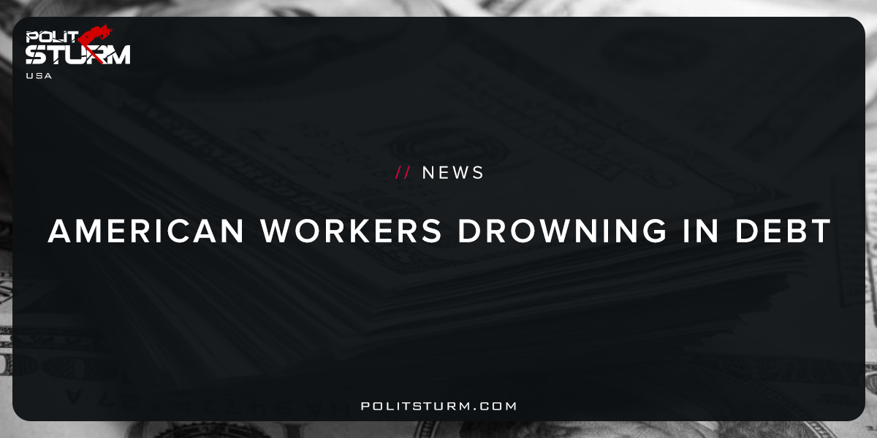

Original article
2017-11-22
1 min read

“The average American household carries $137,063 in debt, according to the Federal Reserve’s latest numbers.
Yet the U.S. Census Bureau reports that the median household income was just $59,039 last year, suggesting that many Americans are living beyond their means.
Here’s how much debt the average U.S. household owes in credit cards, auto loans, student loans, and mortgages.
Those numbers are unlikely to shrink anytime soon, according to NerdWallet. That’s because the cost of living in the U.S. rose 30% over the past 13 years, yet household incomes only grew 28%. As a result, more Americans are using credit cards to cover basic needs like food and clothing.
Medical expenses have grown 57% since 2003, while food and housing costs climbed 36% and 32%, respectively. Those surging basic expenses could widen the inequality gap in America, as a quarter of Americans make less than $10 per hour.
Politsturm:The fact that Americans are overwhelmed with onerous debts is not surprising to those who understand how capitalism works. These debts are largely the result of credit cards, student loans, mortgages, and auto loans. All of these types of debts are loans of money to purchase certain commodities, such as cars, houses, clothes, or even an education. When this loan is created, there is an interest which is paid from the lender to the borrower. The massive loans are simply a reflection of the debt owned as an asset by the capitalist class and owed by the workers. There are two dimensions to this relationship, lender and borrower, asset and liability, capitalist and worker.
The companies and individuals who own this debt are able to profit at the expense of the working class. A portion of the unpaid labor of the working class is paid to the bondholders in the form of interest. This article propagates the absurd argument that the working class American is “living beyond their means”. This is just another way in which the idle, parasitic capitalist tells the worker to grin and bear the insufferable domination of capital. The workers truly have nothing to lose but their chains.
Source

Original article

