American Vultures Circle as Puerto Rico Seeks to Privatize Devastated Utilities
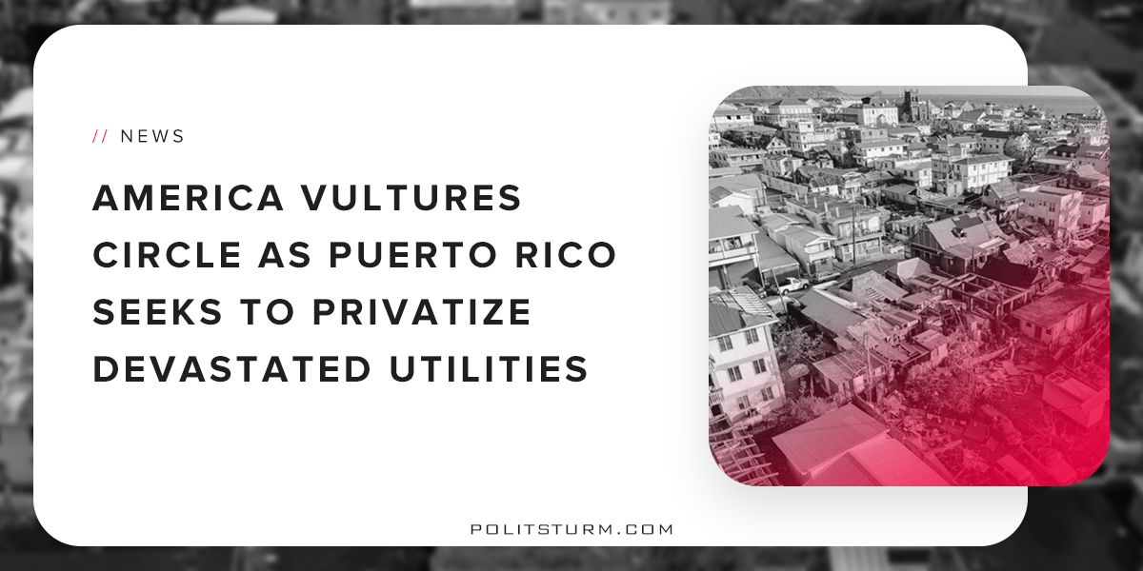

Original article
2018-05-19
3 min read

Stranded a thousand miles out at sea, conditions in Puerto Rico have only deteriorated since Hurricane Maria devastated the island last September. Those who could afford to leave have. The rest are becoming desperate with hurricane season on its way again. The Puerto Rican government has been rendered impotent by the $74 billion debt crisis. Its proven simply too much for the island to handle. Not only does the central government owe money, the publicly owned corporates and utilities do. As an “unincorporated territory” (that’s the politically correct way of saying colony), they are unable to declare bankruptcy the way a state government or state institution can. Congress has little motivation to change this as creditors have lobbied against allowing Puerto Rico to declare bankruptcy.
Despite the island’s chronic economic sluggishness and declining population, Puerto Rican bonds have seen tremendous sales. This is due to the fact that they are not taxable at the federal, state, or local levels. Usually municipal bonds only have this exemption if they’re bought in the city the buyer lives in. This peculiar exemption has made the bonds desirable to small time investors. Hedge funds and mutual funds only hold $26 billion. The other $48 billion is held by individuals. Many of these are middle class Americans and retirees who didn’t realize the bonds were actually a pretty bad investment.
With the local government saddled by debt, many have turned to the island’s colonial masters for solutions. The federal response has been characterized by dishonesty and apathy. President Trump hasn’t even tried to hide his true feelings, using a comedic and insulting Spanish accent when voicing his supposed sympathy. FEMA has cut food and water aid and the Army Corps of Engineers has announced it will be leaving while thousands of Puerto Ricans still lack shelter and electricity. What work they did was less than promised. Of the more than 70,000 people without roofs who qualified for tarps, only 25,000 have received them. Tens of thousands of tarps sit unused in warehouses.
With nothing more than broken promises, Puerto Rican Governor Ricardo Rossello has been pushing for mass privatization, a move which has been heavily criticized but may be nonetheless entirely necessary given the state of the government and the lackluster support they’ve received from their colonizers. Rossello has already begun auctioning off the utility companies. He is especially eager to sell the island’s publicly owned energy company which alone owes $9 billion. In a televised address that only about 20% of the population could even see, Rossello said: “The Puerto Rico Electric Power Authority [PREPA] does not work and cannot continue to operate like this. … we cannot face the risks of living in an area of high vulnerability to catastrophic events.” Needless to say, it‘s Yanqui colonizers and foreign capitalists who will be the ones “helping.”
There’s little chance of Puerto Rico getting much money from the sale. Even before the hurricane, PREPA was badly in need of renovation and repair. The system is significantly older than those in most US states and burns expensive, polluting gas. Worst of all, most generators are located in the south of the island despite the vast majority of Puerto Ricans living in the north. This requires a significant amount of infrastructure which is extremely vulnerable in a storm. This has been the biggest challenge in restoring power. Miles of wiring needs to be repaired before the majority of Puerto Ricans can be connected to the power grid.
Two American companies and one South Korean have already proposed buying PREPA in its entirety. Francisco Rullán, executive director of the State Office of Public Energy Policy, confirmed for el Centro de Periodismo Investigativo that the island’s energy would likely be monopolized but did not reveal the companies identities. Rullán did, however, identify a fourth company hoping to buy PREPA. Sunnova, a Texas-based company, threw its hat in the ring immediately after the storm but is struggling to gain the government’s trust. Sunnova and Puerto Rico have something of a history together. The company loaned faulty solar panels which stopped working after the storm. And customers claim the company failed to maintain their promised rates. As of now, nothing has been made official. Rullán stated that they’re still in negotiations. He also said that: “I disagree that PREPA be privatized by a single corporation.” Unfortunately, Rullán and his office have no authority to make such decisions.
PREPA is surely not the only piece of Puerto Rico to be stripped off and sold for scrap. The island has been cutting benefits and raising taxes since 2010. They’ve little room to bargaining and no time to waste. Soon enough, American companies just may own everything worth buying on the island. Indeed, it’s easy to see disaster capitalism at work. But this is just another in a long line of injuries to the long-suffering colony of Puerto Rico.
Sources: 1, 2, 3, 4, 5, 6, 7, 8

Original article

