American Communist on the Russian Revolution
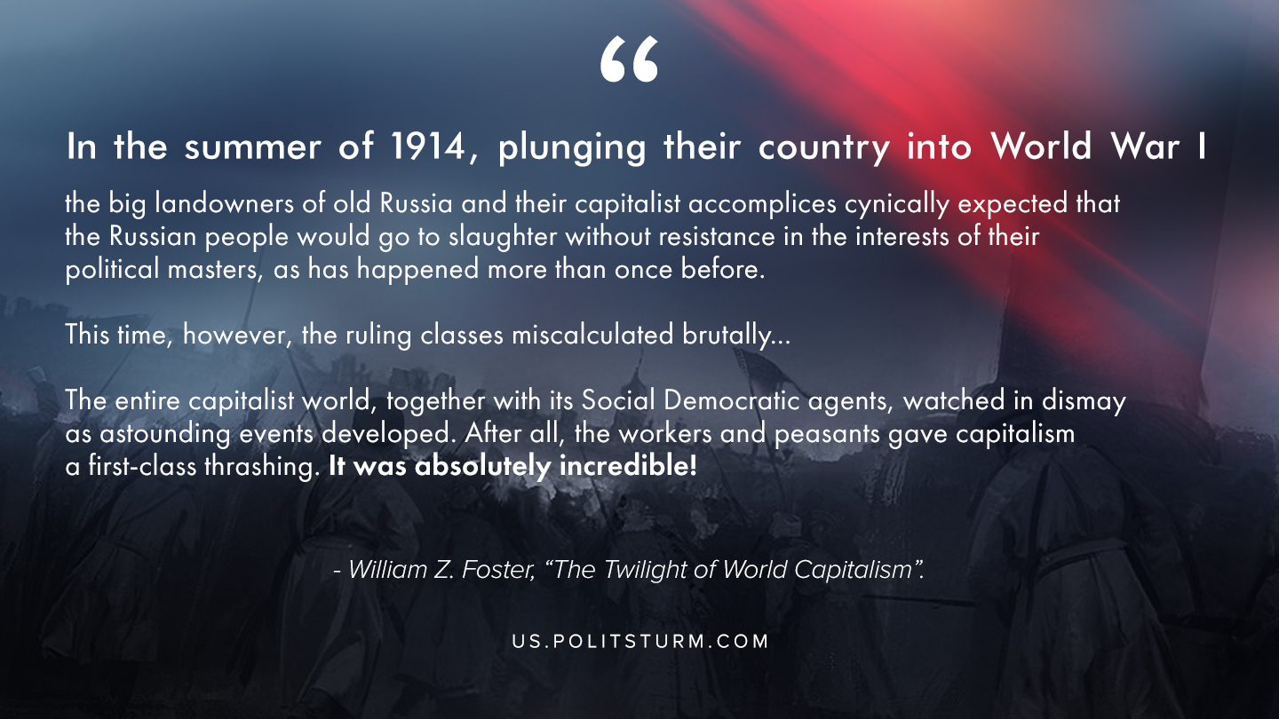

Original article
2019-11-07
1 min read

“In the summer of 1914, coolly plunging their country into World War I, the big landowners of old Russia and their capitalist accomplices cynically expected that the Russian people would go to slaughter without resistance in the interests of their political masters, as has happened more than once before. This time, however, the ruling classes miscalculated brutally…
The entire capitalist world, together with its Social Democratic agents, watched in dismay as astounding events developed. After all, the workers and peasants gave capitalism a first-class thrashing. It was absolutely incredible!”
William Z. Foster, The Twilight of World Capitalism

Original article

