American Communist on the American Revolution
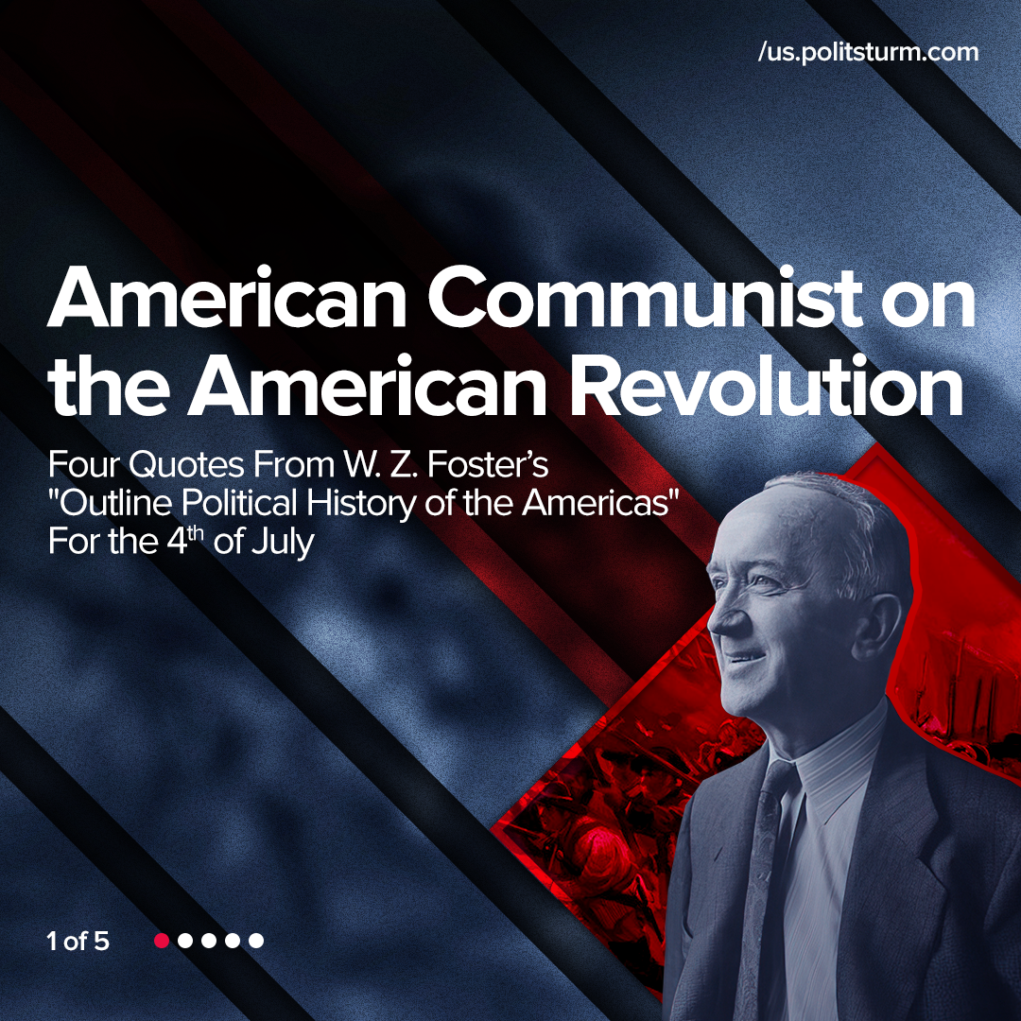

Original article
2022-07-04
1 min read

4th of July is celebrated in USA as “Independence Day”. On this day in 1776 the Declaration of Independence was signed, making the Thirteen colonies independent from the British monarchy.
William Z. Foster was the General Secretary of the Communist Party USA in 1924-1934 and 1945-1957. Foster was the author of works on the problems of scientific socialism, the history and theory of the labor movement, and the key problems of US history.
In his book “Outline Political History of the Americas” Foster gave a Marxist-Leninist point of view on the revolutions that took place on the American continent in the late 18th and early 19th centuries. One of the key events of that period was the North American bourgeois-democratic revolution, known as “The American Revolution”, or “The American War of Independence”. In his work, Foster gave an objective view of this revolution, showing its progressive and reactionary sides.
Error loading image
Error loading image
Error loading image
Error loading image

Original article

