America Presses for Russia-Ukraine Peace Deal
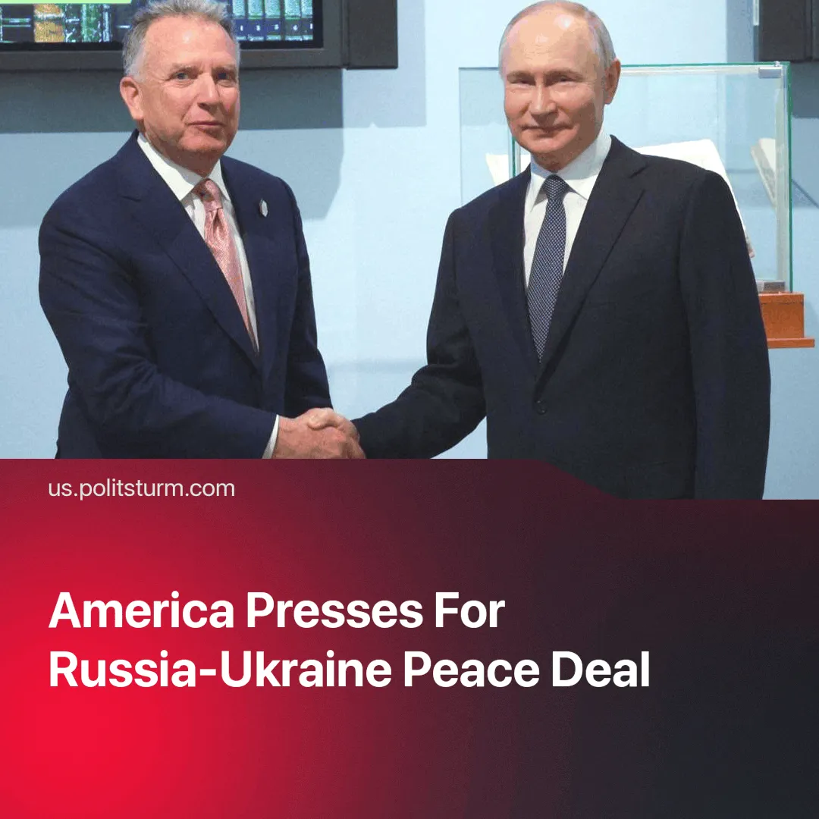

Original article
2025-04-23
1 min read

Negotiations over Ukraine have intensified sharply in the last few days, with the US openly insisting on recognizing the current borders.
► Earlier we reported on the weak progress in US-Russia talks in late March, as well as Russia’s failed “Easter Truce”.
Details. Over the past two days, there has been a noticeable increase in the intensity of negotiations, as evidenced by the visits of a U.S. official Witkoff to Moscow and a U.S.-UK-EU-Ukraine meeting in London.
► Several major media outlets published reports about ongoing talks overnight. According to the Financial Times, Putin proposed freezing the current front line during negotiations with Witkoff. Within an hour and a half of that report, Putin's spokesperson Dmitry Peskov made a statement that did not directly deny the FT's information.
► The U.S. peace plan, published by Axios, includes Ukraine's legal renunciation of Crimea, a commitment not to join NATO, and de facto recognition of the current front line as the new border.
► A meeting between the U.S., EU, and Ukraine was scheduled to take place in London this Wednesday, during which the U.S. was expected to present this plan to Ukraine. However, it was soon announced that Secretary of State Rubio and special envoy Witkoff had withdrawn from the meeting.
► Following this, a meeting between the foreign ministers of the UK, France, Germany, and Ukraine was also postponed. This may be linked to President Zelensky’s statement declaring it legally impossible for Ukraine to recognize Crimea as Russian territory, as well as reports that Ukrainian diplomats were trying to shift the discussion from peace negotiations to a 30-day ceasefire.
► The next round of negotiations between Russia and the U.S. will take place "soon", Russian Foreign Minister Lavrov said today.

Original article

