Amazon Exposes Workers to Unsafe Work Conditions
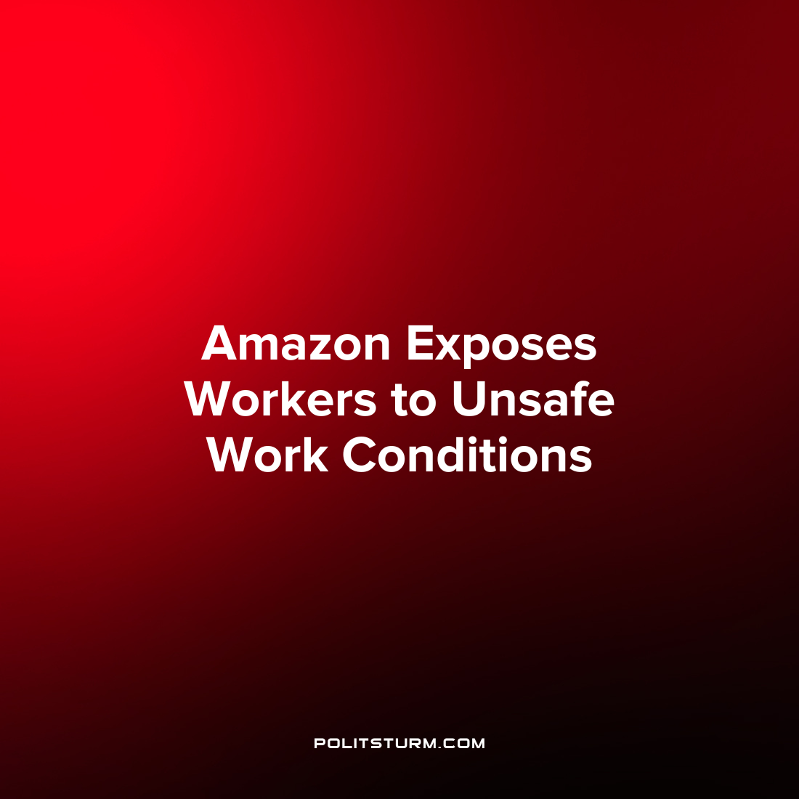

Original article
2023-02-06
1 min read

A release by the U.S. Department of Labor announced that the Occupational Safety and Health Administration (OSHA) issued citations at three more Amazon warehouses. The administration found that at the warehouse locations in Aurora Colorado, Nampa Idaho, and Castleton New York, the workers were exposed to ergonomic hazards. The finding comes after referrals from the U.S. Attorney’s office of Southern New York to the agency for similar violations in Florida, Illinois, and New York in July 2022.
The investigators found that Amazon exposed their workers to conditions which put them at risk for lower back injuries and other musculoskeletal disorders.
As a result, OSHA proposed a penalty of $46,875 for the violations at the three locations. Amazon had net sales of $514 billion in 2022.
“They need to take these injuries seriously and implement a company-wide strategy to protect their employees from these well-known and preventable hazards”, said OSHA Assistant Secretary Doug Parker.
The penalty assessed by the agency demonstrates the extent that the government of the bourgeois is willing and able to protect workers from workplace injuries. The meager fine will not deter the company from its practices which are intended to maximize profits for the capitalist class. As long as capitalism continues to exist, the workers will be exposed to unnecessary harm for the benefit of the oligarchs and corporate owners.
Source: 1 2

Original article

