Amazon Warehouse Workers Vote to Unionize
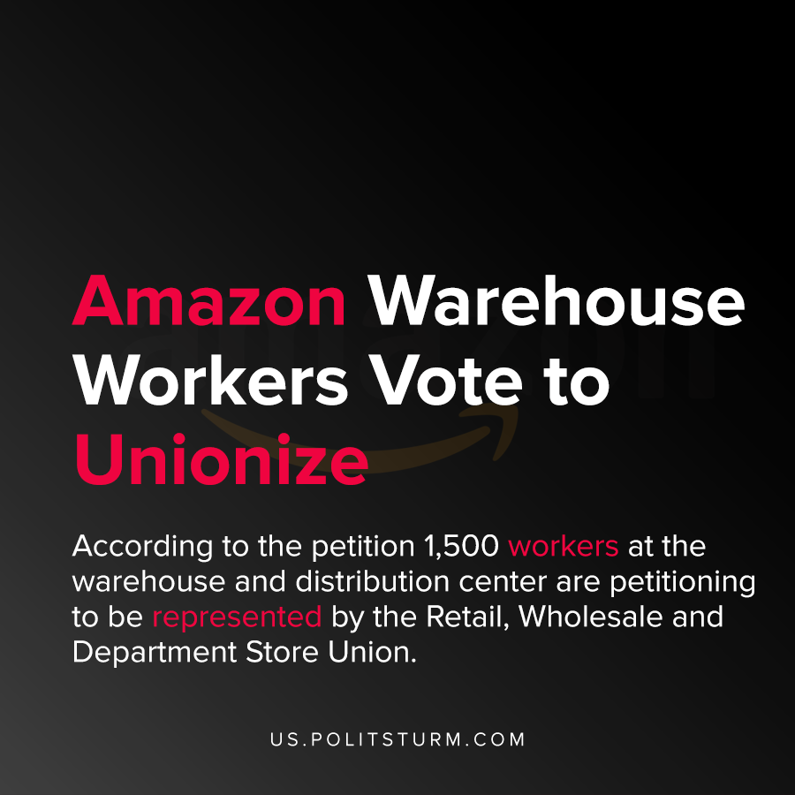

Original article
2020-11-25
1 min read

Amazon warehouse workers in Bessemer, Alabama filed a petition to unionize pursuant to the National Labor Relations Act. According to the petition 1,500 workers at the warehouse and distribution center are petitioning to be represented by the Retail, Wholesale and Department Store Union.
The union is fighting for safer working conditions, formal grievance procedures and the removal of “at-will” employment status for which an employee can be fired for no reason.
Amazon has vocally come out against the unionization of its workforce in the past. Amazon has specifically trained its managers to restrict union activity and has stated that it does “not believe that unions are in the best interests of our customers, our shareholders, or, most importantly, our associates”.
The unionization of Amazon workers and the struggle of Amazon to resist unionization efforts is a clear expression of the class struggle. Amazon struggles to secure the maximum profit through suppressing collective bargaining which can reduce the rate of exploitation of the workers.
The unionization of the workers at the Bessemer warehouse is a courageous act to resist capitalist exploitation. However, in order to eliminate capitalist exploitation and wage slavery it is necessary to understand Marxist-Leninist theory to end the rule of the oligarchic bourgeoisie.
Sources: 1 , 2 , 3

Original article

