Amazon VP Quits Over Whistleblower Firings
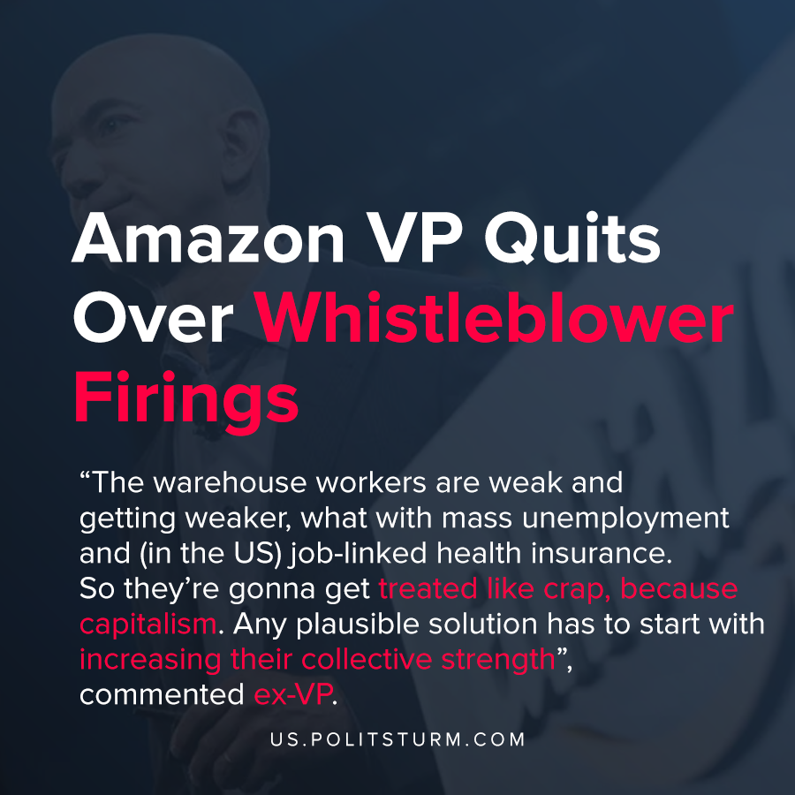

Original article
2020-05-05
1 min read

Former VP and Distinguished Engineer at Amazon Web Services Tim Bray quit his position over Amazon firing whistleblowers. Whistleblowers have been fired from Amazon for speaking out on issues ranging from climate change to employee safety during the COVID-19 epidemic.
In addition to telling the personal stories of workers who were fired, Bray tells about the discrepancy in how workers are treated between the warehouse workers and at Amazon Web Services.
“The warehouse workers are weak and getting weaker, what with mass unemployment and (in the US) job-linked health insurance. So they’re gonna get treated like crap, because capitalism. Any plausible solution has to start with increasing their collective strength”, said Tim Bray.
By firing whistleblowers, Amazon’s executives are enforcing the will of capital and are capitalizing on the mass unemployment and the lack of U.S medical insurance. Workers who speak up against the current working conditions can be fired and replacements can be drawn from the excess supply of labor. The capitalist system by its structure and internal logic is predicated upon the extraction of unpaid labor, and this contradiction is an insoluble class contradiction between worker and capitalist.
The solution to the problems presented by the capitalist system can only be achieved by overcoming class society itself. The implementation of the collective strength of the workers begins with understanding Marxist-Leninist theory and its implementation.

Original article

