Amazon Nets $789 Million from Tax Cuts
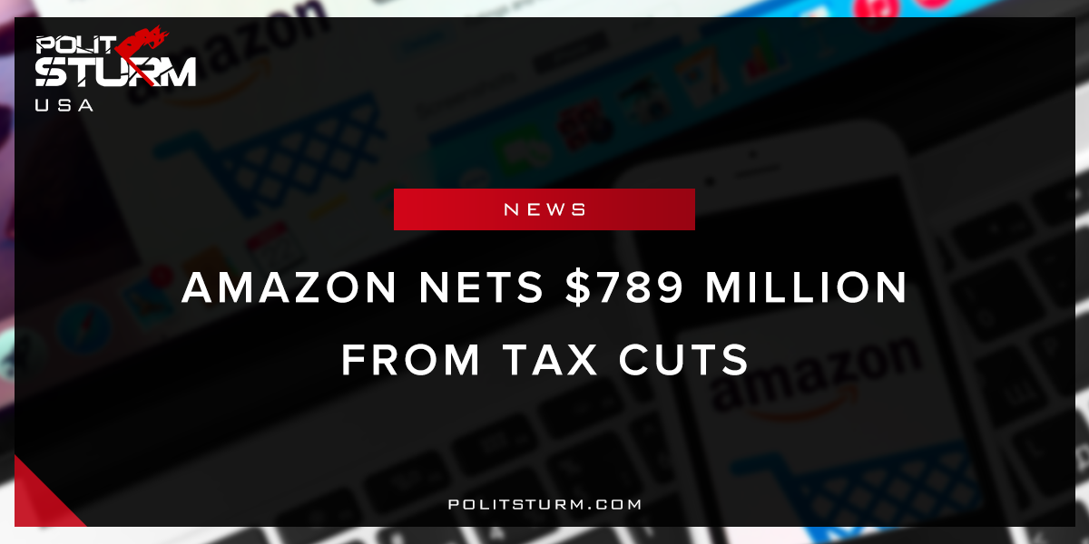

Original article
2018-04-04
1 min read

Amazon has come under increasing pressure from the President of the United States for exploiting the tax system and the U.S Postal service. Despite the oppositional rhetoric, Amazon has undoubtedly benefited from the Trump administration’s tax overhaul. The Tax Cuts and Jobs Act had the effect of lowering Amazon’s corporate taxes and allowing the repatriation of foreign earnings, if applicable. The obvious contradiction is that Trump is saying that Amazon needs to “pay real costs (and taxes) now”, while the legislation signed by the same president cuts Amazon’s tax obligation.
The contradiction is due to the fact that the American government does not represent the will of the working people, but rather the oligarchs and corporations. While the president claims to be a “populist”, his administration is filled with multi-millionaires and billionaires. These same individuals are now giving tax cuts to the wealthiest individuals and to corporations. The problem is that the capitalist economic system incentivizes and necessitates this perverse situation. The $789 million that Amazon will save in taxes will benefit the class of shareholders who can afford to pay $1447.34 for a single share of Amazon stock. As long as capitalism exists, the class of parasitical shareholders and landlords will continue to use the government to their advantage.

https://www.cnbc.com/2018/03/31/trump-bashes-amazon-again-saying-post-office-loses-billions.html

Original article

