Amazon Introduces AmaZen Booths for Warehouse Workers
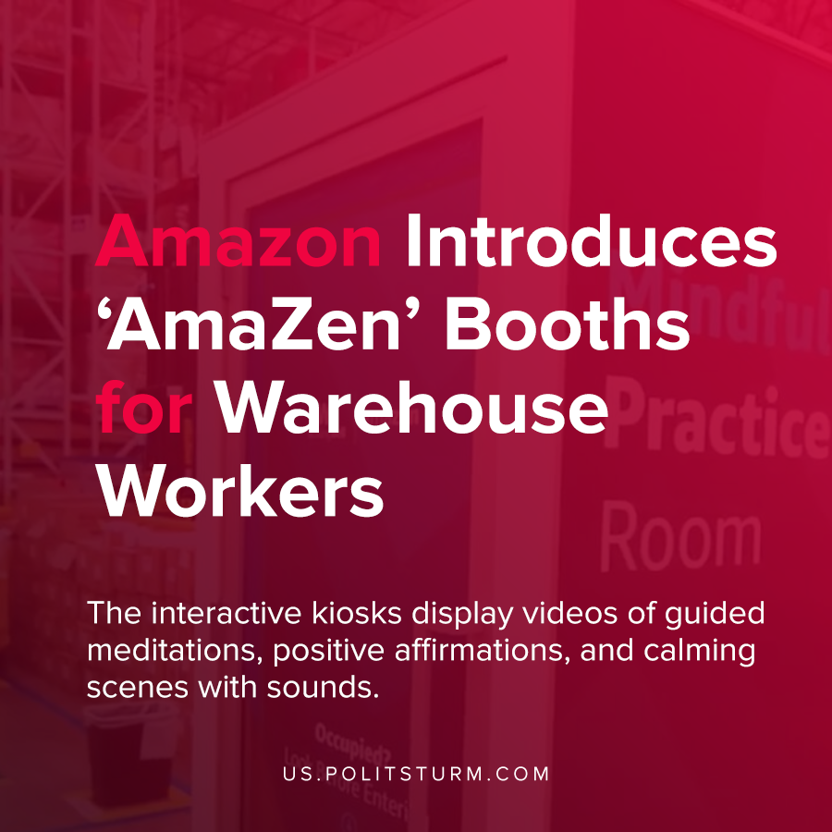

Original article
2021-05-29
1 min read

Amazon recently announced the launch of an employee wellness program called “WorkingWell” which purportedly intends to provide employees with physical and mental health resources.
The company also claims that the physical and mental health of the employees, and not the maximization of profits for shareholders, has always been the top priority for the company.
One of the aspects of the program is called AmaZen which involves the installation of kiosks in the warehouses. The interactive kiosks display videos of guided meditations, positive affirmations, and calming scenes with sounds.
After the concerted effort by Amazon to defeat the unionization efforts, the company instituted this mindfulness and wellness initiative to distract workers from their stressful and demanding workplace environment. The capitalist class, rather than improving the conditions of the workers in the workplace, prefer to institute idealistic wellness campaigns to continue the material exploitation of the workers.
Source: 1 , 2

Original article

